# BodyWorks │ Floor 3

Exhibition Guide

|  |  |
| --- | --- |
| Last updated on: 17 June 2013  Last updated by: Duncan Smith  Document saved here:  W:\_Exhibition Projects\BodyWorks Floor 3\ Admin\Operations\Sci comm guide |  |

# Quick look

Your body fights back Research Capsule

Pages

89-101

Respirat-ory & Cardio-vascular exhibits

Pages

43-59

About You exhibits

Pages

19-41

Reproduct-ion & Ageing exhibits

Pages

149-161

Your bionic body Research Capsule

Pages

211-221

Musculo-skeletal exhibits

Pages

187-209

Entrance exhibits

Pages

11-17

Mending your broken heart Research Capsule

Pages

61-75

Digestive & Urinary exhibits

Pages

103-123

Defence exhibits

Pages

77-87

DNA & Cell Biology exhibits

Pages

131-147

Getting under your skin Research Capsule

Pages

125-129

Making sense of your brain Research Capsule

Pages

179-185

Nervous & Endocrine exhibits

Pages

163-177

# Contents

Introduction 8

BodyWorks within GSC 8

Exhibition themes 9

Exhibition zones 9

My BodyWorks (barcode cards) 10

Microsite 10

Privacy notice 10

Entrance exhibits 11

What body shapes can you make? 12

Sensory homunculus 14

Sensory walls and seat 16

About You exhibits 19

How powerful is your cycling? 20

How tall are you? 22

How fast can you sprint? 24

How strong is your grip? 26

How long can you stay balanced? 28

How much air can you expel? 30

How long can you hang on? 32

How high can you jump? 34

How fast are your reactions? 36

Login stations 38

Scoreboard 40

Respiratory & Cardiovascular exhibits 43

What does smoking do to your body? 44

How does smoking damage your lungs? 48

What affects your breathing? 50

Heart ECG: What does your heart trace look like? 52

Where are your veins? 54

How hard does your heart work? 56

How fast is your heart beating? 58

Mending your broken heart Research Capsule 61

Replacing a broken heart 62

Heart gadgets information screen 64

Replacing heart valves 66

Accessing the heart 68

Repairing blood vessels 70

Replacing blood vessels 72

Heart surgery information screen 74

Defence exhibits 77

Antiviral Hero 78

Going Viral 80

Holophonic macrophage journey 82

Mucus Ninjas 84

Bendy Microscope 86

Your body fights back Research Capsule 89

Pathogen Slideshow 90

Identifying the carriers of parasites 92

Parasite Playground 94

Living with arthritis 96

Immune system research information screen 98

Living with asthma 100

Digestive & Urinary exhibits 103

How much energy can you burn? 104

Where is fat stored in your body? 106

How does alcohol affect your vision? 108

10-Year Time Machine 110

What is inside you? 112

Shifting Waistline 114

How good are your surgical skills? 116

Where do your organs belong? 118

Intestines – peristalsis 120

Intestines – feely boxes 122

Getting under your skin Research Capsule 125

Human torso 126

Virtual Autopsy: What lies hidden under the skin? 128

DNA & Cell Biology exhibits 131

What is the structure of your DNA? 132

DNA Decider: How unique are you? 134

DNA Detective: Can you solve the crime? 136

Future Therapies: What is the potential of stem cells? 138

Cell Top Trumps: Can you beat the computer? 140

Family Name: Which is your family name most popular? 142

Drugs and your DNA: Can you stop the outbreak? 144

DNA Disco: Can you copy the sequence? 146

Reproduction exhibits 149

Can you tell unborn animals apart? 150

Run the Risk: Will the pressure get too much? 152

My Journey through Pregnancy 154

How does a baby grow? 156

Sperm Race: Can you reach the egg? 158

Facial Features: Which faces do you find attractive? 160

Nervous & Endocrine exhibits 163

Getting Emotional: What will you respond to most? 164

Can you speak while listening? 166

Concentration Station: How do you balance speed with accuracy? 168

Memory Challenge: How good is your memory? 170

Multitasking Brain: How can you keep going? 172

Whose brain is more relaxed? 174

Face Evolver: Can you reproduce the criminal’s face? 176

Making sense of your brain Research Capsule 179

Brain Explorer 180

Human head 182

Spot the Difference: Can you see the brain pathology? 184

Musculoskeletal exhibits 187

Can you control a mechanical arm? 188

How do your forearm bones move? 190

How does your spine move? 192

Every body is different 194

Crawl inside a bone 196

What is the shape of your skeleton? 198

X-ray viewer 200

Lenticular skeleton & muscles 202

How do your joints move? 204

How does your skeleton move? 206

Landing Gently: How softly can you land? 208

Your bionic body Research Capsule 211

i-limb ultra 212

Human hand 214

Bionic Body information screen 216

Designed for athletic performance 218

Get Moving: Can you identify the athletic action? 220

Appendices 222

Appendix A – Keys 222

Appendix B – Washing lung capacity mouthpieces 222

Appendix C – Additional resources on particular exhibits 222

# Introduction

This guide is intended to answer common questions that might arise when working with the exhibits in the BodyWorks exhibition.

# BodyWorks within GSC

Here is an overview of the conceptual visitor experience for the Science Mall and how BodyWorks fits within the larger picture.

### Explore & Discover

* Floor 1

Explore and discover the foundations of science

The initial experience for most visitors, this is a 'high energy' floor that encourages visitors to engage in open exploration of the free-standing interactive exhibits. The hands-on exhibits will be in loose clusters that illustrate the principle phenomena and experiments associated with the broad subject areas. They will be designed to promote and facilitate exploration and self-discovery. Visitors will learn that exploration and discovery are the driving forces behind scientific research.

### Science in Action

* Floor 2

Science turns into technology

Society’s relationship with science & technology

This gallery will explore the role of creativity and innovation in science, showcasing examples of innovative technologies from industry and academia through displays and meet the expert events. The interactives and work-bench style exhibits will encourage visitors to make and do things, spending more time with the exhibits, getting more involved. Exhibitions and displays will encourage visitors think about and discuss the relationship of Science with Society – the consequences, risk and impact of scientific progress. Issues affecting society will be presented to encourage informed dialogue and debate.

### Science & You

* Floor 3

Science of yourself, you are the experiment

Arriving on the third floor in the prominent and bright area in front of the full-height glass wall, the visitor will be greeted by the energetic and active gallery about aspects of human biology. Here visitors will become guinea pigs in their own experiments, recording information about themselves and learning and understanding how they work. The exhibits will be a mix of interactives, multimedia, workstations and open labs spaces. There will be opportunities to discuss the ethics of medical research and how it will affect our futures.

# Exhibition themes

BodyWorks is an exciting new approach to involving the public and schoolchildren in biomedical sciences. The practical, hands-on exhibition uses a combination of interactive exhibits and live laboratory experiences to raise awareness of the science underpinning human health and well-being in the 21st century.

### Major themes

* How does scientific research contribute to improving human health and well-being?
* What affects our health and well-being?
* The complexity of the human body
* Investigating and understanding our bodies
* Nature versus nurture
* Stages of life

### Concept statements

* The work of scientists helps us to find ways to improve our health and well-being.
* The human body is an amazing and dynamic biological system; the same fundamental functions and processes are carried out in every human body, but the diversity in human abilities and behaviour is vast.
* We are all scientists in the experiment of life. Internal and external influences affect the health and well-being of the sample, i.e. our bodies.

# Exhibition zones

There are three main zones in the Bodyworks exhibition: About You, the Research Capsules and the Interactive Zones. There is also a Live Lab where the public have the opportunity to engage with vibrant practitioner-led activities or volunteer to participate in real research experiments on-gallery.

In **About You**, visitors become the star participant in their own experiment when they measure their physical and physiological characteristics, compare them with fellow visitors and sports stars and save them to their own personal passport.

The **Research Capsules** showcase cutting-edge developments in biomedical science. Evolving over time, through collaboration with research establishments, the capsules and corresponding interactive zones inspire the visitor to learn more through a host of sensory and interactive experiences.

The **Interactive Zones** provide a ‘hands on’, ‘minds on’ experience for visitors supporting active prolonged engagement with the ideas of fundamental biology.

# My BodyWorks (barcode cards)

My BodyWorks is a tool for visitors to save and access personal information from the exhibits. Each visitor takes a My BodyWorks card, which contains a unique barcode. This card allows them to save data at 15 exhibits in BodyWorks:

* How powerful is your cycling?
* How high can you jump?
* How strong is your grip?
* How much air can you expel?
* How long can you hang on?
* How tall are you?
* How long can you stay balanced?
* How fast can you sprint?
* How fast are your reactions?
* Your heart ECG
* Bendy microscope
* Multitasking brain
* 10-year time machine
* Getting emotional
* How gently can you land?

## Microsite

http://bodyworks.glasgowsciencecentre.org

## Privacy notice

(Available to visitors on the *Login Stations* screens)

**How information about you will be used**

Several exhibits in the BodyWorks exhibition can be used to measure information about you. The information that you measure using the exhibits or supply to us may be used in a number of ways, for example:

* To give you a personalised experience at an exhibit
* To present the measurements in a meaningful context to you and other visitors
* For statistical analysis by visitors to the exhibition website

Other visitors have no access to your personal information other than statistical analyses, for example, an average measurement for an exhibit, split by gender or age.

We will not disclose any personal information to any company outside Glasgow Science Centre.

If you do not wish to take part, you can still use the exhibits without a barcode card. However, you will be unable to save and access your results or exhibit media at a later stage.

If you need any further information, please contact a member of staff.

# Entrance exhibits

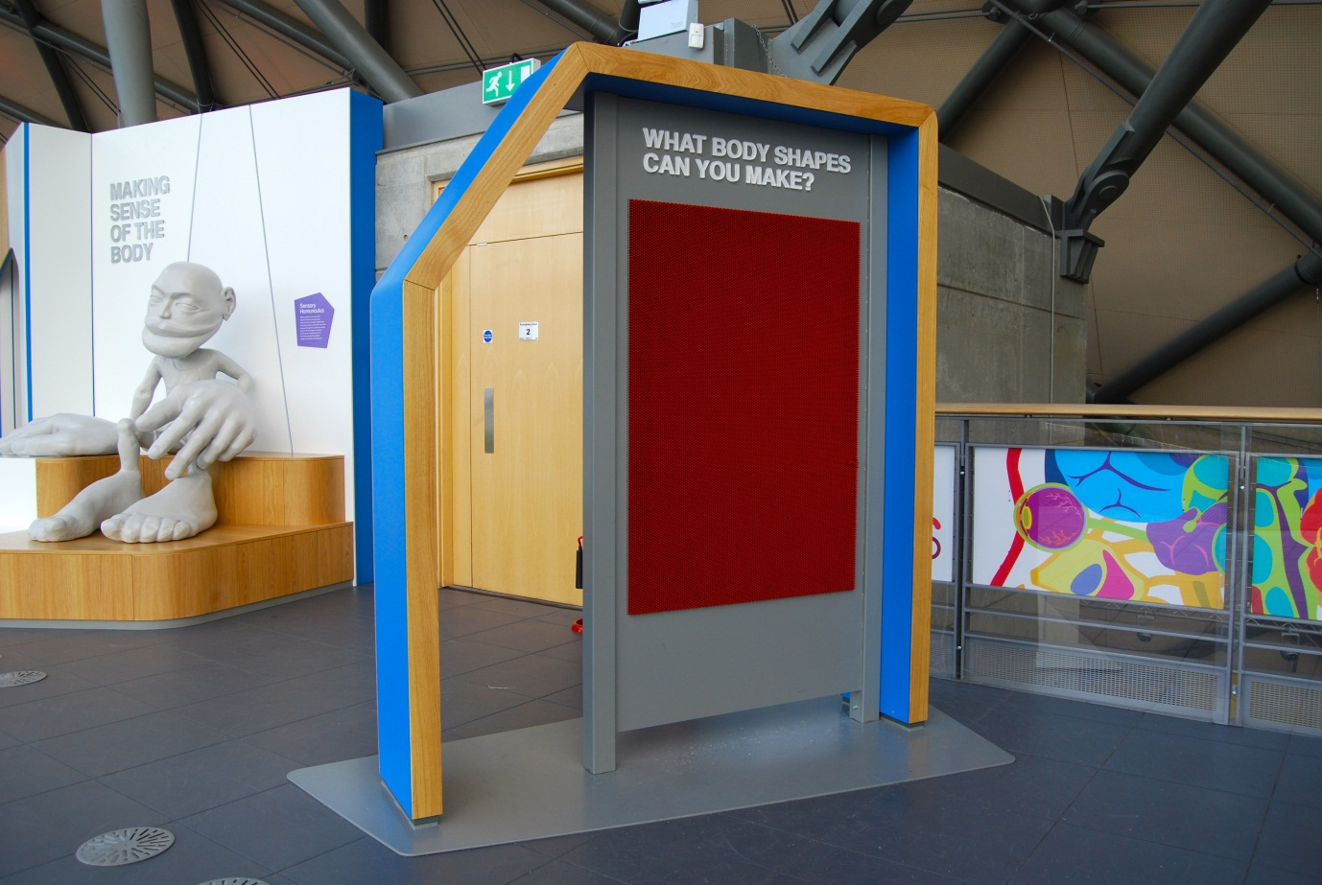

## What body shapes can you make?

Also known as Pin Screen Wall / A0.01

### Description

A free-standing wall of horizontal, moveable pins that visitors can push from behind to make shapes. The impressions remain static until reset. Located at the top of the stairs from Floor 2, the exhibit serves as a thematic bridge between the ‘creative’ themes of Floor 2 and the ‘human body’ themes of Floor 3.

### Visitor experience

Visitors can make relief patterns using their body.

### Visitor interaction tips

* Encourage visitors to use this exhibit one at a time. Why not bring over the resetting panel stored in the Floor 3 cupboard and help visitors reset the screen in between uses.
* Suggest to visitors that they record their creations by taking a photo or a video.
* Why not encourage a group of visitors to play a guessing game to see if they can match a body shape with a member of their group. First one person leaves their body shape, as others in the group have their backs turned to the screen. Then part of the group tries to guess who it was that left their body shape in the screen.

### Accessibility

For visitors with sight problems, point out that there is a beam at head height.

### Good to know

This exhibit is intended to be an open-ended exploration and does not have traditional learning outcomes.

### Daily checks by science communicators

Check the exhibit is good working order. In particular:

* There are no foreign objects in between the pins.
* No pins have fallen out. If any loose pins are found, collect them in Floor 3 cupboard for the Exhibit Engineers.

### Cleaning

Sweep the floor platform with a broom and dustpan & brush.

Dust the ledges with a telescopic static duster.

### Risks

See risk assessment in Risk Assessments folder.

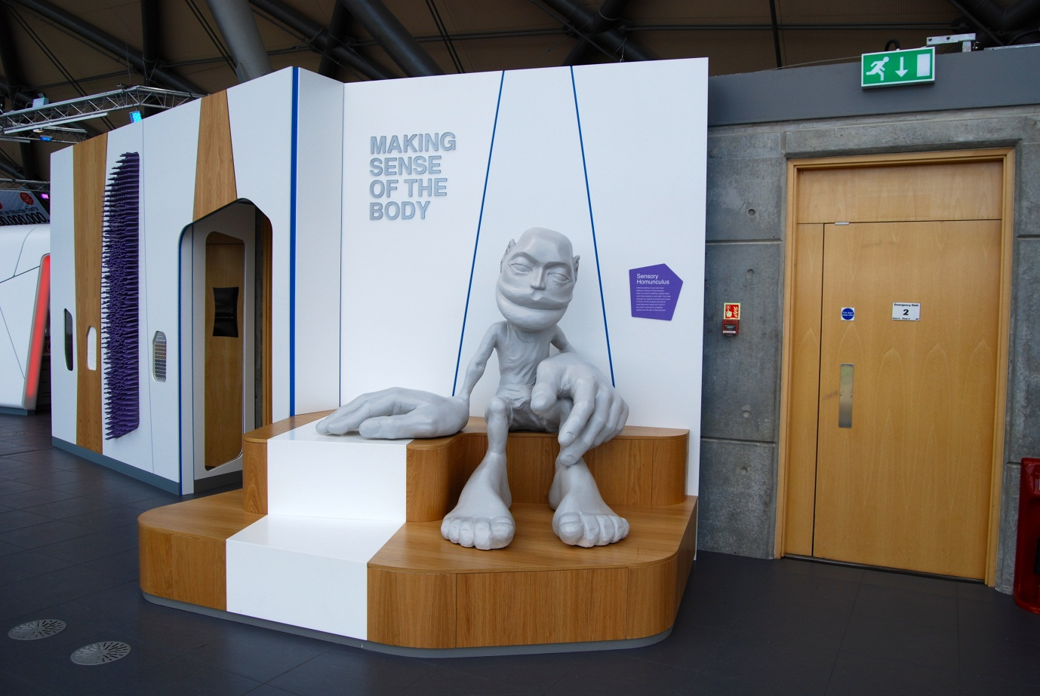

## Sensory homunculus

Also known as A0.02

### Description

A ‘homunculus’ sculpture that illustrates a touch sensory map of your brain. The sculpture shows you which parts of your skin send most signals to your brain from the touch receptors of your skin. The bigger the body part on the sculpture, the more of your brain is devoted to receiving signals from that body part. The sculpture is sitting on two large steps and welcomes visitors to the exhibition.

### Visitor experience

Visitors can see the extent to which different body parts are more or less sensitive than others. Visitors can take photos with the sculpture.

### Visitor interaction tips

* Share this science fact with visitors: Your sensitive fingertips have 100 touch receptors per square centimetre but your elbows have as few as 10 per square centimetre.
* Guide visitors to test whether their fingers really are more sensitive than their elbows by doing an experiment with the nearby *Sensory wall and seat* using the different textures.
* There are many skin sensitivity experiments described online that could be used as quick demos. Work with a Senior Science Communicator to develop an idea if you would like to deliver something.

### Accessibility

For visitors with sight problems, offer to guide them on a tactile tour of the sculpture (but be careful of the large steps). Alternatively, offer to describe the sculpture and guide them to experiment using the textures found on the nearby *Sensory wall and seat*.

### Good to know

This sculpture was one of the original exhibits from when Glasgow Science Centre opened in 2001. Originally the sculpture was on Floor 1 behind the escalators but it was moved and renovated for BodyWorks.

### Daily checks by science communicators

The sculpture and steps are in good condition, showing no signs of damage.

### Cleaning

Clean the steps with a broom and dustpan & brush.

Clean the surfaces with appropriate surface cleaner.

### Risks

See risk assessment in Risk Assessments folder.

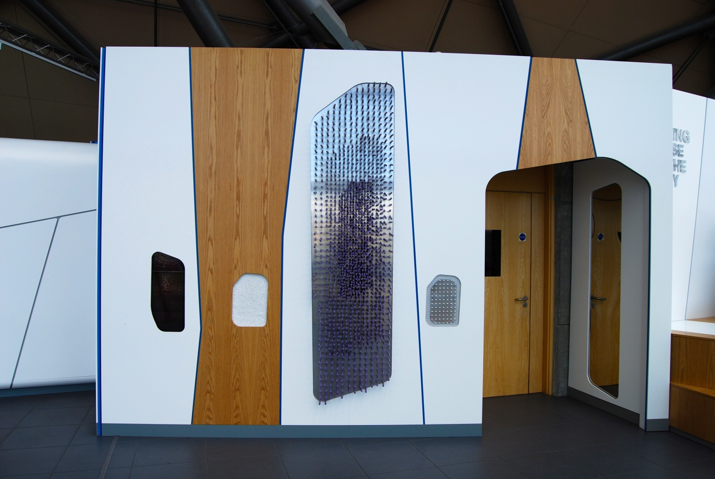

## Sensory walls and seat

Also known as A0.26

### Description

Note: As of 7 June 2013, the second wall and seat has not yet been installed on Floor 3.

Two walls of sensory stimuli for visitors to explore with touch and sight. One wall is free-standing and connected to a seat. The touch stimuli are designed to make it easy to compare the sensitivity of fingers versus elbows. These quick-interaction exhibits are designed to encourage visitors to use their senses to explore and think about their bodies (to then investigate the rest of the exhibition).

### Visitor experience

The visitor approaches the walls and runs their hands over different textures and surfaces. The visitor can also look at a range of visual stimuli.

### Visitor interaction tips

* Share this science fact with visitors: Your sensitive fingertips have 100 touch receptors per square centimetre but your elbows have as few as 10 per square centimetre.
* Guide visitors to compare the touch sensitivity of their fingers versus elbows using the different textures. Use the *Sensory homunculus* to explain that fingers have a greater concentration of touch receptors than elbows (making them, therefore, more sensitive to touch).
* There are many skin sensitivity experiments described online that could be used as quick demos. Work with a Senior Science Communicator to develop an idea if you would like to deliver something.

### Accessibility

For visitors unable to reach any particular texture, offer to find alternative, portable textures.

### Good to know

This exhibit is intended to be an open-ended exploration and does not have traditional learning outcomes.

### Daily checks by science communicators

The exhibit components are in good working order. In particular:

* The textures are not so worn that the visitor experience is compromised.

### Cleaning

Clean the surfaces with appropriate surface cleaner.

Clean the mirrors with appropriate glass cleaner.

### Risks

See risk assessment in Risk Assessments folder.

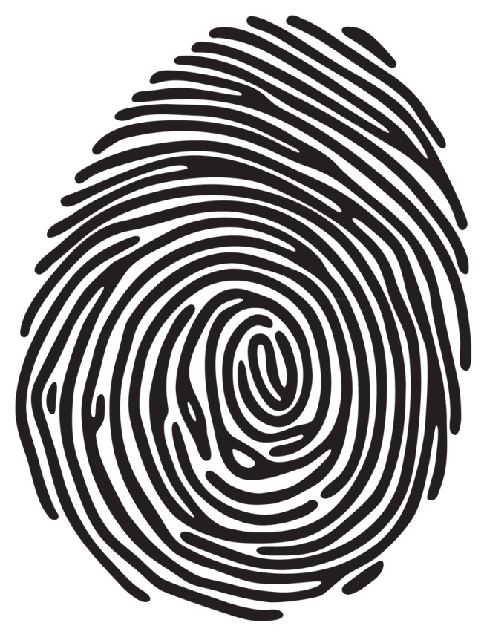

# About You exhibits

“We each have unique physical and physiological abilities, but how do yours compare to other visitors?”

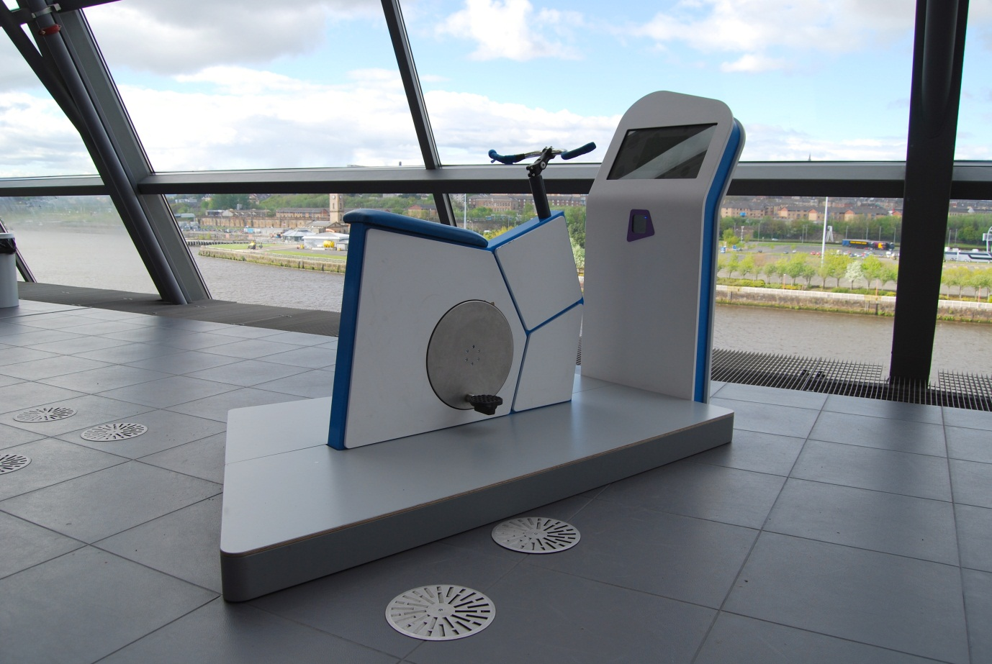

## How powerful is your cycling?

Also known as Power Bike / Cycling Power / A0.03

### Description

A free-standing exhibit that allows visitors to discover how much power they can generate while cycling. It consists of an adapted bicycle on raised platform, touchscreen and barcode scanner. It is designed for visitors over 6 years old.

### Visitor experience

The visitor activates the exhibit by either pressing the touchscreen or by scanning their My BodyWorks barcode card. During the 10-second test, the visitor pedals as fast as they can and their power reading is shown on screen as a graph of power over time. At the end, the visitor is given their maximum power reading in watts together with their total energy output over the 10 seconds, measured in joules. The visitor can save their results and graph to their My BodyWorks profile.

### Visitor interaction tips

* Encourage use of the My BodyWorks cards by explaining how they work and highlighting the benefits of using the website.
* Measure the visitor’s heart rate before and after the test using a portable pulse oximeter. Discuss why the heart rate changes with physical activity.
* Try asking thought-provoking questions related to the visitor, such as ‘how could you increase the power of your legs?’, ‘what is it inside your legs that provides the power to pedal?’ or ‘how did you compare to cycling champion Sir Chris Hoy?’

### Accessibility

For visitors with sight problems, offer assistance with mounting the bicycle and operating the touchscreen.

For visitors unable to use the bicycle, offer an explanation of the exhibit before pointing them in the direction of a similar experience that is accessible to them (potentially measuring grip strength, reaction time or even sprint speed).

### Good to know

As of 17 May 2013, the most common energy output recorded at this exhibit was 1420 joules. The overall average was 1600 joules.

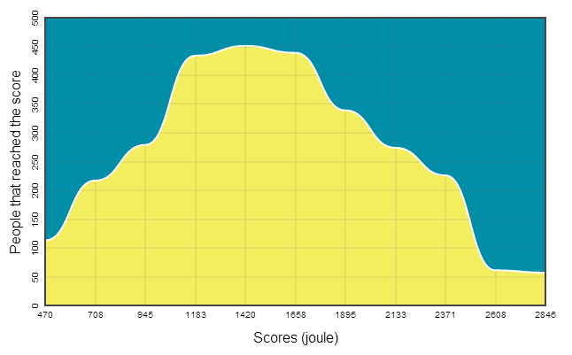

Your muscles are made up of thousands of thin fibres. When the fibres receive messages from your brain, they shorten, and as they shorten they pull on your bones to move your body. To turn the pedals of a bicycle, your leg muscles need to work in a sequence. Some muscles pull your leg down then others pull your leg back up to start again.

### Daily checks by science communicators

The exhibit components are in good working order. In particular:

* The handlebars are secure.

### Cleaning

Clean the screen with appropriate screen cleaner.

Clean the raised platform with a broom and dustpan & brush.

Clean the surfaces with appropriate surface cleaner.

### Risks

See risk assessment in Risk Assessments folder.

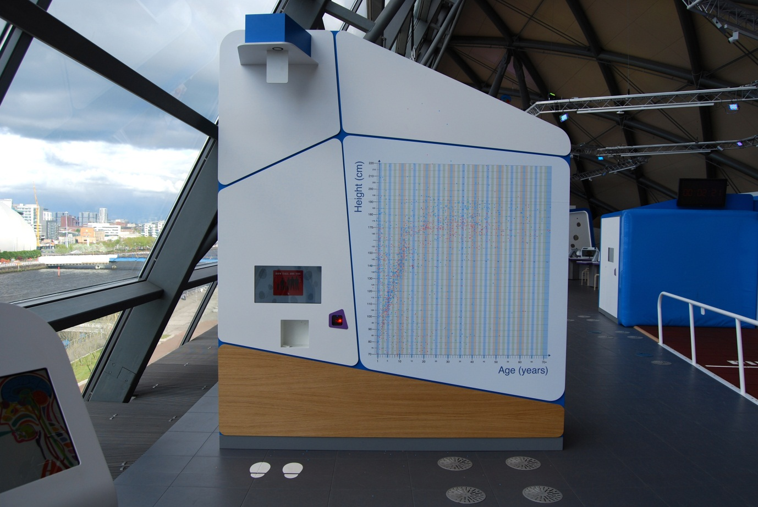

## How tall are you?

Also known as Height Chart / A0.12

### Description

A free-standing exhibit that allows visitors to measure their height before adding their result to a graph of height versus age. The exhibit features an ultrasound height device, touchscreen and barcode scanner. Results are added to the graph using blue or pink sticker dots, which are available in a recess under the screen.

### Visitor experience

The visitor activates the exhibit by either pressing the touchscreen or by scanning their My BodyWorks barcode card. During the measurement, the visitor stands on the white footprints, looks forward and keeps their head level. At the end, their height is given in centimetres (and in feet and inches). The visitor can save their reading to their My BodyWorks profile.

On the results screen, the visitor is prompted to add their height reading to the large graph. They take a blue or pink sticker dot from the recess and stick it to the graph at the intersection of their height and age.

### Visitor interaction tips

* Encourage use of the My BodyWorks cards by explaining how they work and highlighting the benefits of using the website.
* Point out some of the interesting things that can be seen in the large graph: the growth of children, the point when puberty stops et cetera.

### Accessibility

For visitors with sight problems, offer assistance with the touchscreen and the correct position to stand directly under the ultrasound sensor.

### Good to know

As of 23 May 2013, these were the height measurements taken by the exhibit:

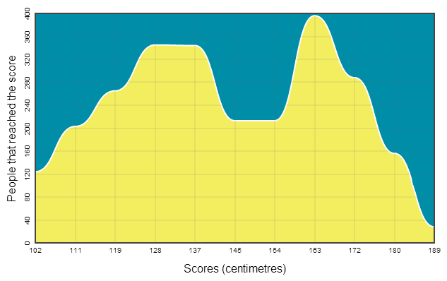

Many of your physical characteristics are determined by your genes, the instructions contained in your DNA. But your genes are not the whole story when it comes to your height. Your diet also has a major impact. In the period from 1880 to 1980, as food became more plentiful, the average height of men in the UK increased by almost 10 centimetres.

### Daily checks by science communicators

The exhibit components are in good working order. In particular:

* There are plenty of sticker dots available in the recess. Spares are available in the Floor 3 cupboard. When spares are running low, contact the Exhibit Engineers.

### Cleaning

Clean the screen with appropriate screen cleaner.

Remove and bin any sticker dots that are not on the graph.

Clean the surfaces, including sticker recess, with appropriate surface cleaner.

Dust the ledges using a microfibre duster or static duster.

### Risks

See risk assessment in Risk Assessments folder.

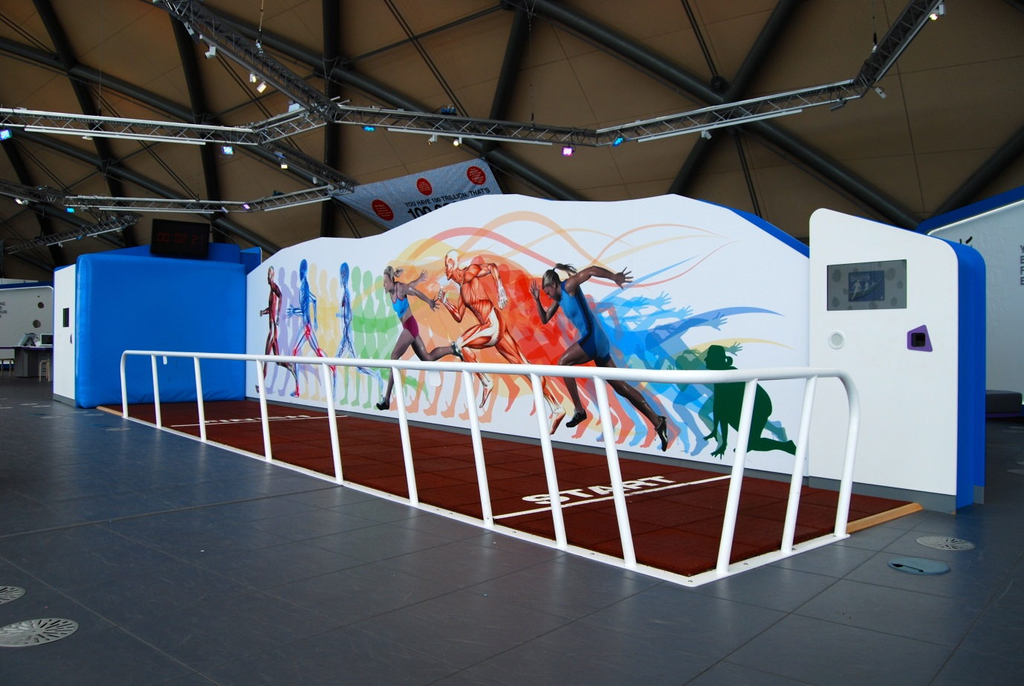

## How fast can you sprint?

Also known as Sprint Track / A0.22

### Description

A sprint track that visitors use to measure the time it takes them to travel the 5-metre distance between the start and finish line. It consists of one lane of athletics-grade matting, a vertical crash mat at the end, a barrier along the side, touchscreen at start, display screen above crash mat, results touchscreen beside crash mat, speaker and two barcode scanners. The results are taken by two light gates and a video camera above the sprint track.

### Visitor experience

The visitor enters the starting area and activates the exhibit by either pressing the touchscreen or by scanning their My BodyWorks barcode card. The start button triggers an automatic sequence of ‘ready, set, go’. As the visitor crosses the finish line, their sprint time is shown on the display above the crash mat in seconds and hundredths of a second. If the visitor scanned their barcode card before they ran, they can use the results touchscreen by scanning their card to view their results and video replay.

### Visitor interaction tips

* Encourage visitors to use this exhibit one at a time. When busy, why not operate the touchscreen and control the queue to speed up visitor flow.
* Measure the visitor’s heart rate before and after the test using a portable pulse oximeter. Discuss why the heart rate changes with physical activity.
* Encourage use of the My BodyWorks cards by explaining how they work and highlighting the benefits of using the website. Point out to visitors that they can retrieve a video replay of their run by using their barcode card.

### Accessibility

For visitors with sight problems, offer to walk them through the track first. During the sprint, give a verbal notice when they cross the line so that they can stop in time.

For visitors who use a wheelchair, offer assistance to enter the starting area and offer to operate the touch screen.

### Good to know

As of 23 May 2013, the most common sprint time recorded at this exhibit was 2.14 seconds. The overall average was 2.15 seconds.

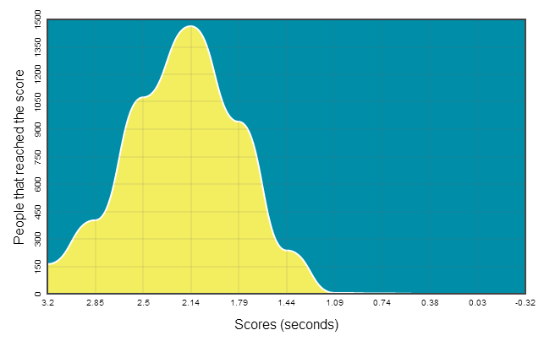

Your sprinting ability develops from a combination of ‘nature and nurture’. Variations in your genes contribute to how your muscles and nerves are built and function, but diet and training are also critical factors. Other aspects allow you to perform at your best including having a robust immune system and a calm, focused mental attitude.

### Daily checks by science communicators

The exhibit components are in good working order.

### Cleaning

Clean the running surface with a vacuum cleaner.

Clean the two touchscreens with appropriate screen cleaner.

Clean the barrier and surfaces with appropriate surface cleaner.

Dust the ledges along the track, top of crash mat and above results screen with a telescopic static duster.

If the screen above the crash mat needs cleaned, contact the Exhibit Engineers.

### Risks

See risk assessment in Risk Assessments folder.

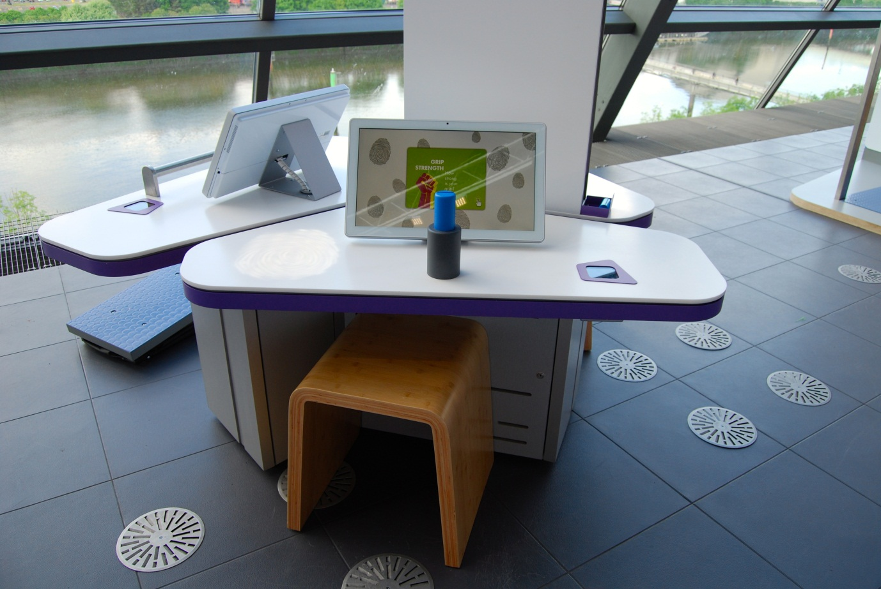

## How strong is your grip?

Also known as Grip Strength / A0.06

### Description

A table-top exhibit that allow visitors to carry out a grip strength experiment. It consists of a metal handle, touchscreen, barcode scanner and moveable stool.

### Visitor experience

The visitor activates the exhibit by either pressing the touchscreen or by scanning their My BodyWorks barcode card. The visitor can test the strength of one hand at a time. As they squeeze the handle, their strength reading (force) is shown on screen. At the end, their maximum strength reading is given in newtons. The visitor can save their reading and graph to their My BodyWorks profile.

### Visitor interaction tips

* Encourage use of the My BodyWorks cards by explaining how they work and highlighting the benefits of using the website.
* Why not act as a guide, leading visitors through the interaction by operating the touchscreen and tailoring the learning content to each individual visitor.
* Try asking thought-provoking questions related to the visitor, such as ‘which of your hands do you think is stronger?’, ‘why does your grip strength decrease during the test?’ or ‘which of your hobbies needs a strong grip?’

### Accessibility

For visitors with sight problems, offer assistance with the touchscreen.

For visitors unable to reach the exhibit handle, offer to use a portable grip strength dynamometer (currently kept by GSC On Tour – ask a Senior Science Communicator if one is available to borrow).

### Good to know

As of 17 May 2013, the most common grip strength reading recorded at this exhibit was 123 newtons. The overall average was 186 newtons.

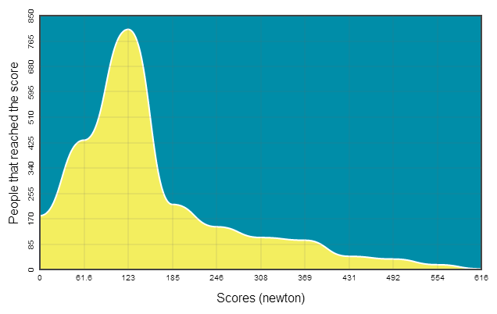

Most people find that their dominant hand is stronger than their other hand. Left-handed people usually have a stronger left hand and right-handed people have a stronger right hand. Your handedness is influenced by your genes, but environment is important too. Some people teach themselves to use their weaker hand.

### Daily checks by science communicators

The exhibit components are in good working order. In particular:

* The grip handle is secure and not wobbly.
* There are no coins or other objects inside the gap of the grip handle: metal could affect the readings.

### Cleaning

Clean the screen with appropriate screen cleaner.

Clean the surfaces, handle and stool with appropriate surface cleaner.

### Risks

See risk assessment in Risk Assessments folder.

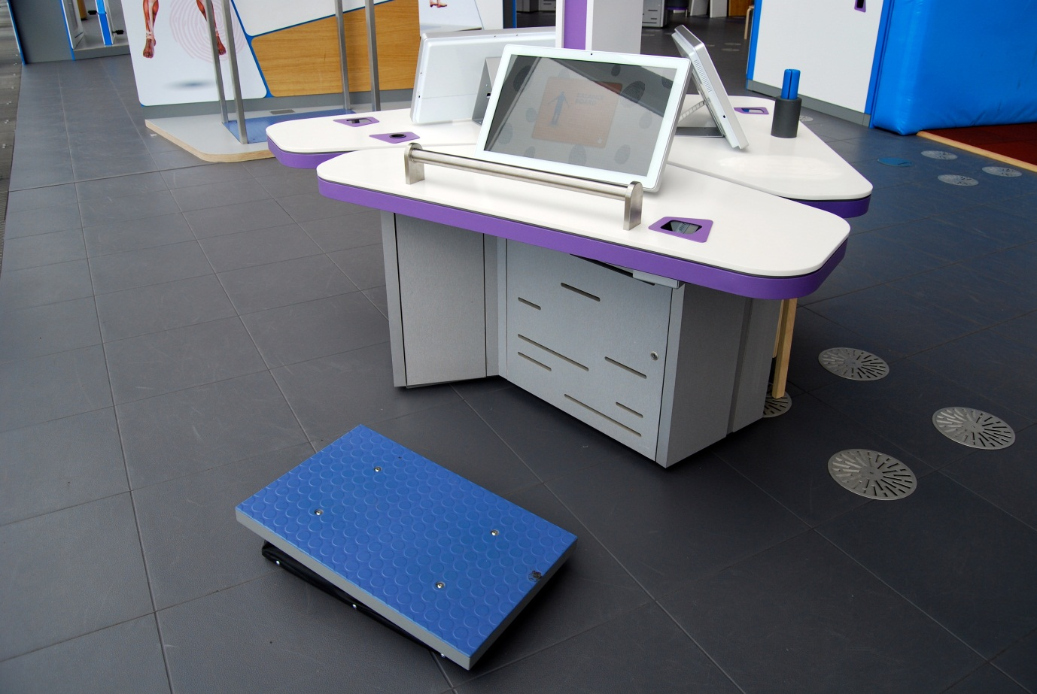

## How long can you stay balanced?

Also known as Balance Board / A0.18

### Description

A pivoted platform that visitors stand on and try to measure how long they can stay balanced. The exhibit consists of a platform, touch-sensitive handrail, touchscreen and barcode scanner.

### Visitor experience

The visitor activates the exhibit by pressing the touchscreen, scanning their My BodyWorks card or by touching the handrail. The visitor stands on the platform, facing the screen. When prompted, they hold the handrail and move the platform until it is level. When they release the handrail, they try to balance for as long as they can. The timer stops when the platform makes contact with the floor or when the handrail is touched. The visitor has three attempts and is given their best balance time at the end, measured in seconds and hundredths of a second. The visitor can save their best balance time to their My BodyWorks profile.

### Visitor interaction tips

* Encourage use of the My BodyWorks cards by explaining how they work and highlighting the benefits of using the website.
* Try asking thought-provoking questions related to the visitor, such as ‘how can you change your technique to improve your score?’ or ‘where in your body is the part that measures balance?’

### Accessibility

For visitors with sight problems, offer assistance with the touchscreen and getting comfortable with the balance platform.

For visitors unable to use the balance platform, offer an explanation of the exhibit before pointing them in the direction of a similar experience that is accessible to them (potentially measuring grip strength, reaction time or even sprint speed).

### Good to know

As of 17 May 2013, the most common balance time recorded at this exhibit was close to 0 seconds. The overall average was 4.02 seconds.

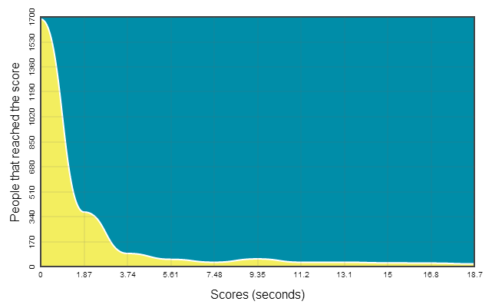

Your balance-sensing apparatus is in your inner ears. Signals about your balance are sent to the brain and are processed with visual information from your eyes. To keep your balance, your brain instructs your muscles to act. You use the core muscles in your back and abdomen, but your arms also help.

### Daily checks by science communicators

The exhibit components are in good working order.

### Cleaning

Clean the screen with appropriate screen cleaner.

Clean the surfaces and handrail with appropriate surface cleaner.

Clean the platform with a broom and dustpan & brush.

### Risks

See risk assessment in Risk Assessments folder.

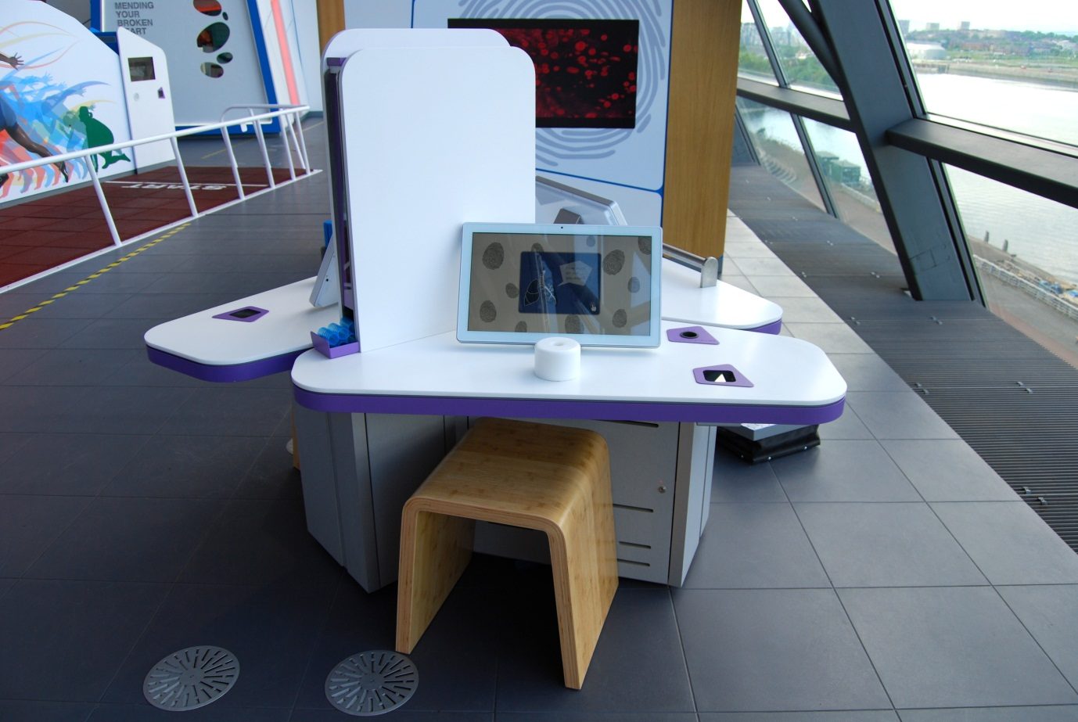

## How much air can you expel?

Also known as Lung Capacity / A0.07

### Description

A table-top exhibit that allows visitors to measure the volume of air they can expel (their Forced Vital Capacity). It consists of a mouthpiece dispenser, sensor, mouthpiece bin, touchscreen, barcode scanner and moveable stool.

### Visitor experience

The visitor activates the exhibit by either pressing the touchscreen or by scanning their My BodyWorks barcode card. They pick up a fresh mouthpiece and place it into the white sensor unit. During the test, they take a deep breath then fully exhale through the mouthpiece. The volume of air measured is displayed in litres. The visitor can save their reading to their My BodyWorks profile. The used mouthpiece should be placed into the bin to the right of the touchscreen.

### Visitor interaction tips

* Encourage use of the My BodyWorks cards by explaining how they work and highlighting the benefits of using the website.
* Why not act as a guide, leading visitors through the interaction by operating the touchscreen and tailoring the learning content to each individual visitor.
* Try asking thought-provoking questions related to the visitor, such as ‘what can affect the health of your lungs?’ or ‘why do you have lungs in your body?’

### Accessibility

For visitors with sight problems, offer assistance with the touchscreen.

For visitors unable to use the sensor because of its position, offer to use a portable spirometer (currently kept by GSC On Tour – ask a Senior Science Communicator if one is available to borrow).

### Good to know

As of 17 May 2013, the most common volume of air expelled at this exhibit was 0.8 litres. The overall average was 1.57 litres.

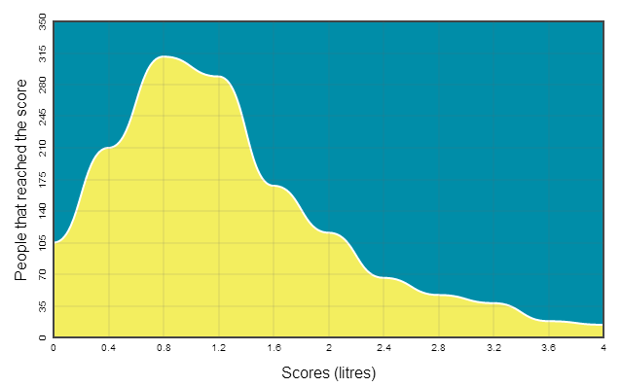

The amount of air you can expel is linked to different aspects of your body. Your height, age, sex and ethnic origins all affect your predicted measurement. A female adult might expel between 1.5 and 5 litres. A male adult might expel between 2 and 6 litres. And a child might expel between 0.5 and 5 litres.

### Daily checks by science communicators

The exhibit components are in good working order. In particular:

* The mouthpiece dispenser contains plenty of clean mouthpieces (see Appendix).
* There is space for used mouthpieces available in the bin (see Appendix).

### Cleaning

Clean the screen with appropriate screen cleaner.

Clean the surfaces and moveable stool with appropriate surface cleaner. Ensure the sensor unit and dispenser tray are thoroughly clean.

### Risks

See risk assessment in Risk Assessments folder.

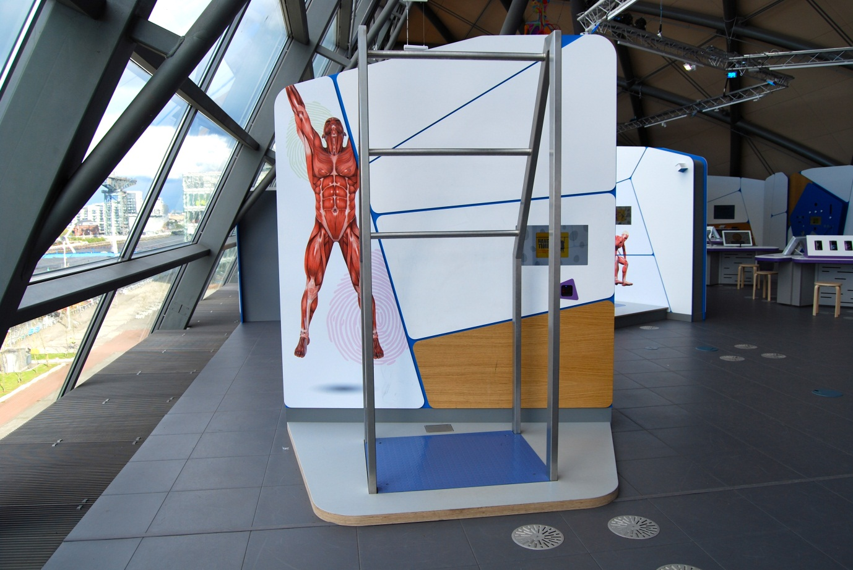

## How long can you hang on?

Also known as Hang Time / A0.09

### Description

A free-standing exhibit that allows visitors to test their limits of endurance by hanging from a metal bar. It consists of three horizontal ‘pull up’ bars at different heights, a floor pressure sensor, touchscreen and barcode scanner, all on a raised platform.

### Visitor experience

The visitor activates the exhibit by either pressing the touchscreen, scanning their My BodyWorks barcode card or by standing on the pressure sensor. For the test the visitor chooses the bar most appropriate to their height, grabs that bar and hangs on.

Their performance is displayed on a timer on the screen and when they release the timer stops. At the end, the visitor is shown their result in seconds and hundredths of a second. The visitor can save their result to their My BodyWorks profile.

### Visitor interaction tips

* Encourage use of the My BodyWorks cards by explaining how they work and highlighting the benefits of using the website.
* Why not act as a guide, leading visitors through the interaction by operating the touchscreen and tailoring the learning content to each individual visitor.
* Try asking thought-provoking questions related to the visitor, such as ‘why do your arms get tired?’ or ‘which sports require a lot of endurance?’

### Accessibility

For visitors with sight problems, offer to help with the touchscreen and raised platform. Be careful with the metal frame at visitor’s head height.

For visitors who are unable to hang from the bars, offer an explanation of the exhibit before pointing them in the direction of a similar experience that is accessible to them (potentially measuring grip strength, reaction time or even sprint speed).

### Good to know

As of 17 May 2013, the most common hang time recorded at this exhibit was 7.16 seconds. The overall average was 22.52 seconds.

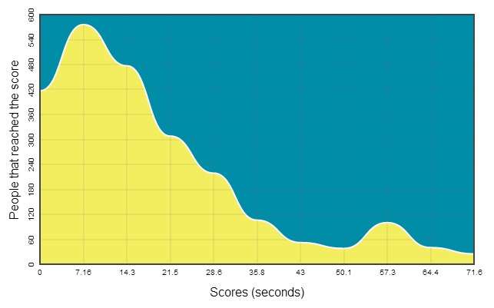

Your muscles are made up of a mixture of 2 types of muscle fibre: slow twitch and fast twitch. Endurance activities, such as hanging from a bar from a long time, use your slow-twitch muscle fibres. These muscle fibres contract more slowly than your fast-twitch muscle fibres, but because they have a rich blood supply, they do not get tired as quickly.

### Daily checks by science communicators

The exhibit components are in good working order.

### Cleaning

Clean the screen with appropriate screen cleaner.

Clean the surfaces, including metal bars, with appropriate surface cleaner.

Clean the raised platform with a broom and dustpan & brush.

### Risks

See risk assessment in Risk Assessments folder.

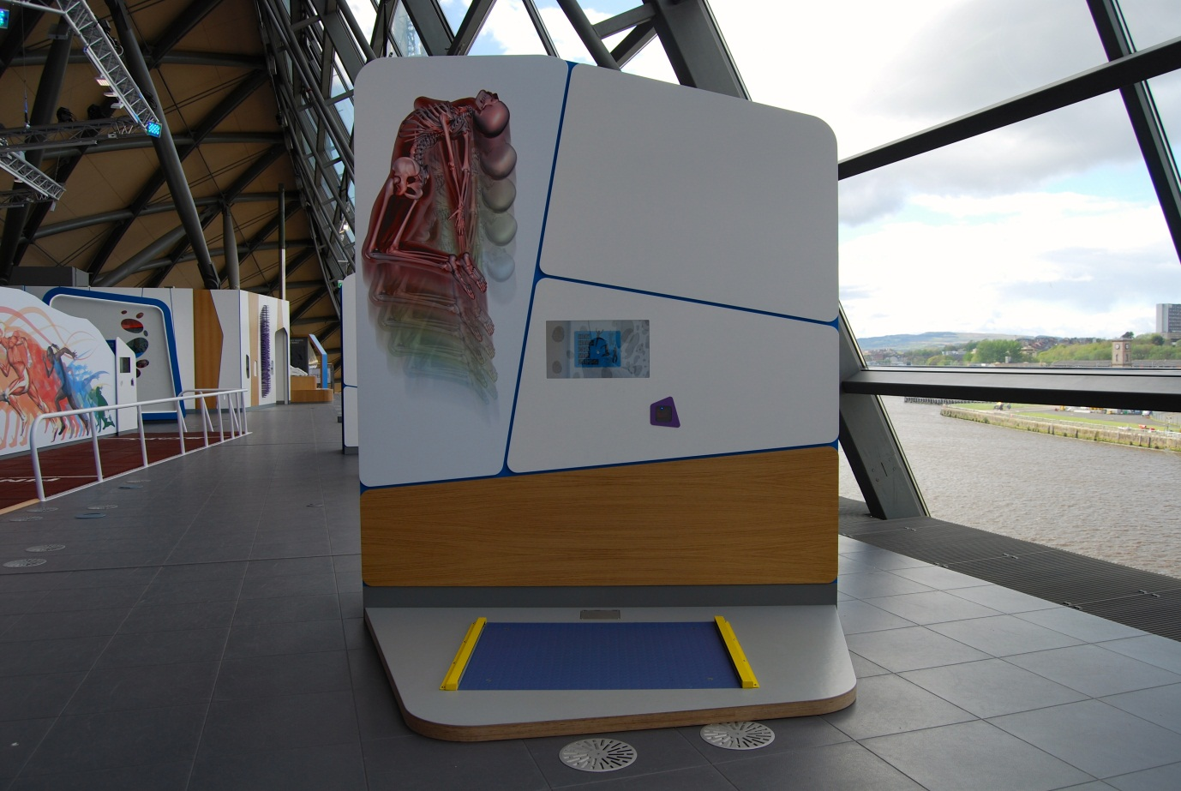

## How high can you jump?

Also known as Standing Jump / A0.04

### Description

A free-standing exhibit that allows visitors to measure how high they can jump. It consists of a floor pad with light gates, touchscreen and barcode scanner, all on a raised platform.

### Visitor experience

The visitor activates the exhibit by pressing the touchscreen, scanning their My BodyWorks barcode card or by standing on the floor pad. For the test, the visitor begins on the floor pad, jumps as high as they can, and lands back on the floor pad. At the end, the visitor is shown their jump height in centimetres, calculated from the length of time the visitor was in the air. The visitor can save their result to their My BodyWorks profile.

### Visitor interaction tips

* Encourage use of the My BodyWorks cards by explaining how they work and highlighting the benefits of using the website.
* Suggest to visitors that they begin their jump crouched low in order to use their legs like springs.
* Try asking thought-provoking questions related to the visitor, such as ‘can you beat the world record?’, ‘which body parts help you to jump high?’ or ‘can you change your technique to jump higher?’

### Accessibility

For visitors with sight problems, offer assistance with the touchscreen and raised platform. Be careful with the raised light gates on the platform.

For visitors who are unable to hang from the bars, offer an explanation of the exhibit before pointing them in the direction of a similar experience that is accessible to them (potentially measuring grip strength, reaction time or even sprint speed).

### Good to know

As of 17 May 2013, the most common standing jump height recorded at this exhibit was 6.56 centimetres. The overall average was 17.3 centimetres.

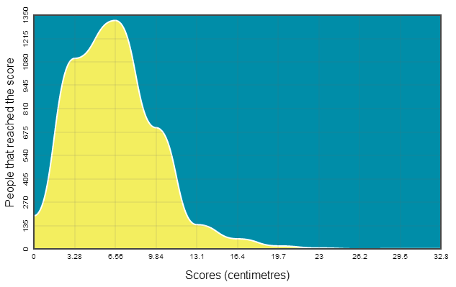

Your muscles are made up of a mixture of 2 types of muscle fibre: slow twitch and fast twitch. For a quick burst of activity like jumping, you use your fast-twitch muscle fibres. These muscle fibres shorten quickly, generating a short burst of speed. But fast-twitch muscle fibres are not as good at endurance activities, which use your slow-twitch muscle fibres.

### Daily checks by science communicators

The exhibit components are in good working order. In particular:

* There are no foreign objects blocking the light of the light gates.

### Cleaning

Clean the screen with appropriate screen cleaner.

Clean the raised platform with a broom and dustpan & brush.

Clean the surfaces with appropriate surface cleaner.

### Risks

See risk assessment in Risk Assessments folder.

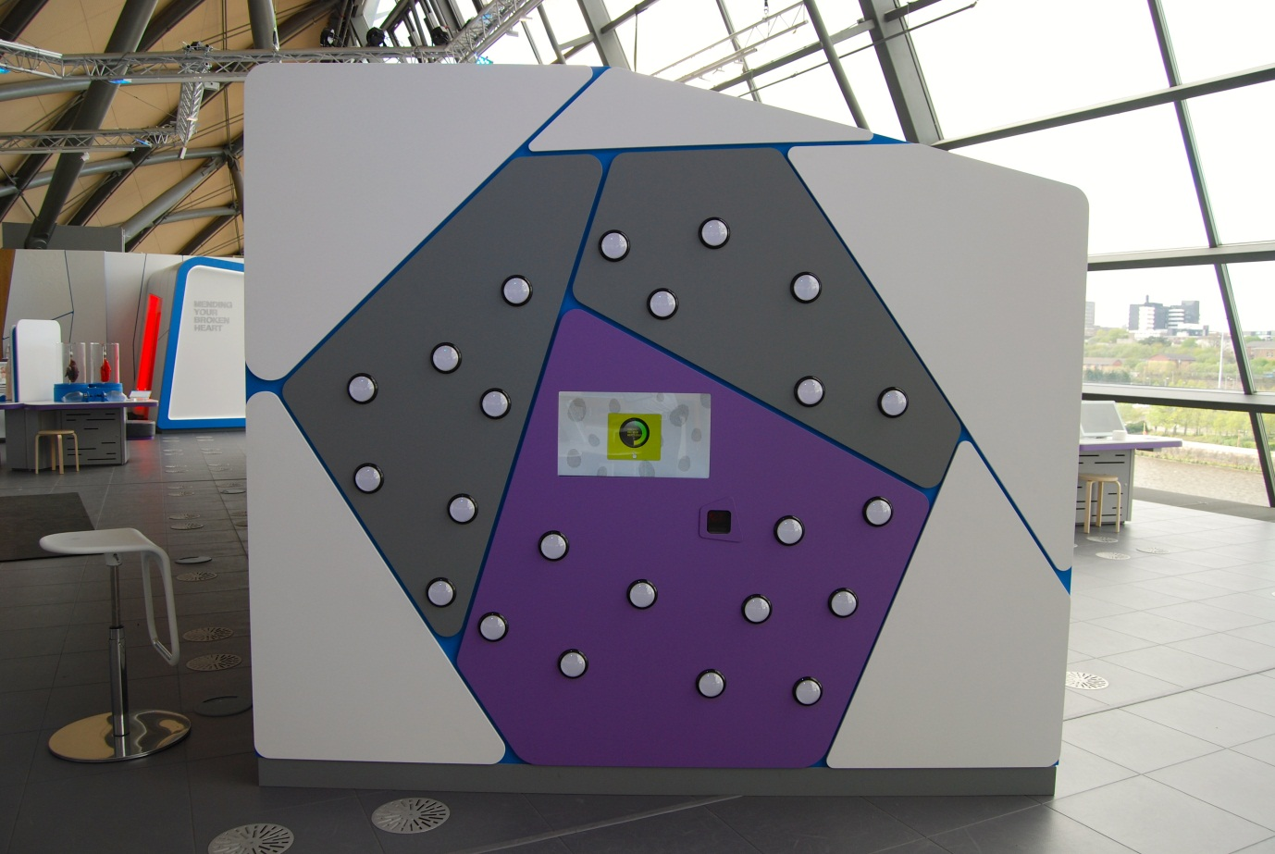

## How fast are your reactions?

Also known as Reaction Timer / A0.17

### Description

An exhibit that allows visitors to test their coordination and reaction times. It consists of an array of buttons that can light up, a touchscreen and a barcode scanner. The challenge of the game is to turn off illuminated buttons as quickly as possible. Only one button will light up at a time and the game ends after 15 buttons have been pressed. The buttons are arranged into two playing areas. The small playing area features ten buttons on a purple background. The big playing area features all twenty-three buttons.

### Visitor experience

The visitor activates the exhibit by either pressing the touchscreen or by scanning their My BodyWorks barcode card. The visitor can choose which playing area they wish to use. At the end of the game, the visitor is given the total time it took them to press all 15 buttons, measured in seconds and hundredths of a second. The visitor can save their result to their My BodyWorks profile.

### Visitor interaction tips

* Encourage use of the My BodyWorks cards by explaining how they work and highlighting the benefits of using the website.
* Recommend which playing area visitors should use, based on their height, age and abilities.
* Try asking thought-provoking questions related to the visitor, such as ‘what could you do to improve your technique?’, ‘why are your reaction times important in everyday life?’ or ‘how could your reactions save your life?’

### Accessibility

For visitors with sight problems, offer an explanation of the exhibit and then offer to do a similar experiment with them: get a 30cm ruler and hold it vertically above their open hand. Explain that you will drop the ruler at the same time as you make a sound. The challenge for the visitor is to grab the falling ruler as quickly as they can.

### Good to know

As of 17 May 2013, the most common game time recorded at this exhibit was 22.9 seconds. The overall average was 20.24 seconds.

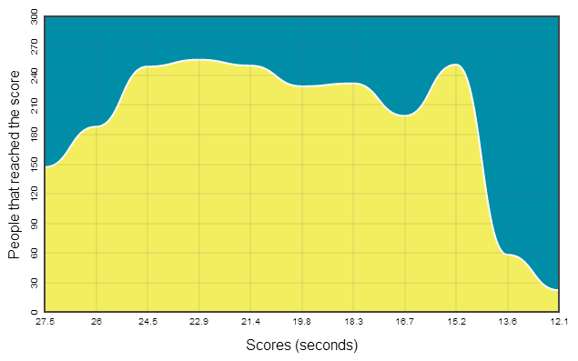

When you react in this game, a message travels from your eyes to your brain and then to your hand. In everyday life, you react faster if you are expecting something to happen. These faster reactions are because your brain is already primed to react. Fast reactions are useful for ball sports, especially goalkeepers during penalty shoot-outs.

### Daily checks by science communicators

The exhibit components are in good working order.

### Cleaning

Clean the screen with appropriate screen cleaner.

Clean the surfaces and buttons with appropriate surface cleaner.

### Risks

See risk assessment in Risk Assessments folder.

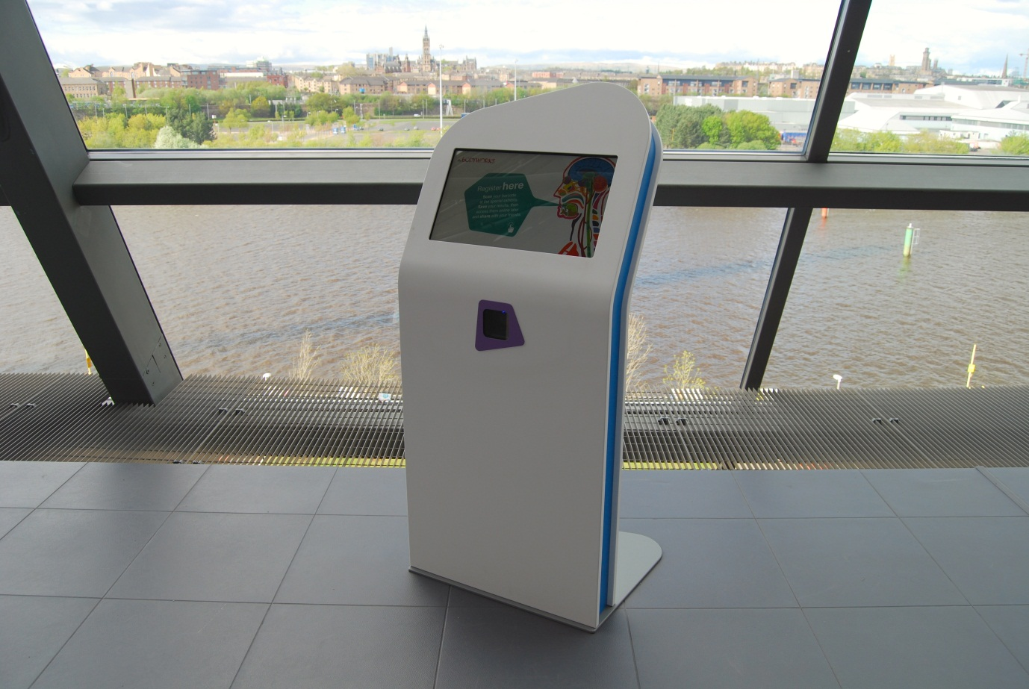

## Login stations

Also known as A0.23

### Description

A pair of free-standing exhibits that allow visitors to register their My BodyWorks barcode card. Each exhibit consists of a touchscreen and barcode scanner. Registering a barcode card gives the visitor access to the data that has been saved to it. The data can be accessed in the exhibition (on this exhibit) or from home (from a website).

### Visitor experience

The visitor activates the exhibit by either scanning their My BodyWorks barcode card or by pressing the touchscreen (then scanning their My BodyWorks barcode card). The visitor needs a My BodyWorks barcode card to use this exhibit.

If the visitor has not previously registered, they should fill in some basic details including first name, email and a password. This allows them to access the scores and exhibit media that have been saved on to the barcode card.

If the visitor registered on a previous visit, and is now using a fresh barcode card, they should log in. This allows them to combine all their results onto a single account.

Once registered, the visitor can return to this exhibit during their visit, scan their barcode card and enter their password to access their data.

### Visitor interaction tips

* Encourage use of the My BodyWorks cards by explaining how they work and highlighting the benefits of using the website.
* Assist visitors with the registration process, explaining that the email and password they supply allows them to access their data from home (through the website).
* Encourage visitors to write their name on their My BodyWorks barcode card so they don’t get them mixed up.

### Accessibility

For visitors with sight problems, offer assistance with the touchscreen.

For visitors who are unable to use the exhibit, offer assistance by explaining how they can register through the website.

### Good to know

See chapter in this document: My BodyWorks (barcode cards).

### Daily checks by science communicators

The exhibit components are in good working order.

### Cleaning

Clean the screen with appropriate screen cleaner.

Clean the surfaces with appropriate surface cleaner.

Clean the floor platform with a broom and dustpan & brush.

### Risks

See risk assessment in Risk Assessments folder.

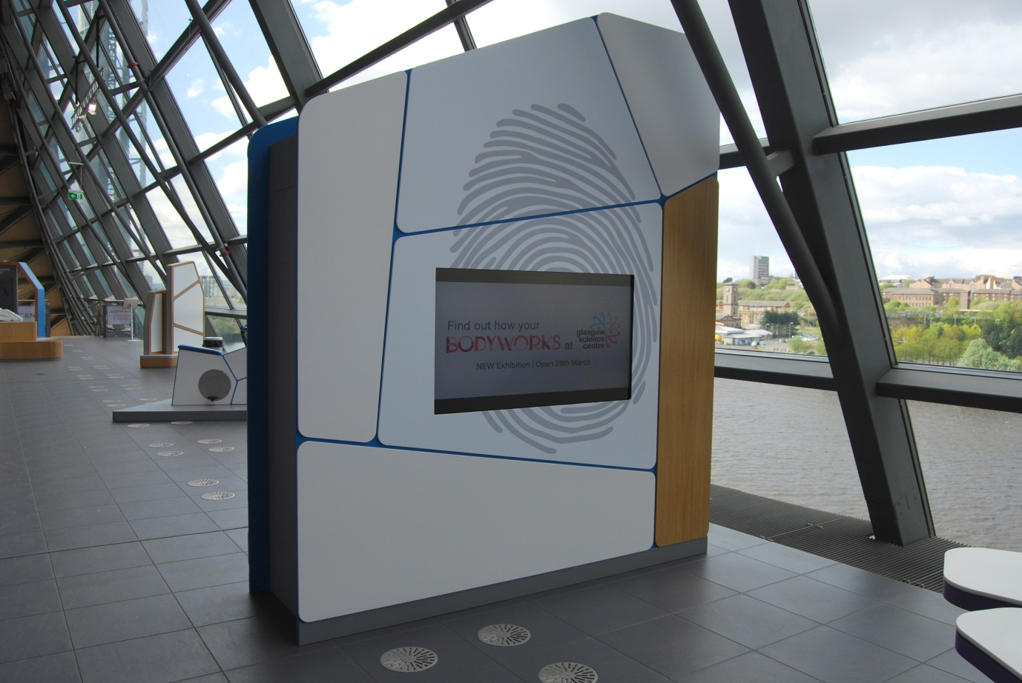

## Scoreboard

Also known as A0.24

### Description

A colourful display of visitor results, taken from the My BodyWorks barcode card system. It consists of a large, wall-mounted screen (not a touchscreen).

### Visitor experience

The visitor can watch as the results from the exhibits are shown. This allows visitors to draw conclusions from the data.

### Visitor interaction tips

* Assist visitors in drawing conclusions from the data.
* Encourage discussions such as whether the data confirms that children have faster reactions and adults have stronger grips et cetera.
* Use the data shown on this screen to help with visitor interactions with related exhibits.

### Accessibility

For visitors with sight problems, offer assistance with reading from the screen.

### Good to know

See chapter in this document: My BodyWorks (barcode cards).

### Daily checks by science communicators

The exhibit components are in good working order.

### Cleaning

Clean the screen with appropriate screen cleaner. (Note, it is especially important not to spray directly on to this particular screen and to avoid scrubbing the surface)

Clean the surfaces with appropriate surface cleaner.

Dust the ledges using a microfibre duster or static duster.

### Risks

See risk assessment in Risk Assessments folder.

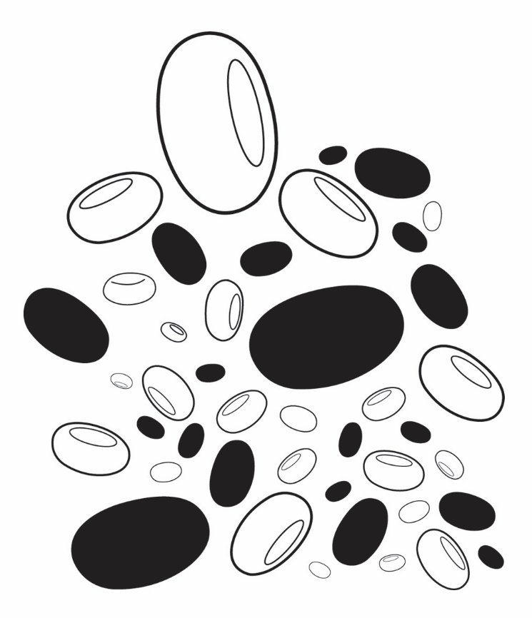

# Respiratory & Cardiovascular exhibits

“You are always breathing and your heart is always beating, but how do these systems work together to keep you alive and what can damage them?”

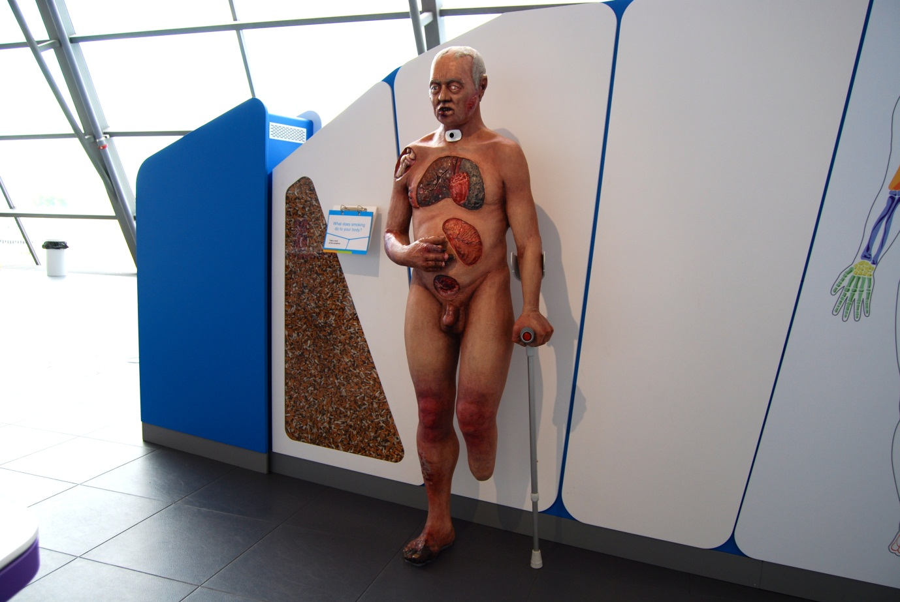

## What does smoking do to your body?

Also known as the Smoker’s Body / A1.05a

### Description

A life-size sculpture of a person with a range of smoking-related health conditions. Part realistic, part abstract, the sculpture visually illustrates around 20 side effects of smoking. It is mounted beside a display case of real cigarette butts. This exhibit has a 4-layer flapper label next to the sculpture. Further information on each condition is available on an interactive webpage, which can be accessed via the QR code or through the GSC website.

### Visitor experience

Visitors can examine the sculpture up close to investigate a range of health conditions caused by smoking tobacco. Visitors are not prevented from touching the sculpture.

### Visitor interaction tips

* Use together with *Healthy and Smokers Lungs* to illustrate the effects of smoking on the lungs.
* Borrow a GSC iPad and allow visitors to explore the interactive webpage found at www.glasgowsciencencentre.org/

### Accessibility

For visitors with sight problems, offer to describe each health condition as the visitor touches the sculpture.

### Good to know

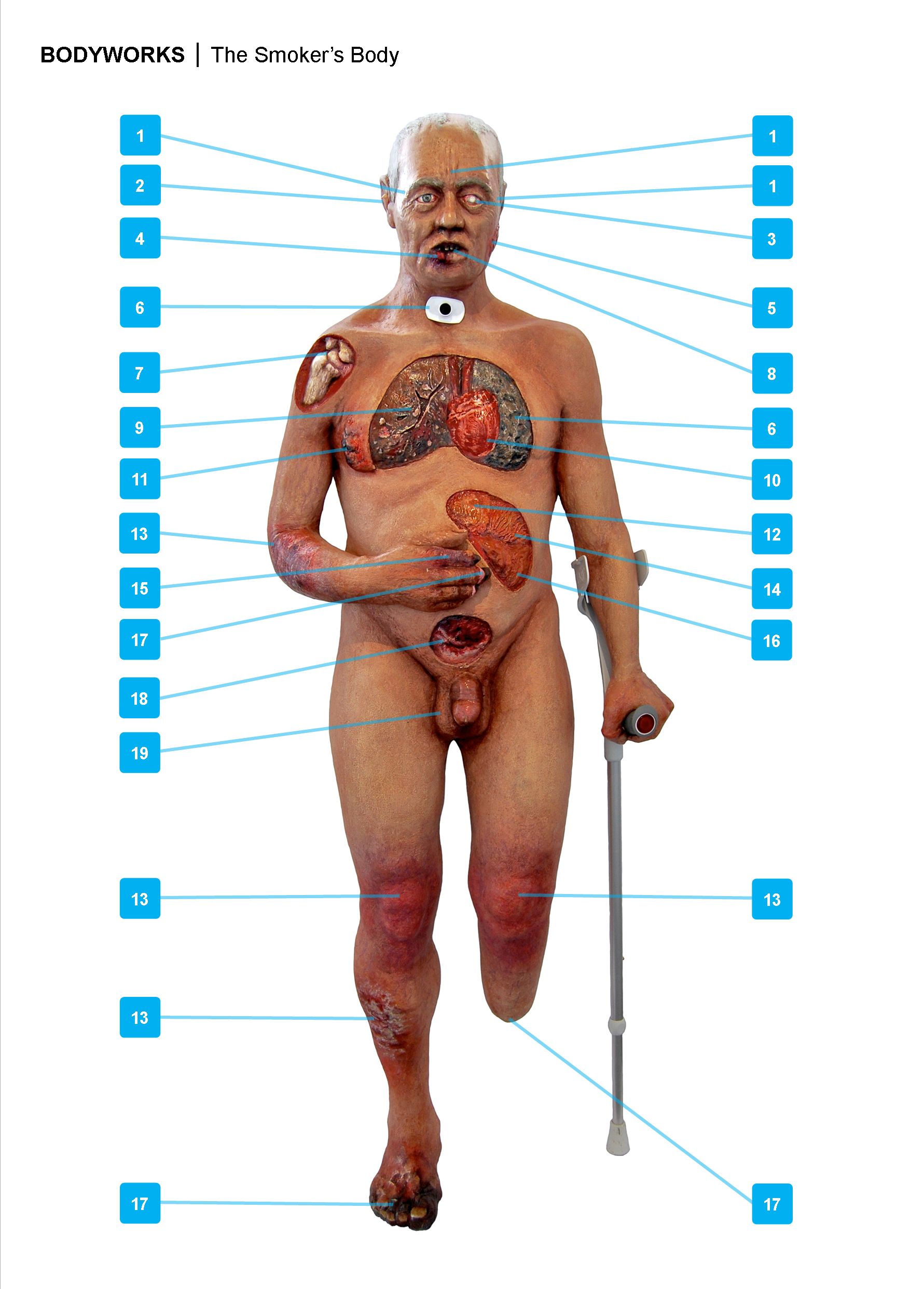

**1 Wrinkling**

Smoking prematurely ages the skin, causing deeper wrinkles. The nicotine in tobacco narrows the blood vessels under the skin, reducing the delivery of oxygen and nutrients to the skin.

**2 Hearing loss**

Smokers are more susceptible to hearing loss than non-smokers. Smoking creates plaque on the walls of blood vessels and this can reduce the blood flow to the inner ear.

**3 Cataracts**

Smokers are more likely to develop cataracts, a clouding of the eye’s lens which blocks light and can lead to blindness. Chemicals from smoke reach the eyes through the bloodstream after being absorbed through the lungs.

**4 Mouth cancer**

Smokers have a higher risk of developing cancer of the oral cavity, around 4 to 5 times higher than non-smokers. The tumour develops on the surface on the tongue, mouth, lips or gums.

**5 Nasopharyngeal cancer**

Nasopharyngeal cancer affects the nasopharynx, the area where the nose and throat connect. It is a rare cancer but smokers are twice as likely to develop nasopharyngeal cancer compared to non-smokers.

**6 Emphysema**

Smoking causes emphysema, where the air sacs of the lungs swell and rupture. This damage can reduce the surface area of the lungs to just a quarter of their healthy size. For people with severe emphysema, a tracheotomy provides an opening in their windpipe to facilitate breathing.

**7 Osteoporosis**

Tobacco smoke contains carbon monoxide, which is absorbed into the smoker’s blood when inhaled. In the blood, carbon monoxide takes the place of oxygen resulting in less oxygen being delivered around the body. As a result, the smoker’s bones lose density, fracture more easily and take longer to heal.

**8 Tooth decay**

Smoking interferes with the mouth’s chemistry, causes a yellowing of teeth and creating excess plaque. Smokers are more likely to lose their teeth than non-smokers.

**9 Lung cancer**

Lung cancer is one of the most common and serious types of cancer. Smokers are 20 times more likely to develop lung cancer than non-smokers. Early diagnosis makes a dramatic difference in survival rates.

**10 Heart disease**

Smoking is one of the biggest risk factors for developing a cardiovascular disease, including coronary heart disease and stroke. These diseases are responsible for one in three deaths in the world.

**11 Breast cancer**

Breast cancer is the most common form of cancer in the UK. There are many risk factors and some studies indicate there might be a link between heavy smoking and the development of breast cancer.

**12 Stomach cancer**

Smokers are almost twice as likely to develop stomach cancer compared to non-smokers. When tobacco smoke is inhaled, some smoke is swallowed and reaches the stomach where the chemicals of smoke can damage cells.

**13 Psoriasis**

Smokers are more likely to develop psoriasis, a skin condition of itchy, oozing red patches. It can occur on any part of the body but is most common on elbows and knees.

**14 Stomach ulcers**

Smoking is a risk factor for developing stomach ulcers. Smoking can lead to the breakdown of the stomach’s defences against digestive acid, allowing the acid to cause ulcers.

**15 Discoloured fingers**

The residue from burning tobacco, called tar, gathers on the fingers and fingernails of people who smoke. The tar stains their fingers a yellowish-brown colour.

**16 Pancreatic cancer**

Pancreatic cancer develops in the pancreas, a gland that produces and releases digestive enzymes and the hormone insulin. Smokers have a higher risk of developing pancreatic cancer than non-smokers, around 2 to 4 times higher.

**17 Buerger’s disease**

Buerger’s disease is an inflammation of the arteries, veins and nerves in the arms and legs. The inflammation restricts blood flow and if left untreated can lead to gangrene and amputation. Almost everyone that has Buerger’s disease smokes tobacco.

**18 Cervical cancer & miscarriage**

Smoking increases the risk of a woman developing cancer of the uterine cervix and it can also lead to fertility problems. Miscarriage is more common in smokers, as are stillbirths, caused by carbon monoxide and nicotine found in tobacco smoke.

**19 Deformed sperm**

Smoking can deform a man’s sperm, which can cause miscarriage or birth defects after fertilisation. Smoking can also cause impotence by reducing blood flow to the penis. Infertility is more common among smokers.

### Daily checks by science communicators

The exhibit components are in good working order.

### Cleaning

The sculpture should only be dusted – chemicals may damage it.

Clean the cigarette case with appropriate glass cleaner.

Clean the non-sculpture surfaces with appropriate surface cleaner.

Remember to clean the flapper label.

Dust the ledges using a microfibre duster or static duster.

### Risks

See risk assessment in Risk Assessments folder.

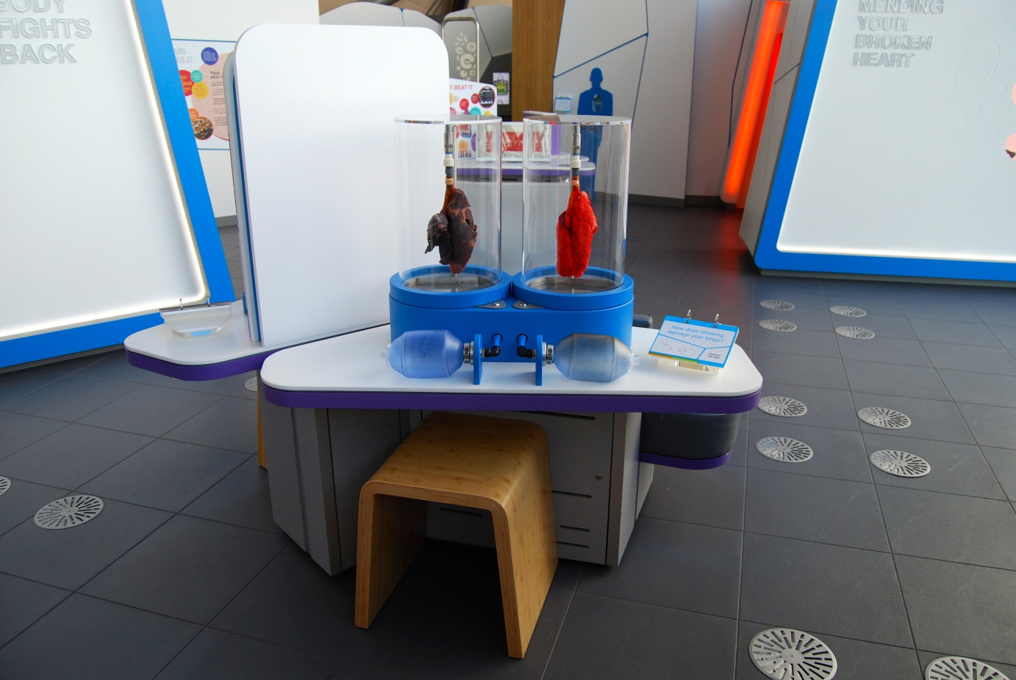

## How does smoking damage your lungs?

Also known as Healthy and Smokers Lungs / A1.07

### Description

A table-top exhibit featuring two pairs of lungs that visitors can inflate. The lungs are housed in separate clear plastic cylinders. One pair of lungs is a healthy pink colour and the other is blackened from tobacco smoke. The lungs are inflated by soft plastic bags (which are taken from Ambu bags, the mask device used by paramedics to assist with a patient’s breathing). The exhibit features a 3-layer flapper label and a moveable stool.

### Visitor experience

On approach, there is a clear view of the two pairs of lungs. The visitor can inflate each pair of lungs by squeezing an Ambu bag. As the lungs inflate, the visitor can compare them to notice that smoker’s lungs do not inflate as fully as the healthy lungs.

### Visitor interaction tips

* Why not point out the lung cancer, which is visible on the smoker’s lung (see below)?
* Why not point out the difference in appearance of lungs? (leading to a discussion of how tar damages the air sacs of the lungs)
* Try asking thought-provoking questions related to the visitor, such as ‘where are your lungs inside your body?’, ‘what do your lungs do?’, ‘what can damage your lungs?’

### Accessibility

For visitors with sight problems, offer to give a description of the lungs as the visitor inflates them.

### Good to know

The lungs are taken from pigs that were slaughtered for meat. The smoker's lungs have been treated to look and behave like the lungs of a smoker who has smoked one pack of cigarettes a day for 20 years.

The lungs were produced by Nasco, an educational and agricultural supplier based in Wisconsin, USA. The educational documents they provide are kept in the Floor 3.

The smoker’s lungs have evidence of lung cancer. Look for the white shape on the surface, about the size of a coin:

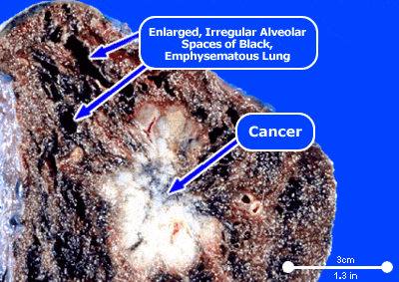

(photo from www.medicinenet.com)

### Daily checks by science communicators

The exhibit components are in good working order. In particular:

* The Ambu bags are intact / not punctured.
* The Ambu bags are secure and have not been pulled off.
* The lungs are in good condition and not dried out.

### Cleaning

Clean the outside of the clear plastic cylinders using appropriate glass cleaner. (If the insides of the cylinders need cleaned, contact an Exhibit Engineer)

Clean the surfaces and moveable stool with appropriate surface cleaner.

Remember to clean the flapper label.

### Risks

See risk assessment in Risk Assessments folder.

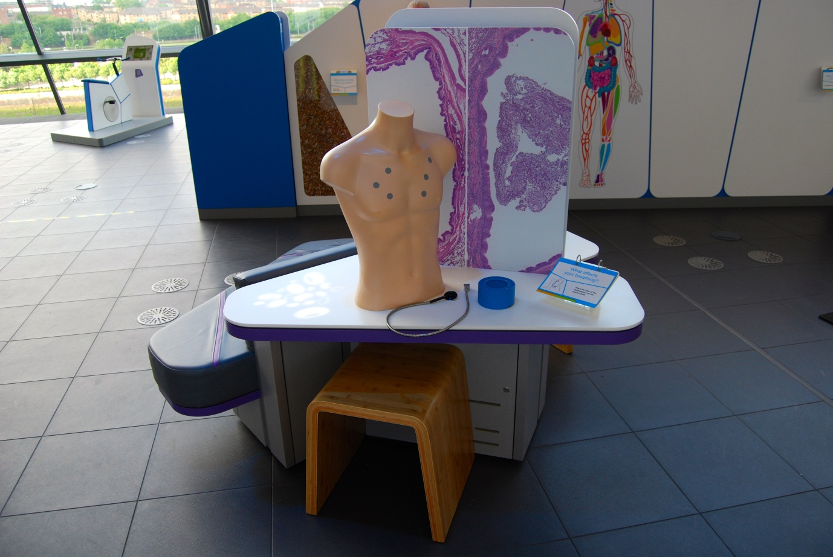

## What affects your breathing?

Also known as Asthma to Bronchitis / A1.15

### Description

A table-top exhibit featuring a human torso model with a stethoscope device. When the diaphragm part of the stethoscope makes contact with one of the six markers on the torso, breathing sounds are played through a speaker. The sounds are real recordings and demonstrate what doctors can hear for different lung conditions. The exhibit features a 3-layer flapper label, a wall-graphic showing microscopic images of lungs, and a moveable stool.

### Visitor experience

The visitor picks up the diaphragm end of the stethoscope and places it on various markers on the torso model. Breathing sounds are played for each marker to allow the visitor to investigate how different lung conditions affect the lungs.

### Visitor interaction tips

* Why not act as a guide, helping visitors to find words to describe each sound, allowing them to easily compare the sounds.
* For visitors who think they can easily identify each sound, try testing them. Remember, medical staff go through years of training.
* Try asking thought-provoking questions related to the visitor, such as ‘why would a doctor use a stethoscope on you?’, ‘what do you think makes the sounds heard through a real stethoscope?’ or ‘can you think of any lung conditions?’

### Accessibility

For visitors with sight problems, offer assistance by identifying the lung condition for each sound triggered by the visitor.

### Good to know

The six markers are placed randomly on the torso model and do not reflect the precise positions a doctor would use to listen to breathing sounds.

Each lung condition has a characteristic breathing sound associated with it. These are the sounds used in this exhibit:

Healthy lungs = Vesicular – Normal

Bronchitis = Rhonchi - Low Pitched Wheezes

Pleurisy = Pleural Rubs

Pneumonia = Bronchial

Asthma = Wheezes – Expiratory

Fluid on the lungs = Crackles - Fine (Rales)

The sounds were donated by MedEdu LLC, [www.easyauscultation.com](http://www.easyauscultation.com)

### Daily checks by science communicators

The exhibit components are in good working order. In particular:

* The stethoscope cable is secure.
* The diaphragm of the stethoscope is intact and has not been unscrewed.

### Cleaning

Clean the surfaces, torso, stethoscope and moveable stool with appropriate surface cleaner.

Remember to clean the flapper label.

Dust the ledges using a microfibre duster or static duster.

### Risks

See risk assessment in Risk Assessments folder.

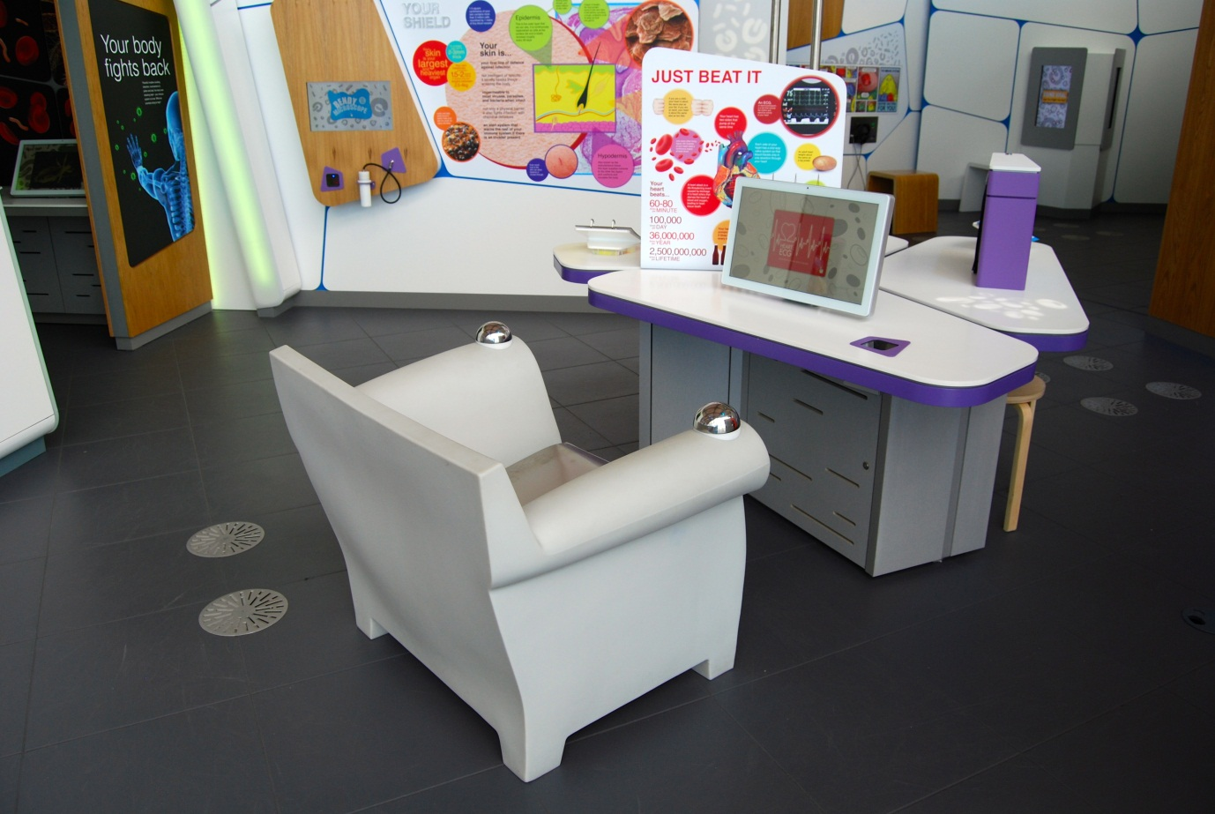

## Heart ECG: What does your heart trace look like?

Also known as A1.13

### Description

A table-top exhibit with seat that allows visitors to measure and record the electricity of their heart. It consists of an armchair, touchscreen, barcode scanner, and a wall-graphic about the heart. The armchair has three metal sensors: a flat sensor where the visitor sits and a ‘dome’ sensor on each armrest.

### Visitor experience

The visitor activates the exhibit by either pressing the touchscreen or by scanning their My BodyWorks barcode card. During the test, the visitor sits back in the armchair, with their hands placed on each armrest sensor. The visitor must remain still to prevent the sensors detecting the electrical activity of their muscles (other than their heart muscle). During the test, the visitor can see a graph of the electrical activity of their heart: their heart trace. The visitor can save their graph to their My BodyWorks profile.

### Visitor interaction tips

* Encourage use of the My BodyWorks cards by explaining how they work and highlighting the benefits of using the website.
* Discuss the clinical uses of ECG machines (see below).
* Try asking thought-provoking questions related to the visitor, such as ‘why do you think your heart uses electrical signals?’, ‘how do you keep your heart healthy?’ or ‘why would a doctor measure your heart with an ECG?’

### Accessibility

For visitors with sight problems, offer assistance with the touchscreen.

For visitors unable to use the armchair, offer an explanation of the exhibit before pointing them in the direction of a similar experience that is accessible to them (potentially heart rate sensor).

### Good to know

(From the British Heart Foundation)

An ECG – or electrocardiogram - is a simple and useful test which records the rhythm and electrical activity of your heart. Small sticky patches called electrodes will be put onto your arms, legs and chest. These are connected to an ECG recording machine which picks up the electrical signals that make your heart beat. The test will only take a few minutes and is painless.

An ECG can detect problems you may have with your heart rhythm. It can help doctors tell if you are having a heart attack or if you’ve had a heart attack in the past. Sometimes an ECG can indicate if your heart is enlarged or thickened.

A **24-hour ECG** helps to diagnose symptoms, such as palpitations, which only happen now and again. Sometimes it can show up an abnormal heart rhythm that might need treatment. It can also help reassure patients if the results are normal.

Your heart needs more blood and oxygen when you are active, so the **exercise ECG** can show whether your heart is getting enough blood from the coronary arteries during physical activity. This can help doctors find out if you have coronary heart disease and, if so, how severe it is. An exercise ECG is also helpful for looking at how well the heart is working after angioplasty or bypass surgery.

### Daily checks by science communicators

The exhibit components are in good working order.

### Cleaning

Clean the screen with appropriate screen cleaner.

Clean the non-metal surfaces with appropriate surface cleaner.

For grubby stains on the stainless steel sensors, use appropriate glass cleaner (marked as suitable for stainless steel).

Dust the ledges using a microfibre duster or static duster.

### Risks

See risk assessment in Risk Assessments folder.

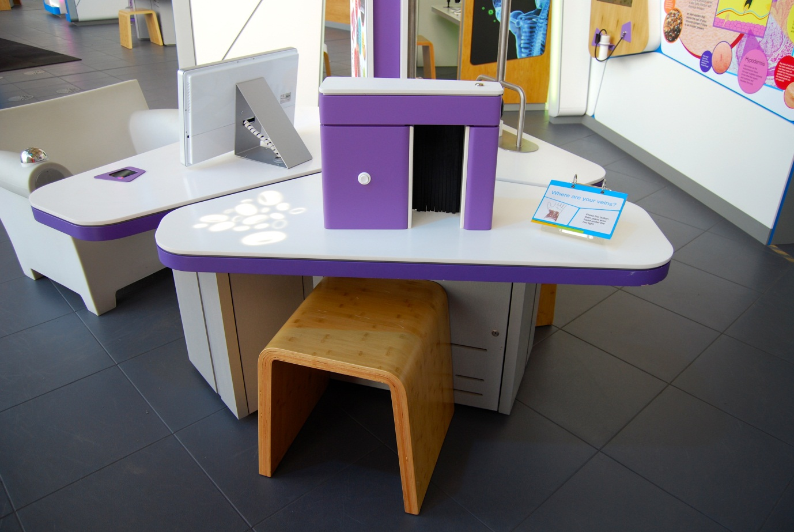

## Where are your veins?

Also known as See your Veins / Vein Viewer / A1.11

### Description

A table-top exhibit that allows visitors to explore the pattern of their veins using a medical vein illumination device. It consists of a vein illumination device (housed within a box), an ‘on’ button, a 3-layer flapper label and a moveable stool.

### Visitor experience

The visitor activates the device by pressing the white ‘on’ button. A red square of light is projected onto the exhibit table and the visitor places their hand or arm under this light. The device, sensing the position of the veins within the hand or arm, projects the pattern onto the visitor’s skin.

### Visitor interaction tips

* Why not act as a guide, helping visitors through the interaction and tailoring the learning content to each individual visitor (using the information on the flapper label and in this guide).
* Try asking thought-provoking questions related to the visitor, such as ‘why do you think your veins make branch-like patterns?’, ‘have you ever had an injection at the doctors?’ or ‘what colour do you think your blood is?’ (see below)
* Suggest related exhibits: ‘If you liked this, you’ll love this’

### Accessibility

For visitors with sight problems, offer to describe the pattern of their veins. If the situation is suitable, offer to trace out the pattern on their skin to allow them to feel the pattern.

For visitors who are unable to place their arm under the sensor, offer to use a portable vein viewer (given to Science Development team).

### Good to know

The vein illumination device is an AccuVein AV300, a device used by phlebotomists and nurses to quickly and accurately locate patient’s veins.

The device uses infrared light to detect the presence of haemoglobin. Haemoglobin is the oxygen-carrying protein found in your red blood cells. When haemoglobin is not carrying oxygen (i.e. when it is in your veins) it absorbs infrared light.

Infrared light is reflected by your skin, muscles and oxygen-rich haemoglobin found in your arteries. In general, your arteries carry oxygen-rich blood away from your heart and your veins carry oxygen-poor blood to your heart. The device detects where the infrared light is absorbed and reflected. This pattern is then projected in visible light onto the surface of the skin.

And did you know? Although your veins have a bluish colour, your blood inside them is red. Your blood is always a red colour. It’s a common myth that your blood is sometimes blue. The shade of red is different depending on how much oxygen the blood is carrying. Oxygen-rich blood is a darker shade of red than oxygen-poor blood. When you look at your arms, your veins look blue because of the way light is absorbed by your skin and reflected by your blood.

### Daily checks by science communicators

The exhibit components are in good working order.

### Cleaning

Clean the surfaces and moveable stool with appropriate surface cleaner.

Remember to clean the flapper label.

### Risks

See risk assessment in Risk Assessments folder.

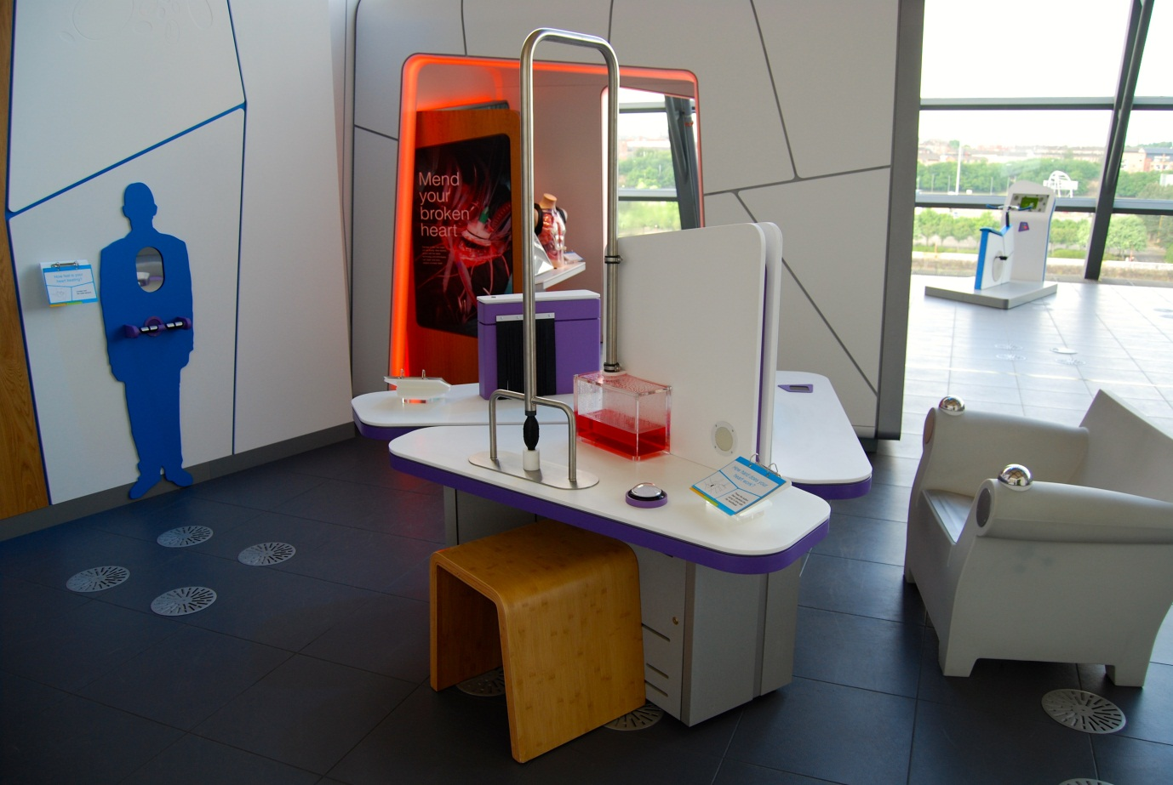

## How hard does your heart work?

Also known as Pump the Heart / A1.04

### Description

A table-top exhibit that allows the visitor to experience the repetition and force required to pump blood around your body. It consists of a hand pump, pipework containing fake blood, a speaker, an ‘on’ button, a 3-layer flapper label and a moveable stool. The ‘on’ button triggers heartbeat sounds to play for 1 minute at the rate of 70 beats per minute.

### Visitor experience

The visitor activates the heartbeat sounds by pressing the button. The visitor then squeezes the hand pump in time to the audible heartbeat. Once started, it becomes difficult for the visitor to keep pumping because hand muscles quickly tire.

### Visitor interaction tips

* Why not act as a guide, helping visitors through the interaction and tailoring the learning content to each individual visitor (using the information on the flapper label and in this guide).
* Try asking thought-provoking questions related to the visitor, such as ‘what is the organ inside your body that pumps your blood?’, ‘is your heart made of muscle?’ or ‘why does your heart not get tired as your hands do?’
* Measure the visitor’s heart rate using a portable pulse oximeter. If the visitor is a child, or an adult who has been active, their heart rate will probably be faster than the audible sounds. Can the visitor keep pumping the blood at this rate?

### Accessibility

For visitors who are hard of hearing, offer assistance by giving a visual beat, such as tapping the table along with the heartbeat sounds.

### Good to know

For more information on the circulatory system, consult the flapper label or the reference books in the Floor 3 cupboard.

### Daily checks by science communicators

The exhibit components are in good working order. In particular:

* There is sufficient fake blood in the system and there are no leaks.

### Cleaning

Clean the clear plastic box with appropriate glass cleaner.

Clean the surfaces, button, and moveable stool with appropriate surface cleaner.

Remember to clean the flapper label.

Dust the ledges using a microfibre duster or static duster.

### Risks

See risk assessment in Risk Assessments folder.

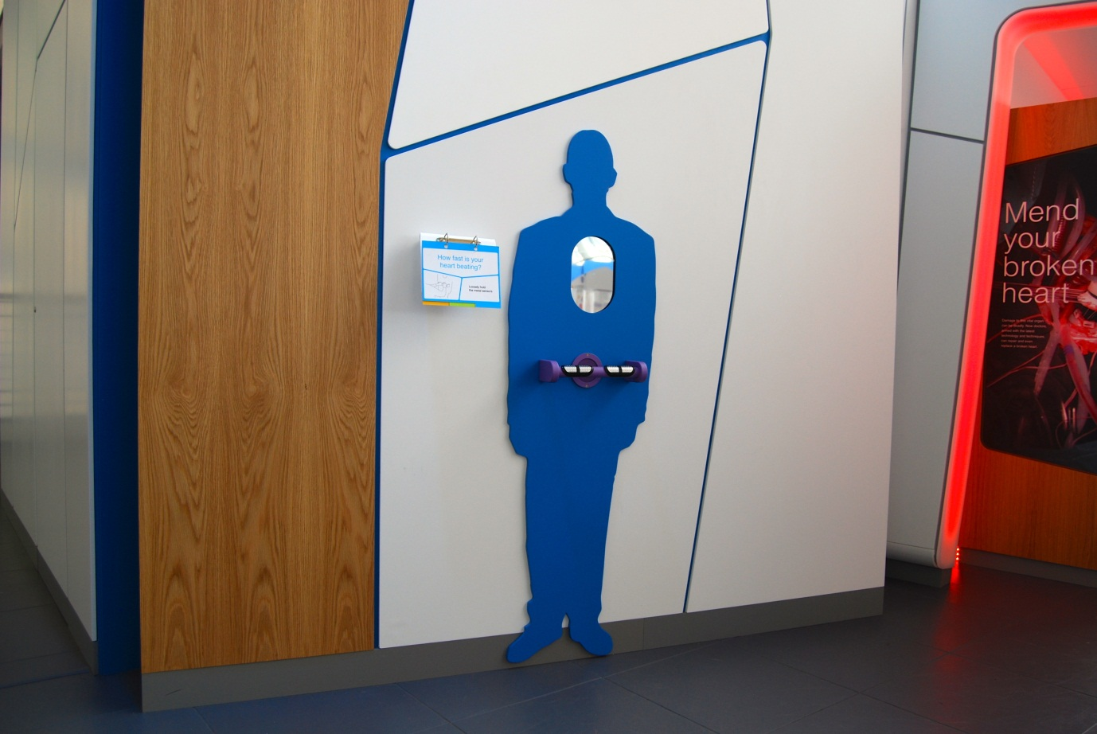

## How fast is your heart beating?

Also known as Your Beating Heart / A1.10

### Description

A wall-mounted exhibit that allows visitors to discover their own heart rate. It consists of a heart rate sensor on a handle, a speaker, mirrored glass and a model heart, all mounted on to a silhouette shape of a body. As visitors hold on to the handle, a model heart appears through the mirrored glass at the same rate as the visitor’s heart rate and is accompanied by audio. The exhibit features a 3-layer flapper label.

### Visitor experience

The visitor holds on to the handle, not gripping too tightly. As they hold on, the sensors detect the visitor’s heart rate and trigger the model heart to appear in time, along with sound.

### Visitor interaction tips

* Encourage visitors to test their heart rate before and after some physical activity. Discuss why their heart rate changes.
* Why not use a pulse oximeter to give the visitor a more accurate heart rate reading in beats per minute.
* Try asking thought-provoking questions related to the visitor, such as ‘why does your heart beat this fast?’, ‘does your heart rate ever change?’, ‘when does your heart beat very quickly?’

### Accessibility

For visitors unable to use the heart rate sensors because of the sensor position, offer to use a portable pulse oximeter to measure their heart rate.

### Good to know

Normative values of resting heart rate, in beats per minute:

* Babies to age 1: 100-160
* Children ages 1 to 10: 60-140
* Children ages 11 to 17: 60-100
* Adults: 60-100
* Well-conditioned athletes: 40-60

### Daily checks by science communicators

The exhibit components are in good working order.

### Cleaning

Clean the mirrored glass with appropriate glass cleaner.

Clean the handle and silhouette with appropriate surface cleaner.

Remember to clean the flapper label.

### Risks

See risk assessment in Risk Assessments folder.



# Mending your broken heart Research Capsule

“Damage to this vital organ can be deadly. Now doctors, armed with the latest technology and techniques, can repair and even replace a broken heart.”

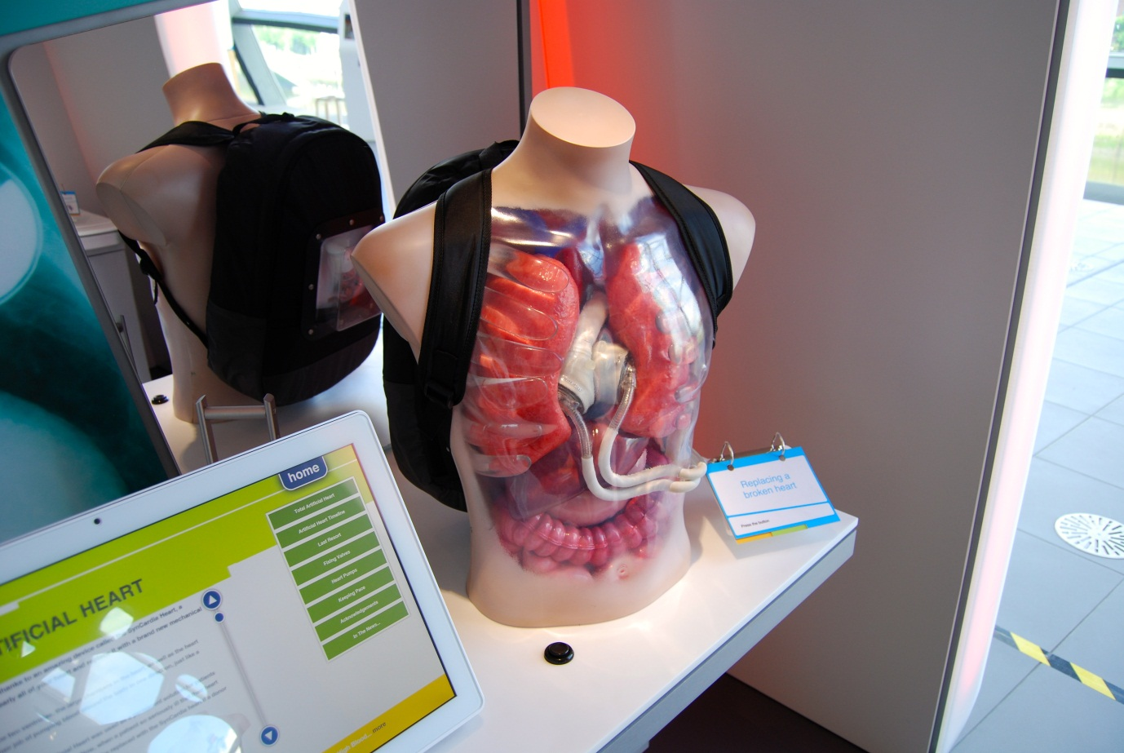

## Replacing a broken heart

Also known as Total Artificial Heart / C1.01b

### Description

An exhibit that showcases a Total Artificial Heart system developed by Syncardia Systems. It consists of a plastic torso model containing LED lights, organs and a Total Artificial Heart; backpack containing pistons; a mirror; a button and a 3-layer flapper label.

### Visitor experience

The visitor presses the button to activate the exhibit. The Total Artificial Heart moves from side to side within the model and LED lights show demonstrate the movement of blood. The pistons in the backpack move too. After a number of seconds, the items automatically stop.

### Visitor interaction tips

* Explain to visitors that they are standing in an area showcasing some of the ways science is helping to mend a broken heart (see the text on the capsule welcome panels).
* Use the information contained on the *Heart gadgets information screen* to explain what the Total Artificial Heart is and why it is used.
* Point out that the pistons can be seen in the backpack. Use the mirror on the wall to help.

### Accessibility

For visitors with sight problems, offer to describe the exhibit.

For visitors unable to use this exhibit, offer to explain how it works before pointing them in the direction of a related exhibit.

### Good to know

We worked with Syncardia Systems Inc to develop this exhibit.

### Daily checks by science communicators

The exhibit components are in good working order.

### Cleaning

Clean the surfaces, button and torso with appropriate surface cleaner.

Remember to clean the flapper label.

Clean the mirror with appropriate glass cleaner.

Dust the ledges using a microfibre duster or static duster.

### Risks

See risk assessment in Risk Assessments folder.

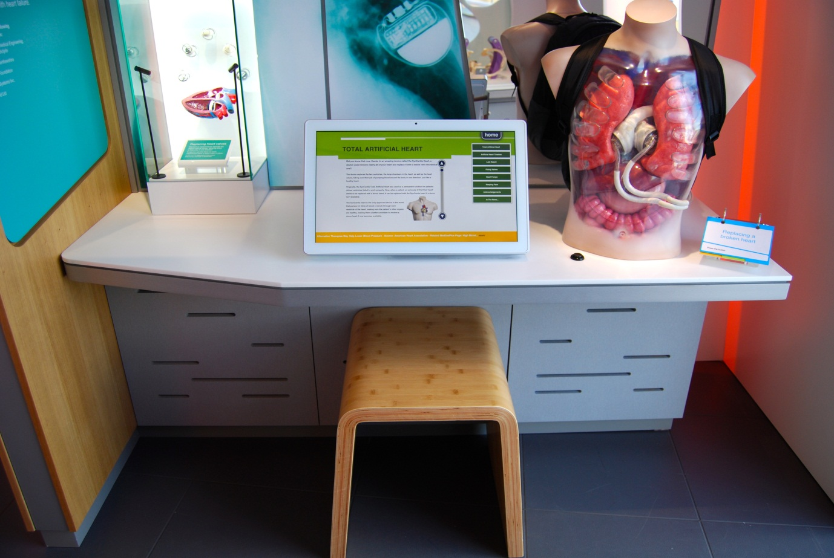

## Heart gadgets information screen

Also known as C1.01a

### Description

An information screen that allows visitors to explore the latest advances in heart repair devices. It consists of a touchscreen, pair of headphones and moveable stool. The exhibit features 6 articles, news RSS feeds and an acknowledgments page. Articles contain text, images and videos.

### Visitor experience

On approach, the exhibit displays an overview article. Visitors tap the scroll buttons to read through the article. Further articles can be selected from the column on the right-hand side of the screen. News articles appear along the bottom of the screen.

### Visitor interaction tips

* Explain to visitors that they are standing in an area showcasing some of the ways science is helping to mend a broken heart (see the text on the capsule welcome panels).
* Point out that many of the stories featured on this screen are related to the surrounding objects, displays and interactive exhibits.

### Accessibility

For visitors with sight problems, offer assistance with the touchscreen.

For visitors unable to use this exhibit, offer to explain how it works before pointing them in the direction of a related exhibit.

### Good to know

The information on this screen is updateable.

### Daily checks by science communicators

The exhibit components are in good working order.

### Cleaning

Clean the screen with appropriate screen cleaner.

Clean the surfaces and moveable stool with appropriate surface cleaner.

Dust the ledges using a microfibre duster or static duster.

### Risks

See risk assessment in Risk Assessments folder.

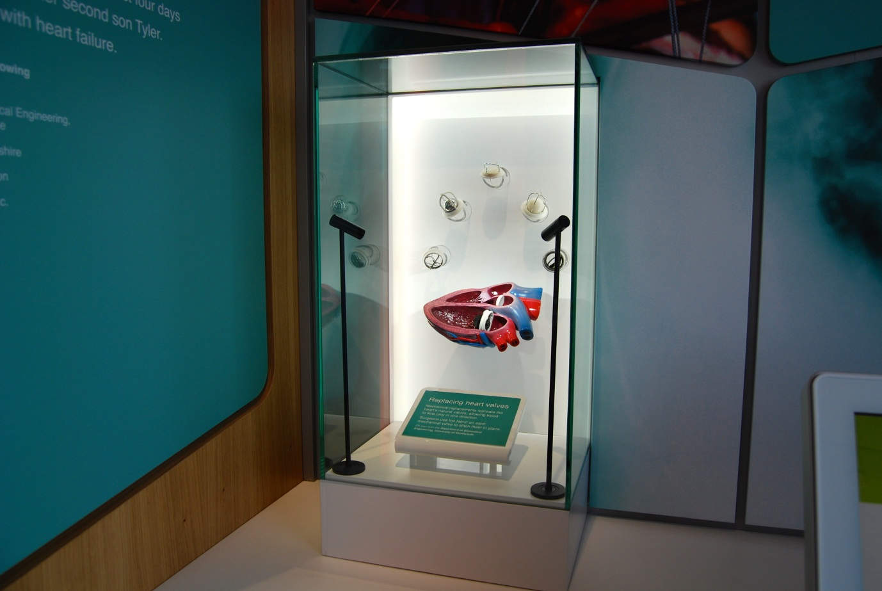

## Replacing heart valves

Also known as Heart Valve Display Case / C1.02e

### Description

A display case that allows visitors to see a range of mechanical heart valves. One heart valve is fixed into a model heart to illustrate how mechanical heart valves are used to replace damaged heart valves. The valves are housed in a glass display case with an A6 label. The objects are lit.

### Visitor experience

The visitor can view the heart valves and the label guides the visitor to notice some of the key features of the valves.

### Visitor interaction tips

* Explain to visitors that they are standing in an area showcasing some of the ways science is helping to mend a broken heart (see the text on the capsule welcome panels).
* Use the information contained on the *Heart gadgets information screen* to explain what the mechanical heart valves do and why they are used.
* Point out the different valve mechanisms in each heart valve, and add that each heart valve has a different heartbeat sound.

### Accessibility

For visitors with sight problems, offer to describe the heart valves.

### Good to know

The heart valves are on loan from the University of Strathclyde.

### Daily checks by science communicators

The exhibit components are in good working order.

### Cleaning

Clean the glass with appropriate glass cleaner.

Clean the surfaces and moveable stool with appropriate surface cleaner.

Dust the ledges using a microfibre duster or static duster.

### Risks

See risk assessment in Risk Assessments folder.

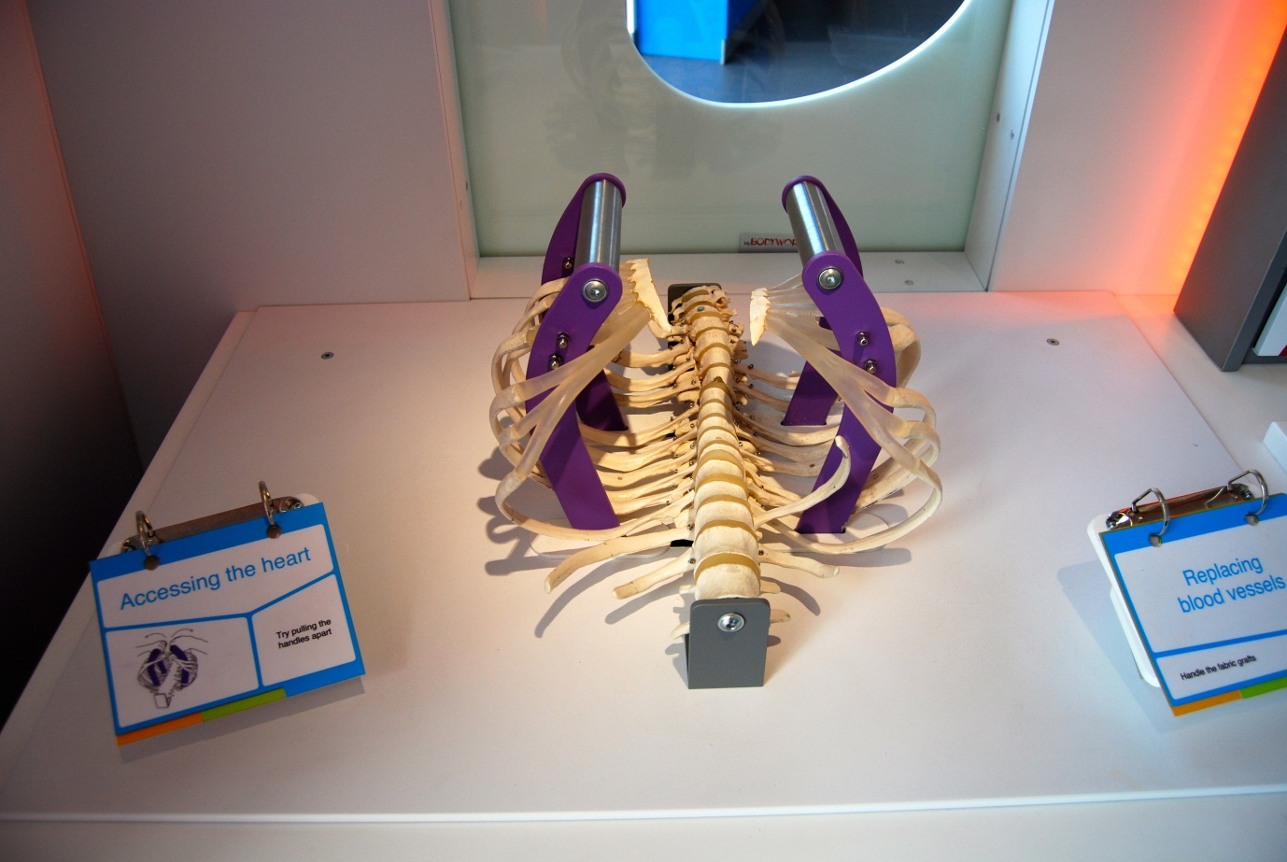

## Accessing the heart

Also known as Open Heart Surgery / C1.03b

### Description

An exhibit that allows visitors to find out how much force is required to open the chest cavity when performing traditional heart surgery. The force gives an indication of how serious and dangerous this procedure is. The exhibit consists of a ribcage model, two handles and a 3-layer flapper label. The handles open the ribcage.

### Visitor experience

The visitor pulls apart the handles to open the ribcage. The force required to move the handles represents the force needed when accessing the heart during traditional heart surgery.

### Visitor interaction tips

* Explain to visitors that they are standing in an area showcasing some of the ways science is helping to mend a broken heart (see the text on the capsule welcome panels).
* Use the information contained on the *Heart surgery information screen* to explain the differences between traditional heart surgery (that requires the ribcage to be opened) to modern, less invasive types of heart surgery.

### Accessibility

For visitors unable to use this exhibit, offer to explain how it works before pointing them in the direction of a related exhibit.

### Good to know

Fabricated by Hüttinger.

### Daily checks by science communicators

The exhibit components are in good working order. In particular:

* The ribcage is intact.

### Cleaning

Clean the surfaces with appropriate surface cleaner.

Remember to clean the flapper label.

### Risks

See risk assessment in Risk Assessments folder.

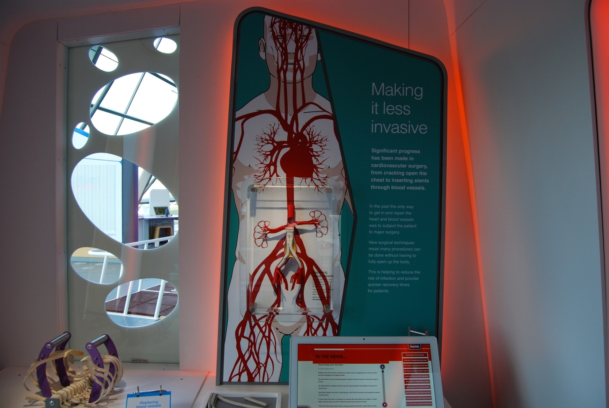

## Repairing blood vessels

Also known as Stent Display Case / C1.02b

### Description

A display case that allows visitors to see a vascular stent and how it can be deployed into a blood vessel. The stent, donated by Vascutek, is attached to a rubber representation of a blood vessel. This exhibit showcases a type of heart-related surgery that is less invasive than traditional heart surgery.

### Visitor experience

The visitor can view the stent shown in context of how it is deployed.

### Visitor interaction tips

* Explain to visitors that they are standing in an area showcasing some of the ways science is helping to mend a broken heart (see the text on the capsule welcome panels).
* Use the information contained on the *Heart surgery information screen* to explain what the object is and how it is deployed in order to repair blood vessels.
* Point out the fatty deposits and bulging of the blood vessel that has required the stent to be deployed.

### Accessibility

For visitors with sight problems, offer assistance by describing the stent in context of the blood vessels of the body.

### Good to know

Donated by Vascutek, Inchinnan.

### Daily checks by science communicators

The exhibit components are in good working order.

### Cleaning

Clean the glass and plastic surround with appropriate glass cleaner.

Clean the surfaces with appropriate surface cleaner.

Dust the ledges using a microfibre duster or static duster.

### Risks

See risk assessment in Risk Assessments folder.

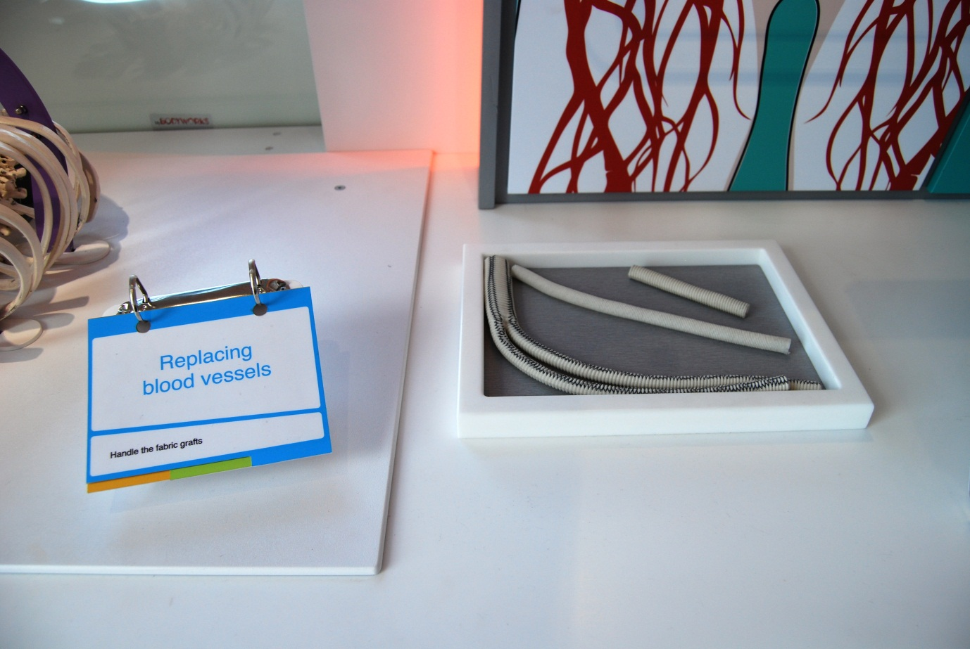

## Replacing blood vessels

Also known as Hands-On Grafts / C1.02c

### Description

An exhibit that allows visitors to pick up and explore a number of vascular grafts. It consists of a table-top recess, up to three fabric grafts and a 3-layer flapper label.

### Visitor experience

The visitor picks up a graft and explores its texture and size.

### Visitor interaction tips

* Explain to visitors that they are standing in an area showcasing some of the ways science is helping to mend a broken heart (see the text on the capsule welcome panels).
* Use the information contained on the *Heart surgery information screen* to explain what the grafts are and why they are used.
* Explain that these grafts are manufactured less than 15 kilometres away (less than 10 miles) in Inchinnan.

### Accessibility

For visitors unable to use this exhibit, offer to explain how it works before pointing them in the direction of a related exhibit.

### Good to know

Donated by Vascutek, Inchinnan.

### Daily checks by science communicators

The exhibit components are in good working order. In particular:

* There is a range of different grafts available for visitors to handle.
* The grafts are in good condition.

### Cleaning

Clean the surfaces with appropriate surface cleaner.

Remember to clean the flapper label.

Dust the ledges using a microfibre duster or static duster.

If the grafts are looking grubby, inform the Exhibit Engineers.

### Risks

See risk assessment in Risk Assessments folder.

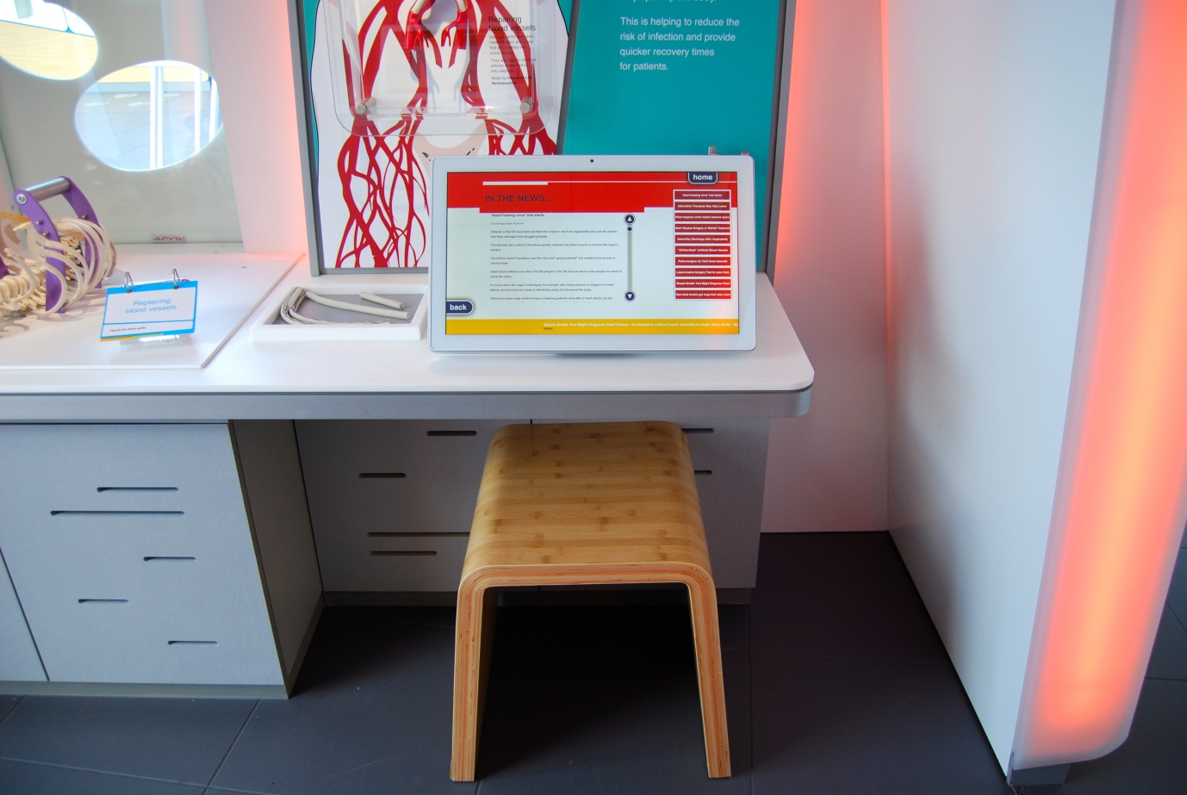

## Heart surgery information screen

Also known as C1.02a

### Description

An information screen that allows visitors to explore the latest advances in heart repair surgery. It consists of a touchscreen, pair of headphones and moveable stool. The exhibit features 6 articles, news RSS feeds and an acknowledgments page. Articles contain text, images and videos.

### Visitor experience

On approach, the exhibit displays an overview article. Visitors tap the scroll buttons to read through the article. Further articles can be selected from the column on the right-hand side of the screen. News articles appear along the bottom of the screen.

### Visitor interaction tips

* Explain to visitors that they are standing in an area showcasing some of the ways science is helping to mend a broken heart (see the text on the capsule welcome panels).
* Point out that many of the stories featured on this screen are related to the surrounding objects, displays and interactive exhibits.

### Accessibility

For visitors with sight problems, offer assistance with the touchscreen.

For visitors unable to use this exhibit, offer to explain how it works before pointing them in the direction of a related exhibit.

### Good to know

The information on this screen is updateable.

### Daily checks by science communicators

The exhibit components are in good working order.

### Cleaning

Clean the screen with appropriate screen cleaner.

Clean the surfaces and moveable stool with appropriate surface cleaner.

Dust the ledges using a microfibre duster or static duster.

### Risks

See risk assessment in Risk Assessments folder.

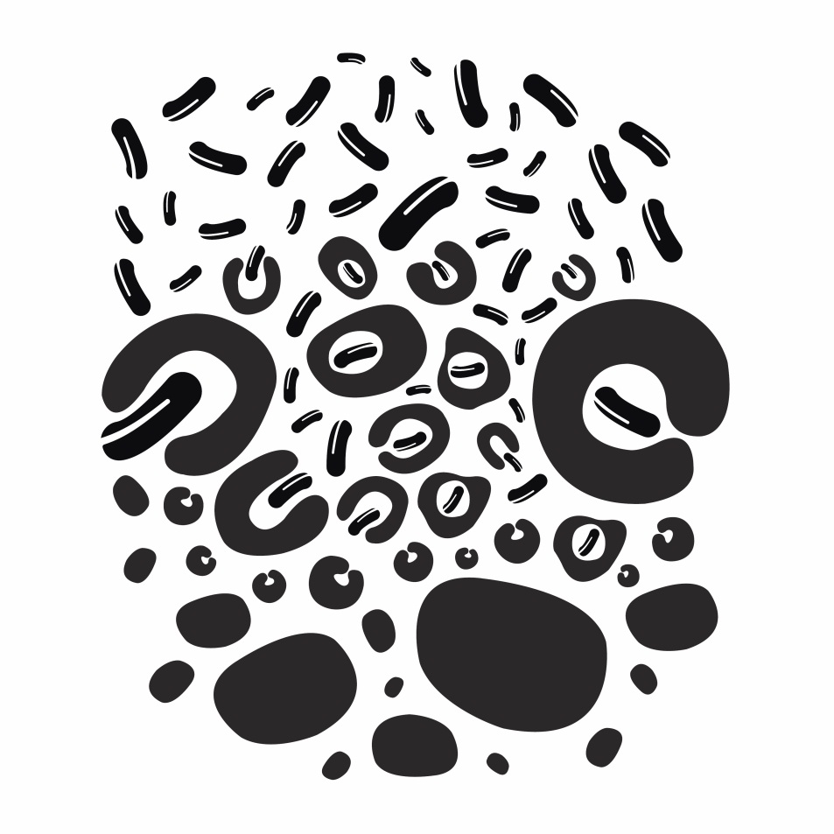

# Defence exhibits

“Your body is attacked by a variety of pathogens, but what body systems are in place for your body to protect itself and fight back?”

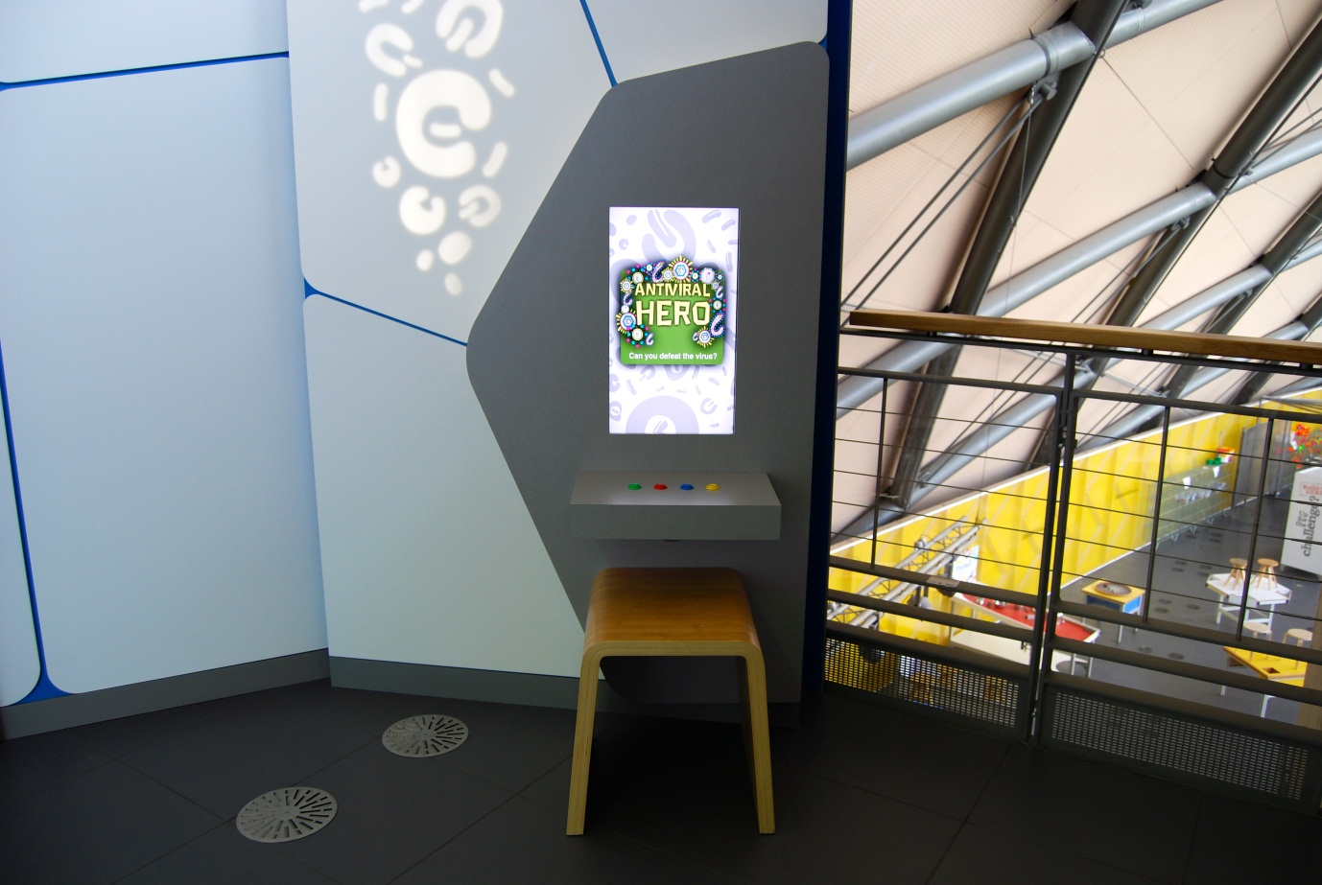

## Antiviral Hero

Also known as A2.01

### Description

An IT game that allows visitors to battle with viruses. It consists of a wall-mounted touchscreen and four arcade buttons.

### Visitor experience

The visitor activates the exhibit by either pressing the touchscreen or by pressing one of the arcade buttons. During the game, viruses descend through blood vessels and the visitor must release an antibody to neutralise each virus particle as it reaches a line on the screen. Pressing the buttons too frequently uses up energy and end the game. The game lasts for 60 seconds. At the end, the visitor is given a score.

### Visitor interaction tips

* Offer assistance on how to play the game, as you highlight key learning outcomes tailored to the visitor.
* Encourage visitors to play again on a harder difficulty setting.
* Suggest related exhibits: ‘If you liked this, you’ll love this’

### Accessibility

For visitors with sight problems, offer assistance with the game. Perhaps assign each button with a number (1,2,3,4) and as virus particles enter the ‘kill zone’, give a verbal announcement mentioning the number.

For visitors unable to use this exhibit, offer to explain how it works before pointing them in the direction of a related exhibit.

### Good to know

Software produced by Pixel Stag.

### Daily checks by science communicators

The exhibit components are in good working order.

### Cleaning

Clean the screen with appropriate screen cleaner.

Clean the surfaces, buttons and moveable stool with appropriate surface cleaner.

### Risks

See risk assessment in Risk Assessments folder.

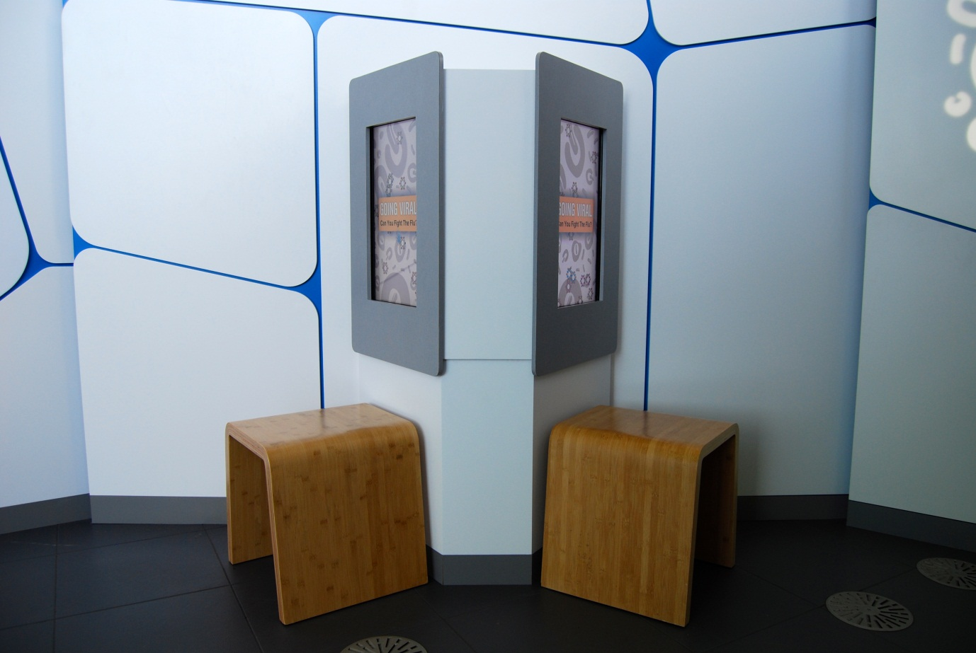

## Going Viral

Also known as A2.02

### Description

An IT game that allows visitors to take on the role of the human immune system in a battle against the influenza virus. It consists of two wall-mounted touchscreens and two moveable stools. The visitor has the option of a single- or two-player game.

### Visitor experience

The visitor activates the exhibit by pressing one of the two touchscreens. If the two-player option is desired, this must be selected on both screens. If one screen is already in use, the two-player option is unavailable. During the game, the visitor sees different strains of the flu virus and tries to destroy each virus particle by selecting the correct ‘ammo’ and pressing on the virus. The game lasts 30 seconds. The two-player option has a sneeze option that releases more viruses on the opponent’s playing zone.

### Visitor interaction tips

* Encourage visitors to play a 2-player game.
* Offer assistance on how to play the game, as you highlight key learning outcomes tailored to the visitor.
* Suggest related exhibits: ‘If you liked this, you’ll love this’

### Accessibility

For visitors with sight problems, offer assistance with the touchscreen.

For visitors unable to use this exhibit, offer to explain how it works before pointing them in the direction of a related exhibit.

### Good to know

Your immune system is your body’s natural defence against infection. The immune system develops very specific defences against infections it has. And in case it should ever get the exact same infection again, the body remembers the infection. So if you’re infected again, you fight if off more quickly than the first time around. This is why you don’t normally get chicken pox more than once. But because the flu and cold viruses change all the time you won’t have memory of them and can get the cold or flu multiple times.

### Daily checks by science communicators

The exhibit components are in good working order.

### Cleaning

Clean both screens with appropriate screen cleaner.

Clean the surfaces and moveable stools with appropriate surface cleaner.

Dust the ledges using a microfibre duster or static duster.

### Risks

See risk assessment in Risk Assessments folder.

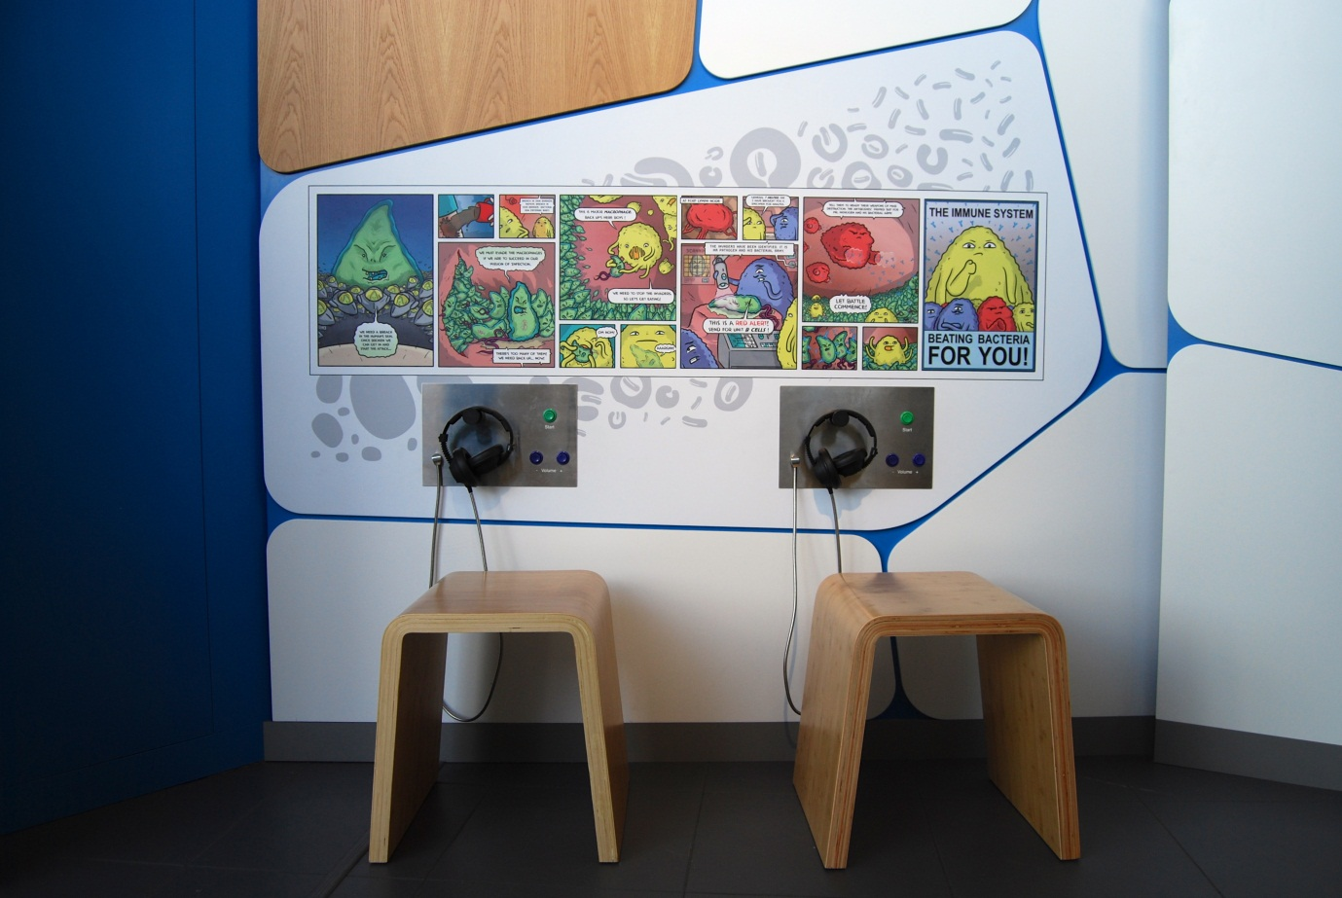

## Holophonic macrophage journey

Also known as A2.03

### Description

A wall-mounted exhibit that allows visitors to listen to a 3D audio story which features personified cells of the immune system. It consists of 2 pairs of headphones, 2 audio control panels (with start and volume buttons), 2 moveable stools and a wall graphic featuring cartoon illustrations of the story. When not in use, the headphones sit on a hook. The audio story lasts 6 minutes and takes advantage of binaural recording to create a 3D audio experience.

### Visitor experience

The visitor sits down, places the headphones over their ears and presses the start button. As they listen to the story, they can look at select scenes illustrated in the cartoon panels.

### Visitor interaction tips

* Suggest related exhibits: ‘If you liked this, you’ll love this’

### Accessibility

For visitors unable to use this exhibit, offer to explain how it works before pointing them in the direction of a related exhibit.

### Good to know

The 3D sounds were recorded and mixed in Govan Town Hall by Savalas.

The cartoon panels were produced by Edward Ross.

### Daily checks by science communicators

The exhibit components are in good working order. In particular:

* The headphones are securely attached to the panel.

### Cleaning

Clean the surfaces, buttons and moveable stools with appropriate surface cleaner. Be careful not to remove the lettering on the control panel. Inform an Exhibit Engineer if letters are missing.

### Risks

See risk assessment in Risk Assessments folder.

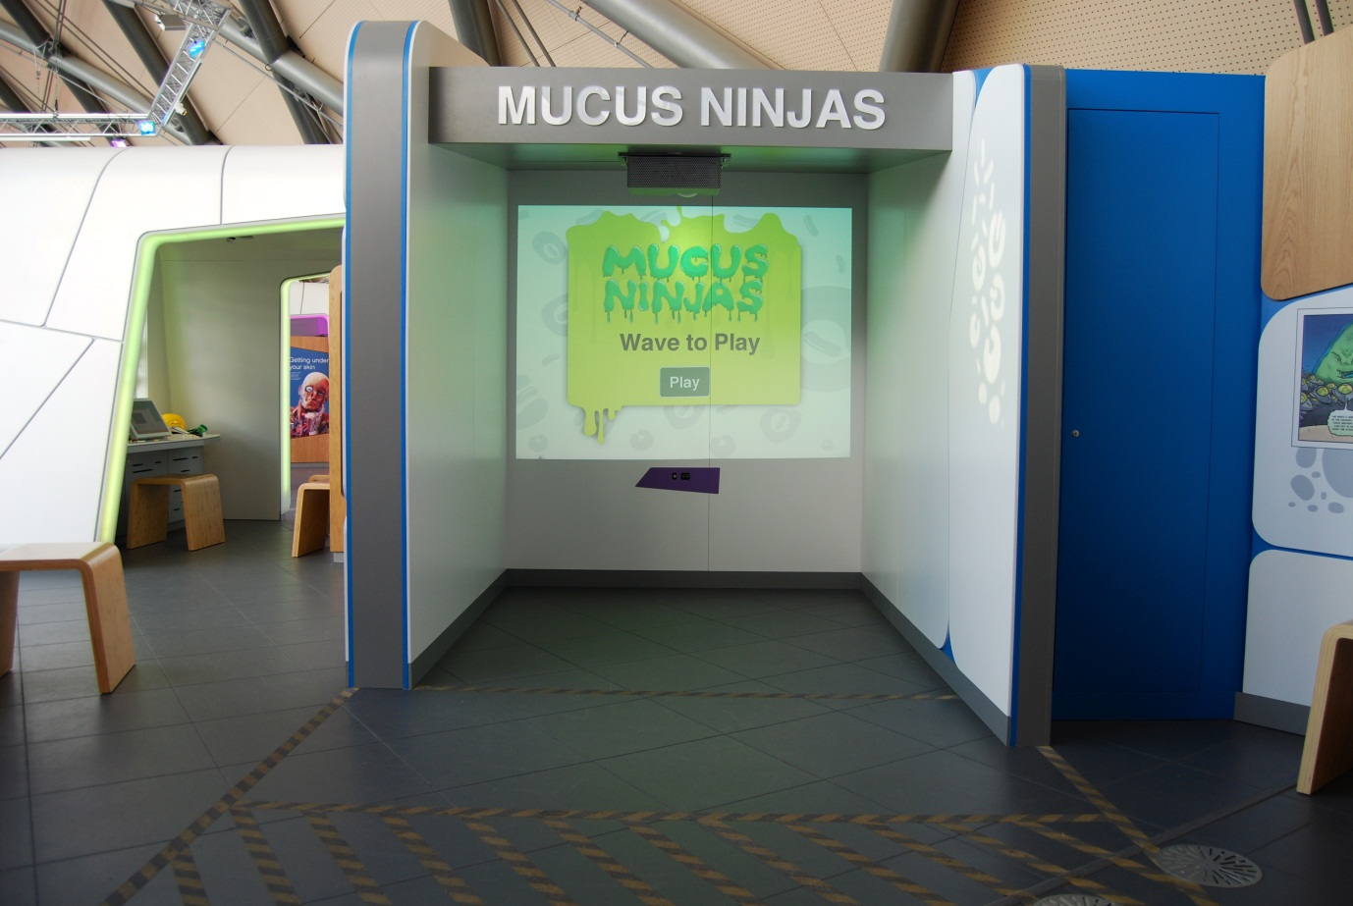

## Mucus Ninjas

Also known as Snot Game / A2.06

### Description

A motion-sensing exhibit that allows visitors to act as a piece of nasal mucus by defending the body from incoming viruses. It consists of a projected screen, Microsoft Kinect sensor and speakers. The playing area is located within a walled zone and marked on the floor. Note, it is a one-player game; the presence of other visitors in the playing area interferes with the motion sensors.

### Visitor experience

The visitor activates the exhibit by standing in the playing area and waving their arm to control a cursor. During the game, the visitor controls a character by moving their body within the playing area. The challenge is to stop incoming virus particles. There are a series of levels of increasing difficulty. At the end, the visitor is given a score.

### Visitor interaction tips

* Encourage only one player to stand within the playing area with others in their group standing outside the range of Kinect motion sensor.
* Offer assistance on how to play the game, as you highlight key learning outcomes tailored to the visitor.
* Suggest related exhibits: ‘If you liked this, you’ll love this’

### Accessibility

For visitors with sight problems, offer assistance with the game. Ensure they are aware of the location of the walls before giving verbal suggestions to win the game.

For visitors unable to use this exhibit, offer to explain how it works before pointing them in the direction of a related exhibit.

### Good to know

Made by Hüttinger.

### Daily checks by science communicators

The exhibit components are in good working order.

### Cleaning

Clean the surfaces with appropriate surface cleaner.

### Risks

See risk assessment in Risk Assessments folder.

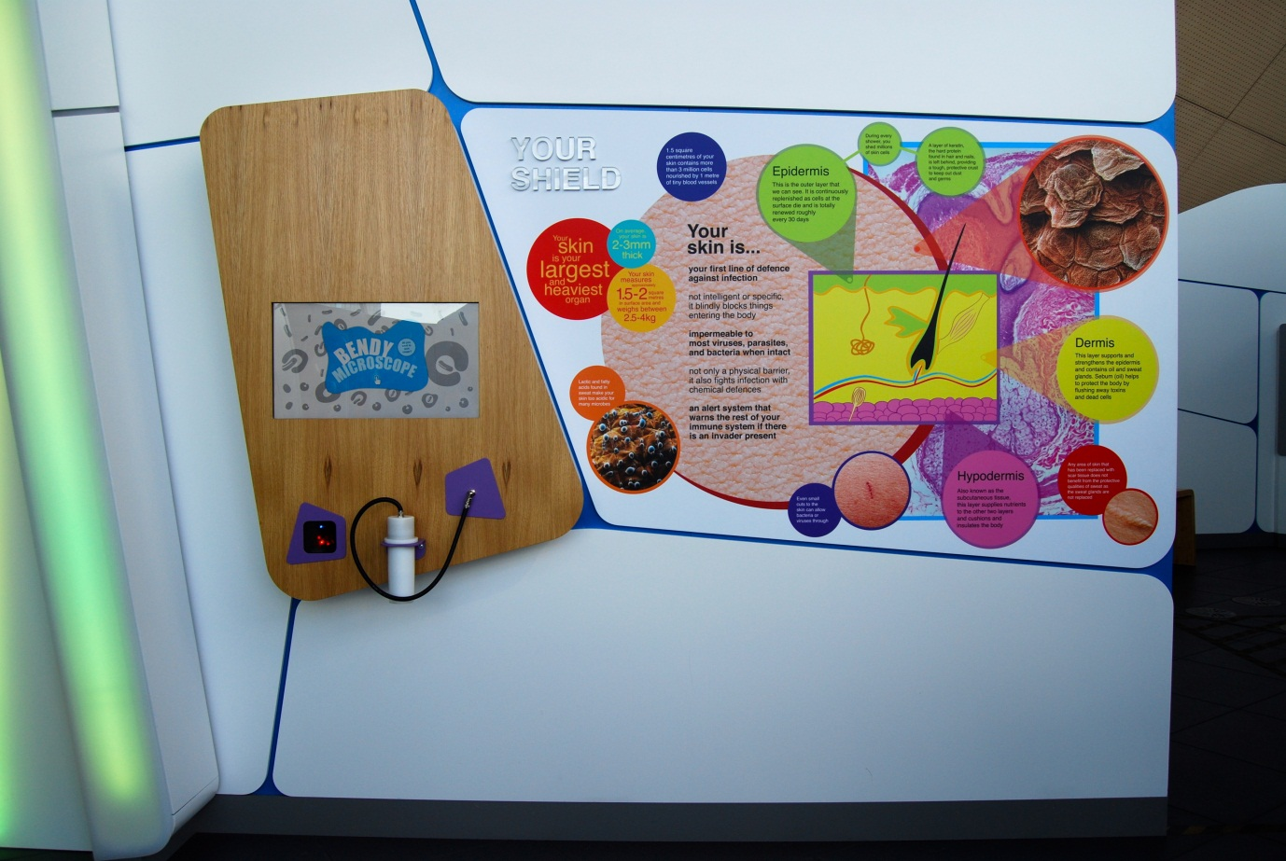

## Bendy Microscope

Also known as A2.05b

### Description

A wall-mounted exhibit that allows visitors to view and record images of their skin from a hand-held microscope. It consists of a video microscope, touchscreen and barcode scanner. The microscope is attached to the wall by flexible tubing and sits in a cradle when not in use.

### Visitor experience

The visitor activates the exhibit either by pressing the touchscreen or by scanning their My BodyWorks barcode card. Live images from the microscope are shown on screen and the pictures focus automatically when the microscope is placed against skin. The visitor can press a camera symbol to take a still image (after a countdown), which they can save to their My BodyWorks profile.

### Visitor interaction tips

* Encourage use of the My BodyWorks cards by explaining how they work and highlighting the benefits of using the website. Explain that they can save several photos using the exhibit.
* Suggest items to view using the microscope including the skin on their arm, fabric and paper.
* Try asking thought-provoking questions related to the visitor, such as ‘why does your body have skin?’ or ‘what happens to your skin when it gets damaged?’

### Accessibility

For visitors with sight problems, offer assistance with the touchscreen.

For visitors unable to use this exhibit, offer to explain how it works before pointing them in the direction of a related exhibit.

### Good to know

Your skin is your body’s first line of defence against infection. When intact, your skin is impermeable to most viruses, parasites and bacteria. It is not only a physical barrier but also fights infection with chemical defences. But small cuts to the skin can allow bacteria and viruses through.

### Daily checks by science communicators

The exhibit components are in good working order. In particular:

* The microscope cable is secure and intact.
* The microscope lens is clean.

### Cleaning

Clean the screen with appropriate screen cleaner.

Clean the microscope lens with appropriate glass cleaner.

Clean the surfaces with appropriate surface cleaner.

Dust the ledges using a microfibre duster or static duster.

### Risks

See risk assessment in Risk Assessments folder.



# Your body fights back Research Capsule

“Parasitic invaders avoiding detection, overreactions to pollen and dust, the body even attacking itself – your immune system is at war. What are scientists doing to help?”

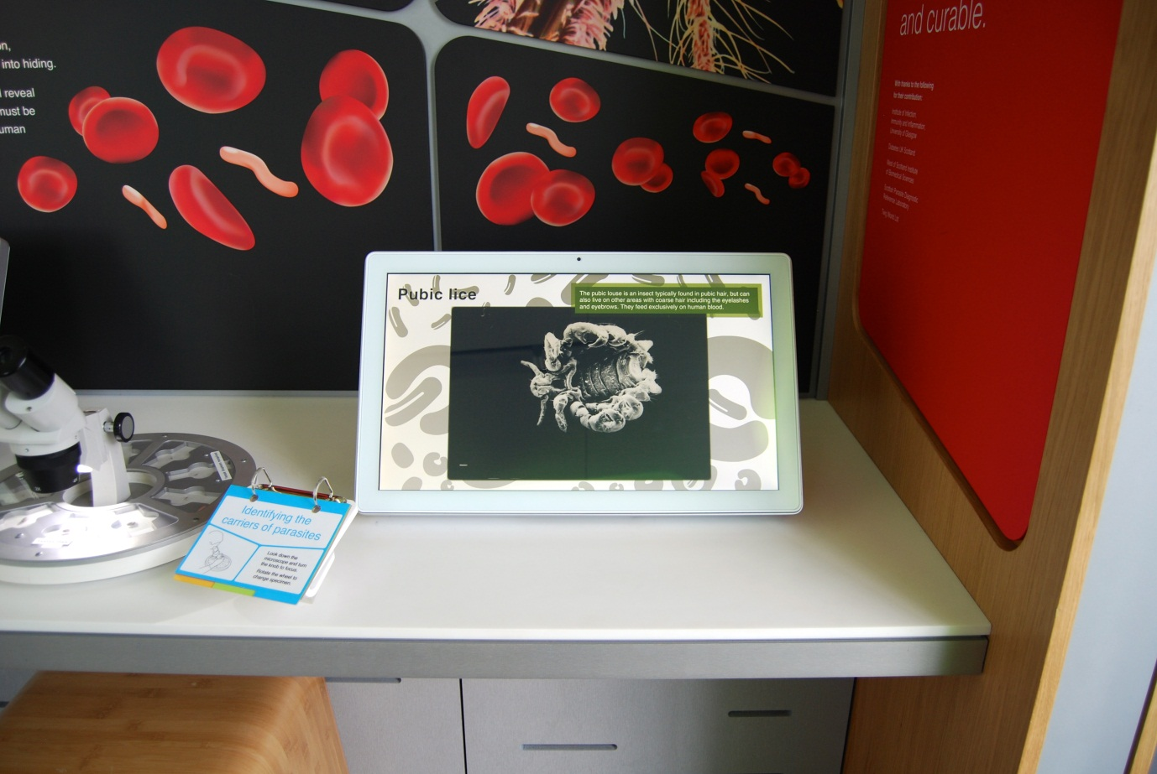

## Pathogen Slideshow

Also known as C2.02

### Description

An information screen that allows visitors to investigate the microscopic world of parasites that infect the human body. It consists of a table-mounted touchscreen.

### Visitor experience

The visitor views great-quality images of parasites together with a brief description. The images automatically change but the visitor can press the screen to activate ‘back’ and ‘next’ buttons to skip through the images.

### Visitor interaction tips

* Explain to visitors that they are standing in an area showcasing some of the ways science is assisting the immune system of the human body (see the text on the capsule welcome panels).
* Explain that the exhibit features images of parasites that can infect the body.
* Suggest related exhibits: ‘If you liked this, you’ll love this’

### Accessibility

For visitors with sight problems, offer assistance by describing the contents of the screen.

For visitors unable to use this exhibit, offer to explain how it works before pointing them in the direction of a related exhibit.

### Good to know

Some of the images were donated by Stobhill Hospital.

### Daily checks by science communicators

The exhibit components are in good working order.

### Cleaning

Clean the screen with appropriate screen cleaner.

Clean the surfaces with appropriate surface cleaner.

Dust the ledges using a microfibre duster or static duster.

### Risks

See risk assessment in Risk Assessments folder.

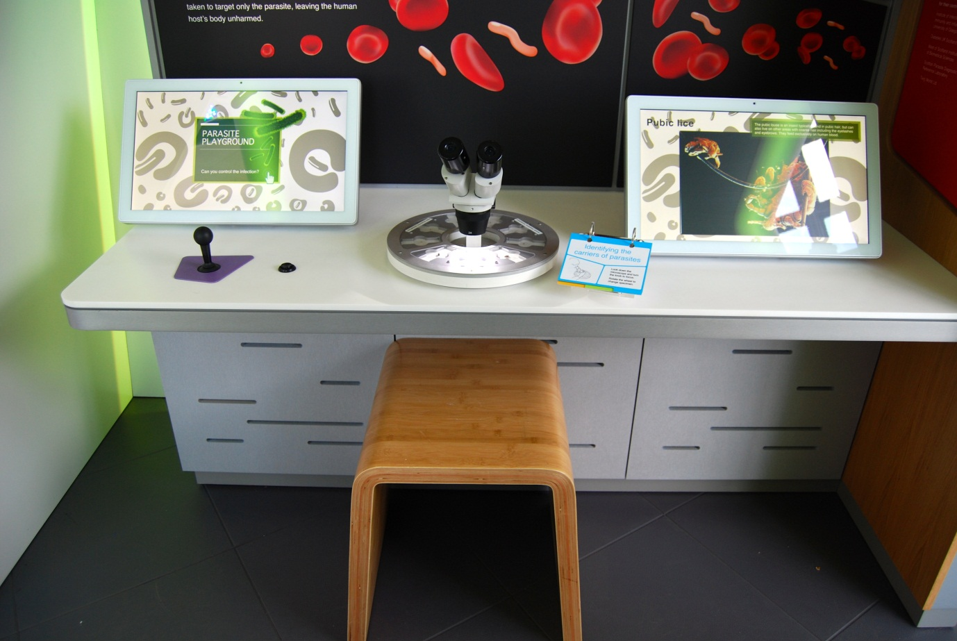

## Identifying the carriers of parasites

Also known as Pathogen Microscope / C2.03

### Description

An exhibit that allows visitors to explore the microscopic world of flies that spread parasitic disease. It consists of a microscope, rotatable sample disc containing 9 flies, a 3-layer flapper label and a moveable stool. The 9 samples cover 3 types of fly: tsetse fly, female anopheles mosquito and male anopheles mosquito.

### Visitor experience

The visitor looks down through eyepieces of the microscope. If the sample is blurry, the visitor can rotate the focus knob. The sample can be moved by sliding the sample disc. To change specimens, the visitor can rotate the disc.

### Visitor interaction tips

* Explain to visitors that they are standing in an area showcasing some of the ways science is assisting the immune system of the human body (see the text on the capsule welcome panels).
* Offer assistance on using the microscope and perhaps even set it up for the visitor.
* Point out things to notice, such as how to tell the difference between a female and male anopheles mosquito (see below).

### Accessibility

For visitors unable to use this exhibit, offer to explain how it works before pointing them in the direction of a related exhibit.

### Good to know

The flies were donated by Prof Mike Turner, University of Glasgow.

The tsetse fly can transmit the sleeping sickness-causing parasite trypanosoma brucei.

The female anopheles mosquito can transmit the malaria-causing parasite plasmodium falciparum.

The male anopheles mosquito cannot pass on the malaria-causing parasite.

It’s easy to tell the male and female mosquitoes apart: the male mosquitoes have much bushier antennae than the females.

### Daily checks by science communicators

The exhibit components are in good working order. In particular:

* Specimens are intact.
* Microscope is correctly set up.

### Cleaning

Clean the glass and microscope lenses with appropriate glass cleaner. Be careful not to scrub off the specimen labels. Inform the Exhibit Engineers if they need replaced.

Clean the surfaces and moveable stool with appropriate surface cleaner.

Remember to clean the flapper label.

Dust the ledges using a microfibre duster or static duster.

### Risks

See risk assessment in Risk Assessments folder.

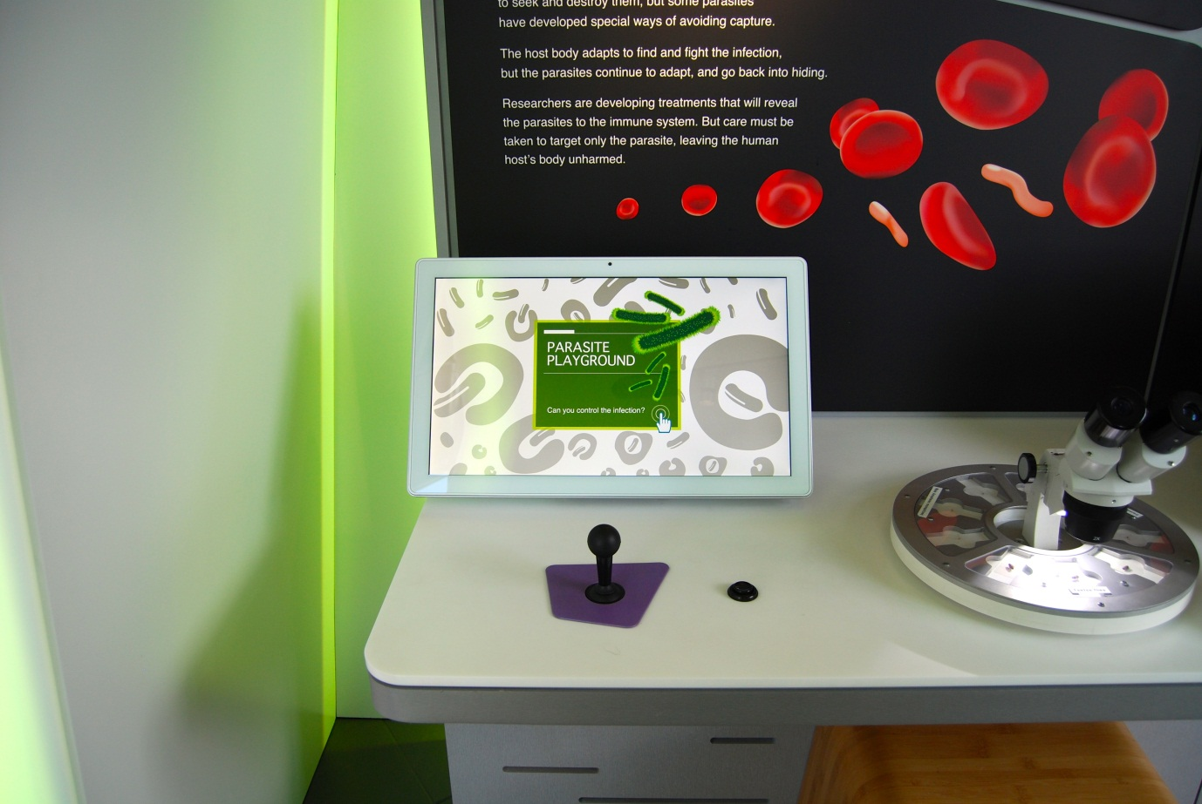

## Parasite Playground

Also known as C2.01

### Description

An IT game that allows visitors to play the cat-and-mouse game performed by the body’s immune system and pathogens. It consists of a joystick, button, touchscreen and moveable stool.

### Visitor experience

The visitor activates the exhibit by either pressing the touchscreen or by pressing the button. During the game, the visitor tries to stop parasites from reaching the brain by firing antibodies at the parasites.

### Visitor interaction tips

* Explain to visitors that they are standing in an area showcasing some of the ways science is assisting the immune system of the human body (see the text on the capsule welcome panels).
* Offer assistance on how to play the game, as you highlight key learning outcomes tailored to the visitor.
* Suggest related exhibits: ‘If you liked this, you’ll love this’

### Accessibility

For visitors with sight problems, offer assistance with the touchscreen.

For visitors unable to use this exhibit, offer to explain how it works before pointing them in the direction of a related exhibit.

### Good to know

Text The parasite Trypanosoma brucei lives in the gut and saliva gland of the tsetse fly and is transferred to the bloodstream of the bitten human when the fly takes a blood meal. A number of strains (clones) of the parasite infect the human, each with different coat coverings. However, one strain makes up the majority of the parasitic population. This is the major clone. The human’s immune system will detect the major clone by special cells binding to its surface coat and stimulating other cells to produce antibodies specific to the major clone parasite. The major clone parasites then get coated in antibodies stimulating certain cells to gobble up the parasites and stimulating processes that will burst the parasites open. Once this major clone is removed, one of the minor clones will expand to takes its place. And so the cycle repeats itself. Researchers seek to expose all parasites to the immune system so that they can all be cleared at once, thereby preventing the parasite reaching the central nervous system and killing the infected person.

### Daily checks by science communicators

The exhibit components are in good working order.

### Cleaning

Clean the screen with appropriate screen cleaner.

Clean the surfaces, joystick, button and moveable stool with appropriate surface cleaner.

Dust the ledges using a microfibre duster or static duster.

### Risks

See risk assessment in Risk Assessments folder.

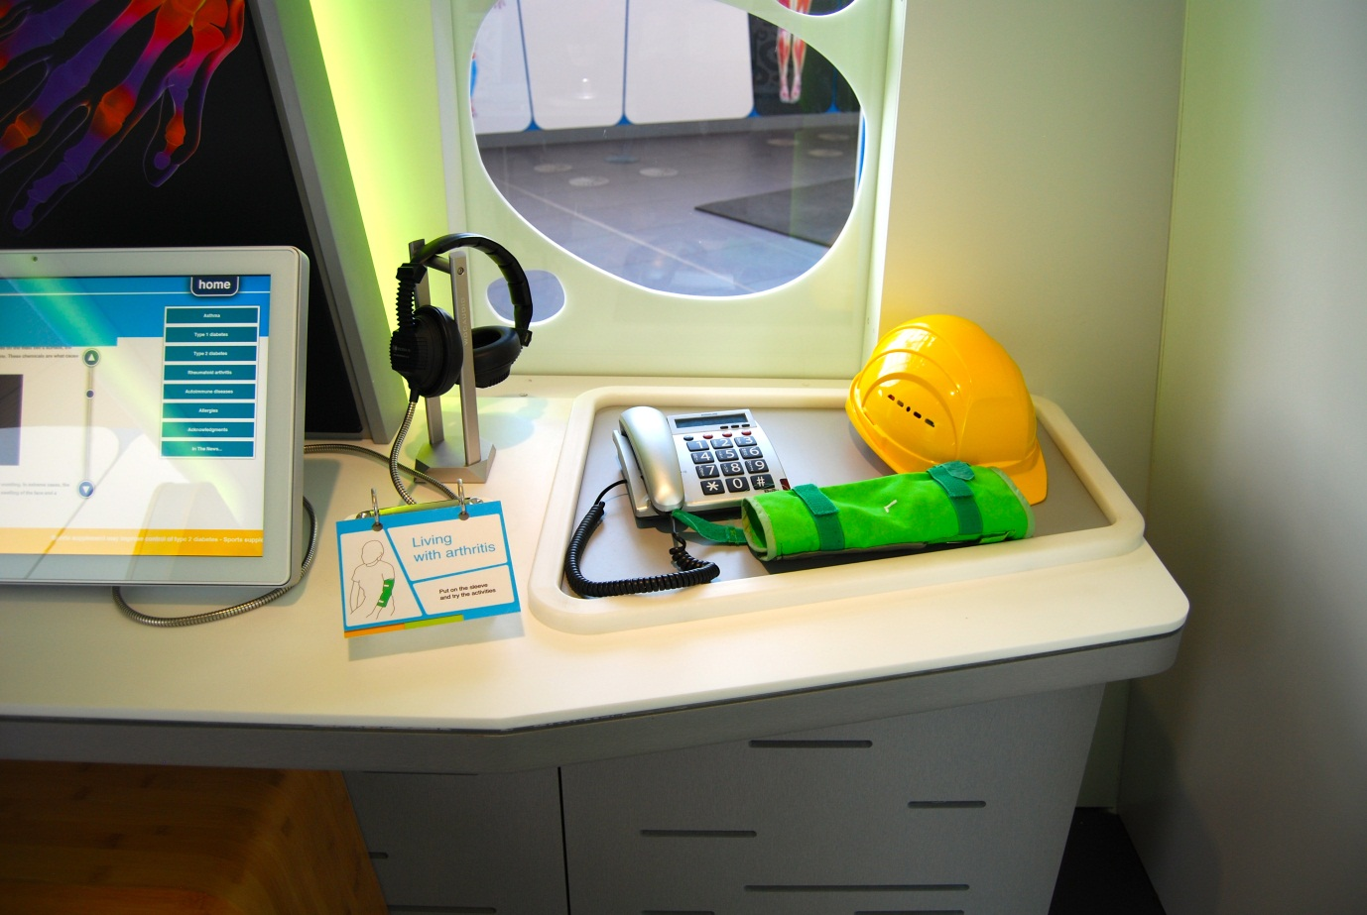

## Living with arthritis

Also known as Arthritis Sleeve / C2.04a

### Description

An exhibit that allows visitors to wear a reduced-mobility sleeve to experience what it might feel like to have rheumatoid arthritis. It consists of a Velcro-fastened arthritis simulation sleeve, telephone, hard hat and 3-layer flapper label.

### Visitor experience

The visitor puts on the sleeve and attempts the everyday activities of lifting the telephone handset and putting on a hat. The reduced mobility illustrates to the visitor the impact of rheumatoid arthritis can have on a person’s joints.

### Visitor interaction tips

* Explain to visitors that they are standing in an area showcasing some of the ways science is assisting the immune system of the human body (see the text on the capsule welcome panels).
* Assist the visitors with putting the sleeve on and encouraging them to try out the everyday activities.
* Suggest related exhibits: ‘If you liked this, you’ll love this’

### Accessibility

For visitors unable to use this exhibit, offer to explain how it works before pointing them in the direction of a related exhibit.

### Good to know

Made by Hüttinger.

### Daily checks by science communicators

The exhibit components are in good working order. In particular:

* The sleeve is in good condition.
* The hardhat and telephone are in good condition.

### Cleaning

Clean the surfaces, hat and telephone with appropriate surface cleaner.

Remember to clean the flapper label.

If the sleeve requires cleaning, inform the Exhibit Engineers.

### Risks

See risk assessment in Risk Assessments folder.

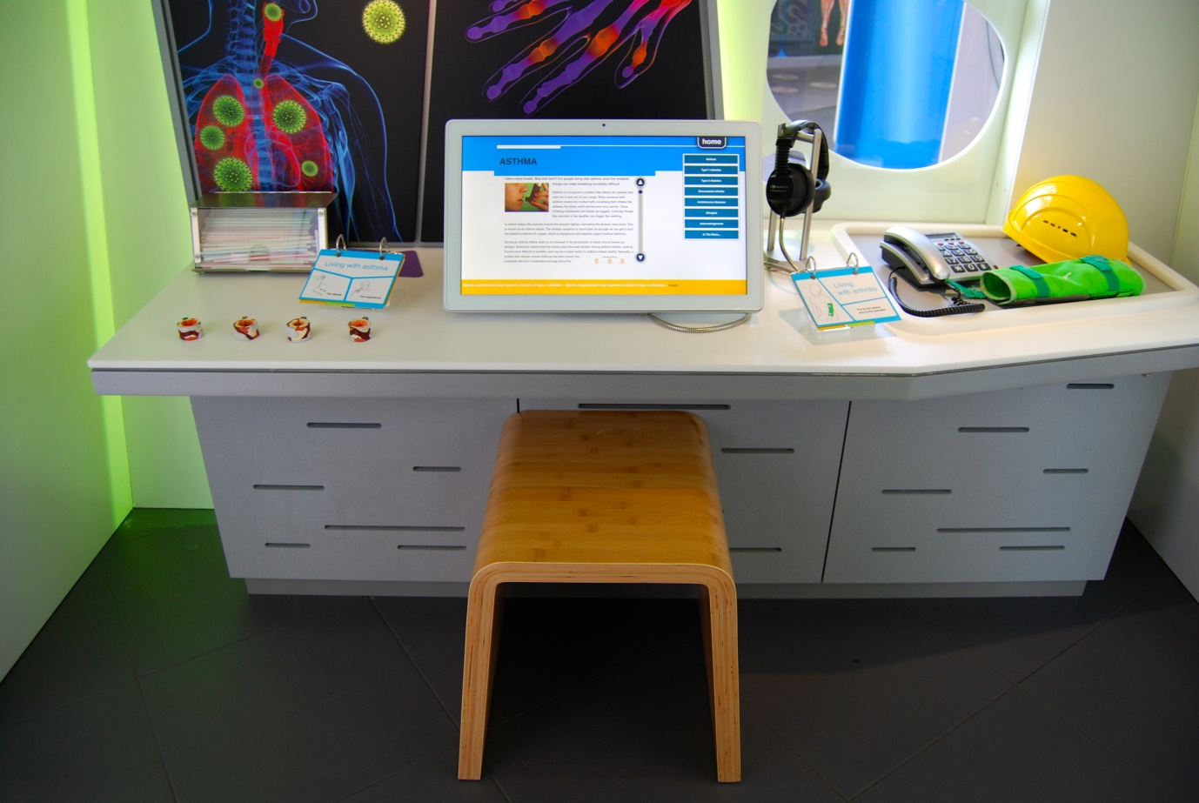

## Immune system research information screen

Also known as C2.04c

### Description

An information screen that allows visitors to explore the latest advances in research into autoimmune diseases. It consists of a touchscreen, pair of headphones and moveable stool. The exhibit features 6 articles, news RSS feeds and an acknowledgments page. Articles contain text, images and videos.

### Visitor experience

On approach, the exhibit displays an overview article. Visitors tap the scroll buttons to read through the article. Further articles can be selected from the column on the right-hand side of the screen. News articles appear along the bottom of the screen.

### Visitor interaction tips

* Explain to visitors that they are standing in an area showcasing some of the ways science is assisting the immune system of the human body (see the text on the capsule welcome panels).
* Point out that many of the stories featured on this screen are related to the surrounding objects, displays and interactive exhibits.

### Accessibility

For visitors with sight problems, offer assistance with the touchscreen.

For visitors unable to use this exhibit, offer to explain how it works before pointing them in the direction of a related exhibit.

### Good to know

The information on this screen is updateable.

### Daily checks by science communicators

The exhibit components are in good working order.

### Cleaning

Clean the screen with appropriate screen cleaner.

Clean the surfaces and moveable stool with appropriate surface cleaner.

Dust the ledges using a microfibre duster or static duster.

### Risks

See risk assessment in Risk Assessments folder.

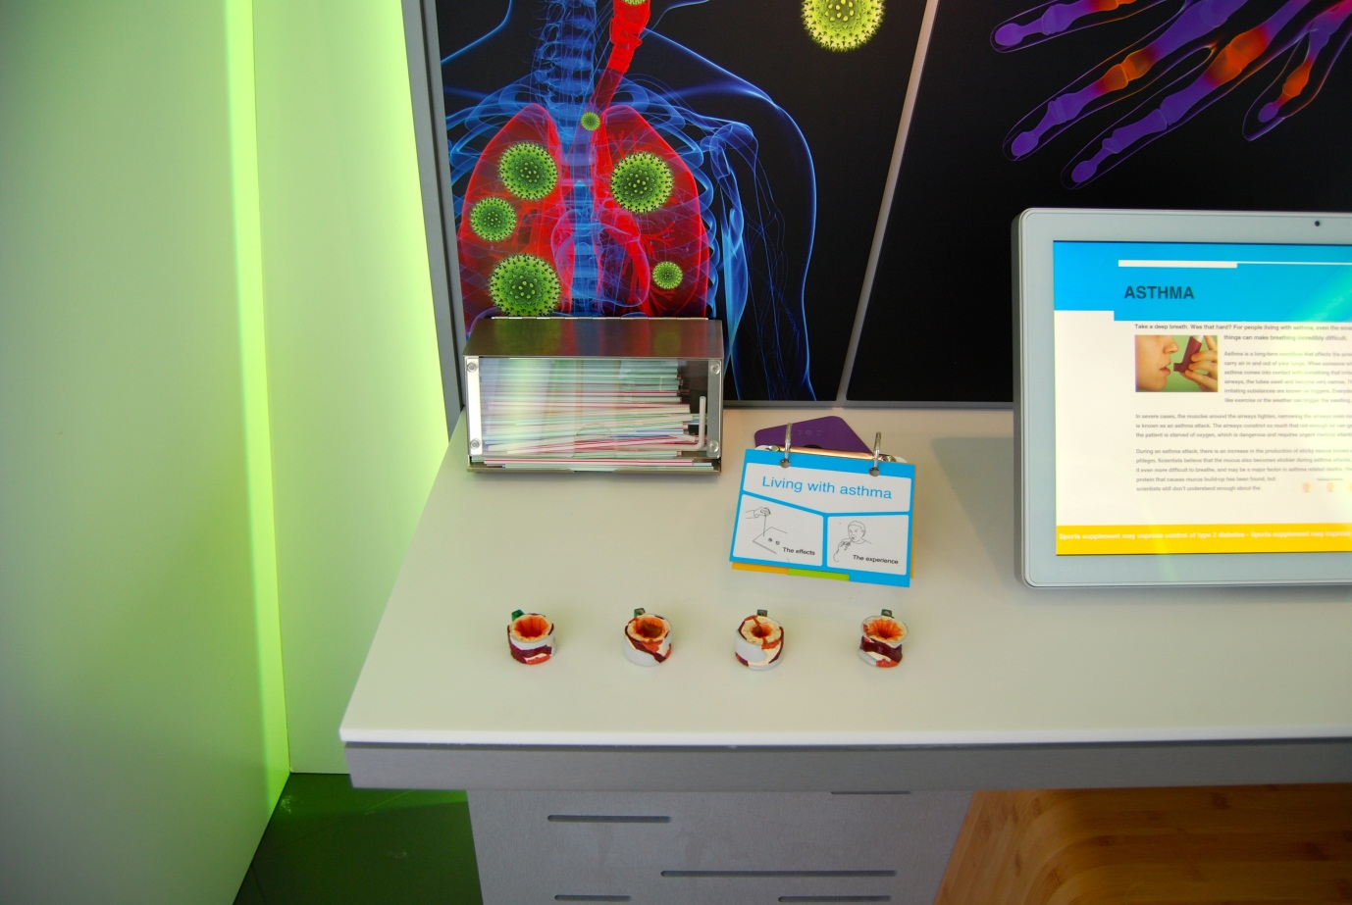

## Living with asthma

Also known as Asthmatic Windpipes / C2.05

### Description

An exhibit that allows visitors to see and experience the effects of asthma on the windpipe. It consists of 4 model windpipes, a drinking straw dispenser, bin and a 3-layer flapper label. The models show cross-sections of a windpipe in three different stages of asthma and one without asthma.

### Visitor experience

The visitor can lift each windpipe model to examine it up close. To experience the effects of asthma, the visitor can pick up a clean drinking straw and breathe through it. This illustrates the impact of breathing through a smaller tube, as if the windpipe was constricted due to asthma. Once complete, the visitor bins the straw by placing it in the bin.

### Visitor interaction tips

* Explain to visitors that they are standing in an area showcasing some of the ways science is assisting the immune system of the human body (see the text on the capsule welcome panels).
* Encourage visitors to pick up a clean straw and breathe through it.
* Point out the different parts of the model windpipes.

### Accessibility

For visitors unable to use this exhibit, offer to explain how it works before pointing them in the direction of a related exhibit.

### Good to know

Made by Hüttinger.

### Daily checks by science communicators

The exhibit components are in good working order. In particular:

* The model windpipes are intact.
* The straw dispenser contains plenty of clean straws.

### Cleaning

Clean the surfaces and straw dispenser with appropriate surface cleaner.

Remember to clean the flapper label.

Avoid using chemicals on the model windpipes.

Dust the ledges using a microfibre duster or static duster.

### Risks

See risk assessment in Risk Assessments folder.

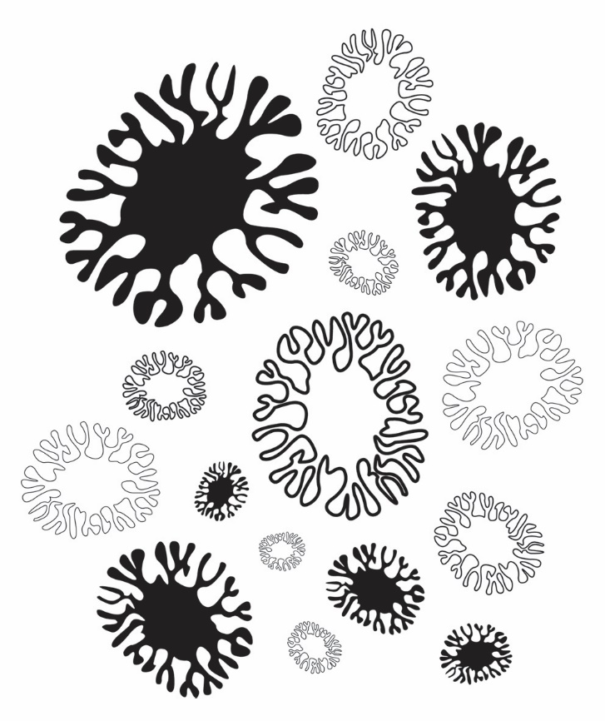

# Digestive & Urinary exhibits

Every day you eat and drink to give you energy, but where does it go and what does your body do with it?

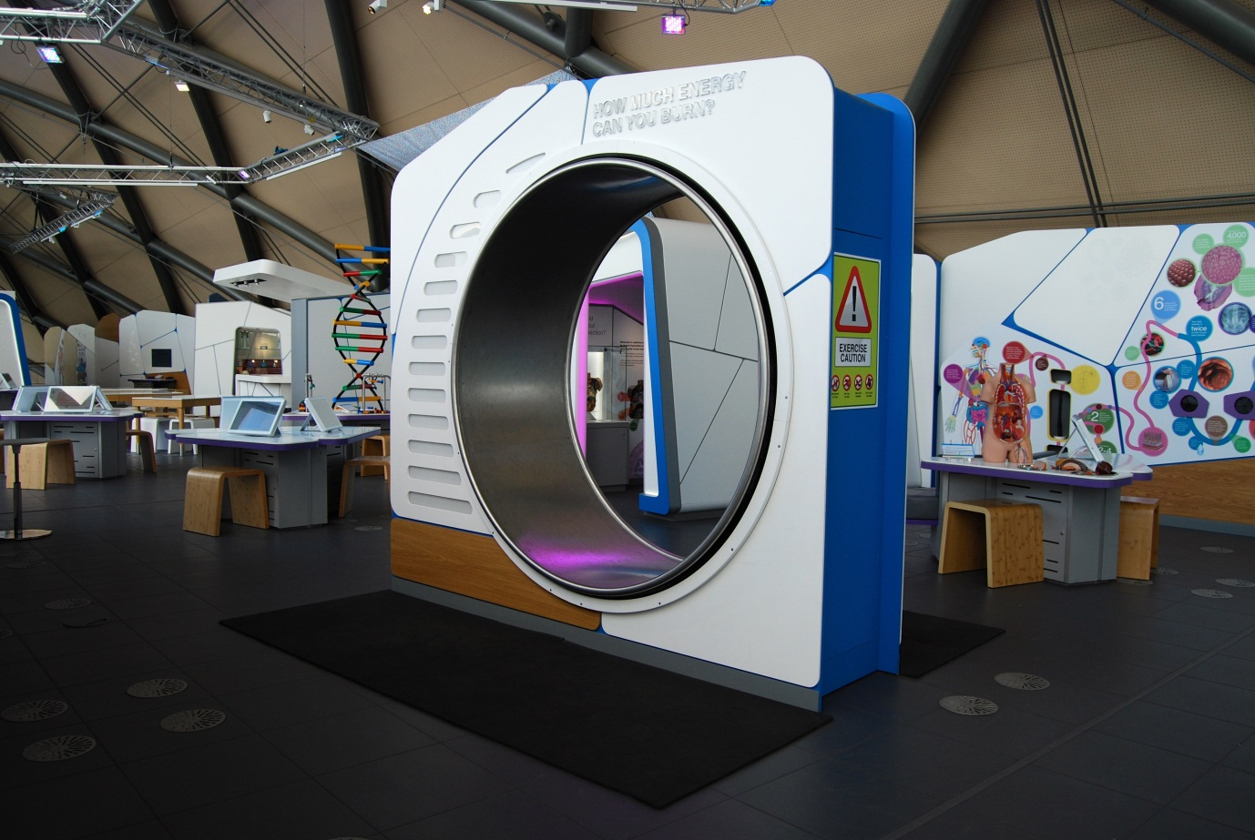

## How much energy can you burn?

Also known as Human Hamster Wheel / A3.12

### Description

An exhibit that allows visitors to burn energy by walking inside a human-sized hamster wheel. It consists of a 2-metre-diameter hamster wheel, lights, floor matting and warning signs. The lights illuminate to show how much energy is being burned by the visitor: the faster they walk, the more lights illuminate.

### Visitor experience

The visitor steps inside the wheel and walks. They can hold on to the edge of the wheel to steady themselves if desired.

### Visitor interaction tips

* Encourage visitors to use this exhibit one at a time.
* Measure the visitor’s heart rate before and after their walk using a portable pulse oximeter. Discuss why the heart rate changes with physical activity.
* Point out how many of the lights the visitor is illuminating as they walk.

### Accessibility

For visitors with sight problems, offer assistance if they wish to use this exhibit. Be sure to mention that they can hold on to the edges of the wheel. As they walk, share with the visitor how many lights they are illuminating.

For visitors unable to use this exhibit, offer to explain how it works before pointing them in the direction of a related exhibit.

### Good to know

Made by Hüttinger.

### Daily checks by science communicators

The exhibit components are in good working order.

### Cleaning

Clean the non-metal surfaces with appropriate surface cleaner.

Clean the metal walking surface with a broom and dustpan & brush. (If a more thorough cleaning is required, use a sponge/cloth and warm soapy water and ensure the surface is not slippy afterwards)

Clean the floor mats using a vacuum cleaner.

Dust the ledges using a microfibre duster or static duster.

### Risks

See risk assessment in Risk Assessments folder.

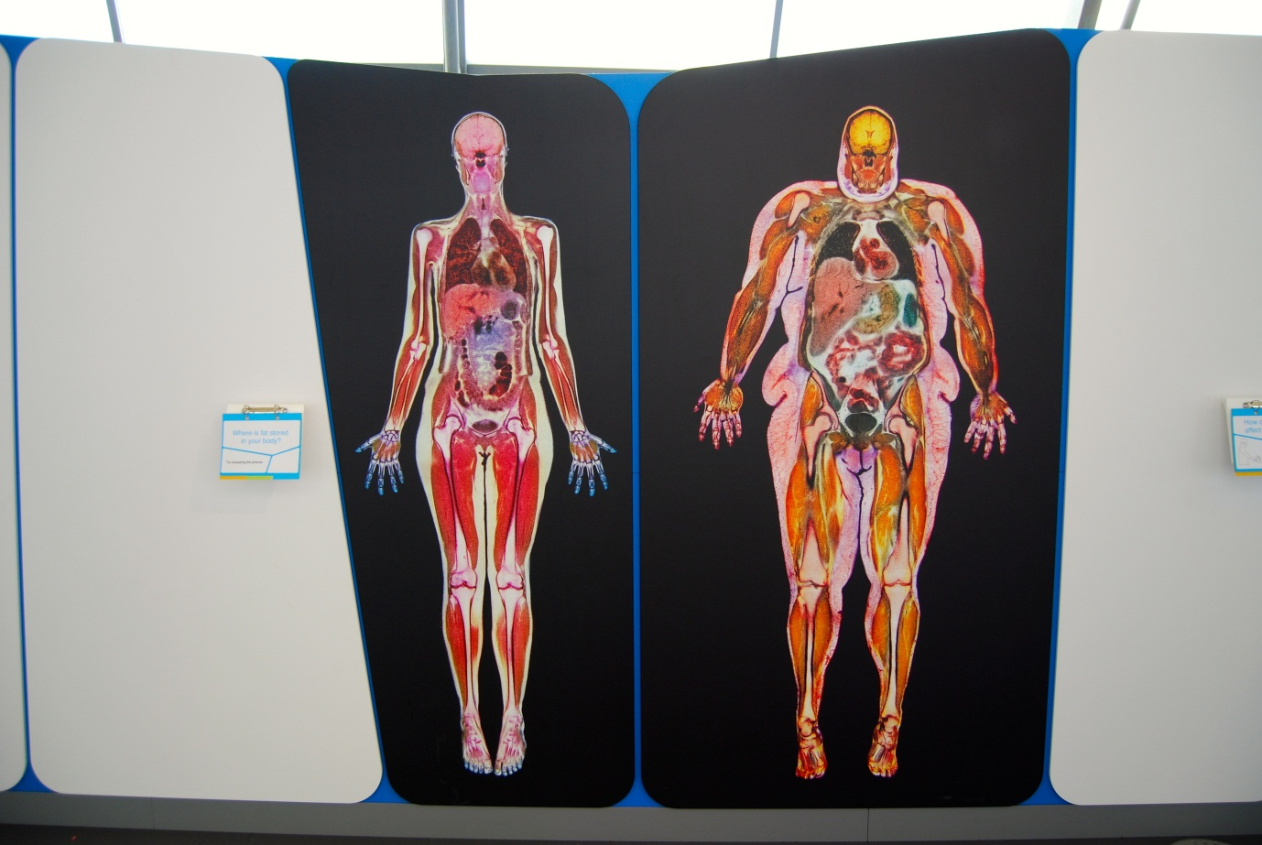

## Where is fat stored in your body?

Also known as Fat & Healthy Body Scans / A3.14

### Description

A visual exhibit that allows visitors to explore the internal makeup of two people with large images taken from MRI scans. It consists of two side-by-side vinyl prints mounted onto wall panels with a 3-layer flapper label. Each image was selected to highlight the presence of fat within the body. One image displays a woman with a healthy BMI and the other displays a woman with an obese BMI.

### Visitor experience

The visitor can get up close to examine the images. The label suggests details to look for and illustrates the health impacts of visceral and ectopic fat.

### Visitor interaction tips

* Point out some of the impacts of visceral and ectopic fat such as the size of liver, compression of lungs, and fat surrounding intestines and stomach.
* Explain that outwardly thin people can have dangerous levels of internal body fat.

### Accessibility

For visitors with sight problems, offer to describe the MRI scans.

### Good to know

Images from Science Photo Library.

### Daily checks by science communicators

The exhibit components are in good working order.

### Cleaning

Clean the surfaces with appropriate surface cleaner.

Remember to clean the flapper label.

Dust the ledges using a microfibre duster or static duster.

### Risks

See risk assessment in Risk Assessments folder.

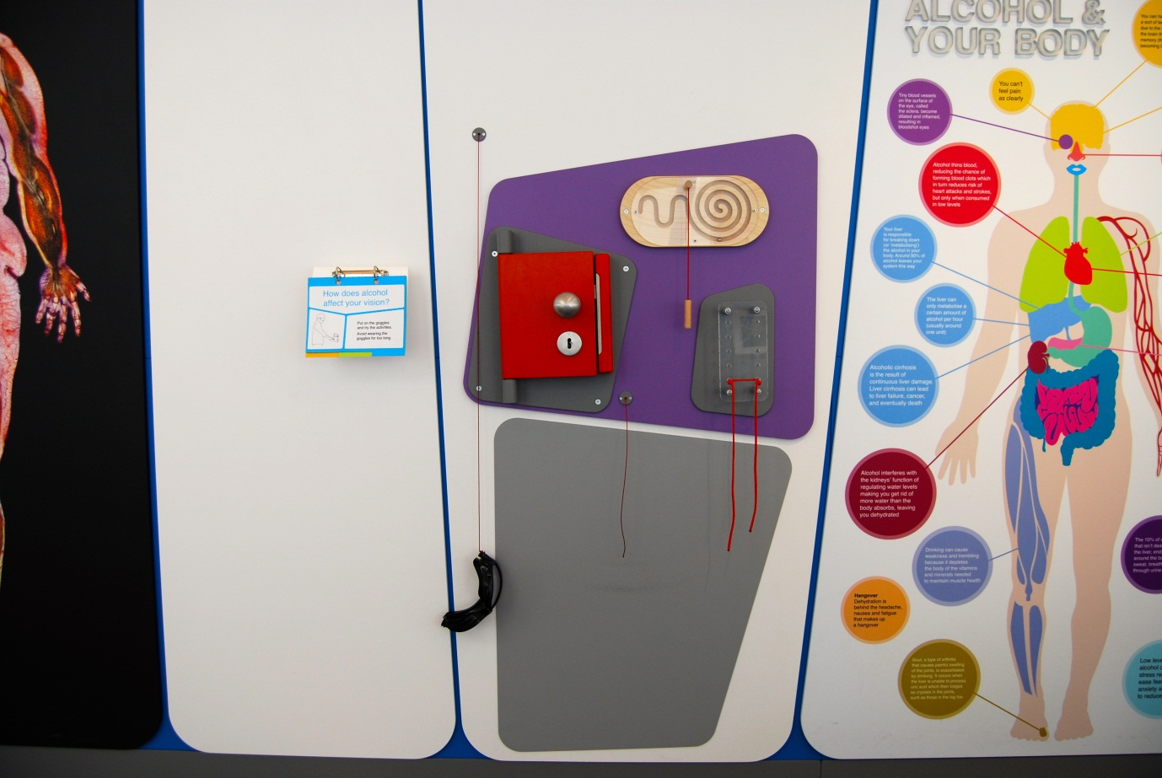

## How does alcohol affect your vision?

Also known as Drunken Goggles / A3.07

### Description

A wall-mounted exhibit that allows visitors to try out simple dextrous activities whilst using vision-altering goggles. It consists of a pair of vision impairment goggles, lock and key, magnetic puzzle, shoelaces and 3-layer flapper label. The goggles are designed to simulate the visual effects of excessive alcohol consumption.

### Visitor experience

The visitor holds the goggles over their eyes and uses their free hand to try the simple activities. They discover that the activities are more difficult because their visual perception has been altered.

### Visitor interaction tips

* Try asking thought-provoking questions related to the visitor, such as ‘how is your vision changed?’ or ‘what sorts of activities would be dangerous with poor vision?’
* Suggest related exhibits: ‘If you liked this, you’ll love this’

### Accessibility

For visitors with sight problems or who are unable to use this exhibit, offer to explain how it works before pointing them in the direction of a related exhibit.

### Good to know

(From the goggle supplier’s website)

Focus on the effects of drink-driving with DIA Vision Impairment Goggles

The truly effective way of reinforcing the 'don't drink and drive' message is by demonstrating what it feels like and how dangerous it can be. The best and easiest way of doing that is with a pair of DIA Vision Impairment Goggles.

These unique goggles simulate the effects of impairment, including reduced alertness, slowed reaction time, confusion, visual distortion, alteration of depth and distance perception, reduction of peripheral vision, poor judgment and decision making, double vision, and lack of muscular coordination.

### Daily checks by science communicators

The exhibit components are in good working order.

### Cleaning

Clean the surfaces, activities and goggles with appropriate surface cleaner.

Remember to clean the flapper label.

Dust the ledges using a microfibre duster or static duster.

### Risks

See risk assessment in Risk Assessments folder.

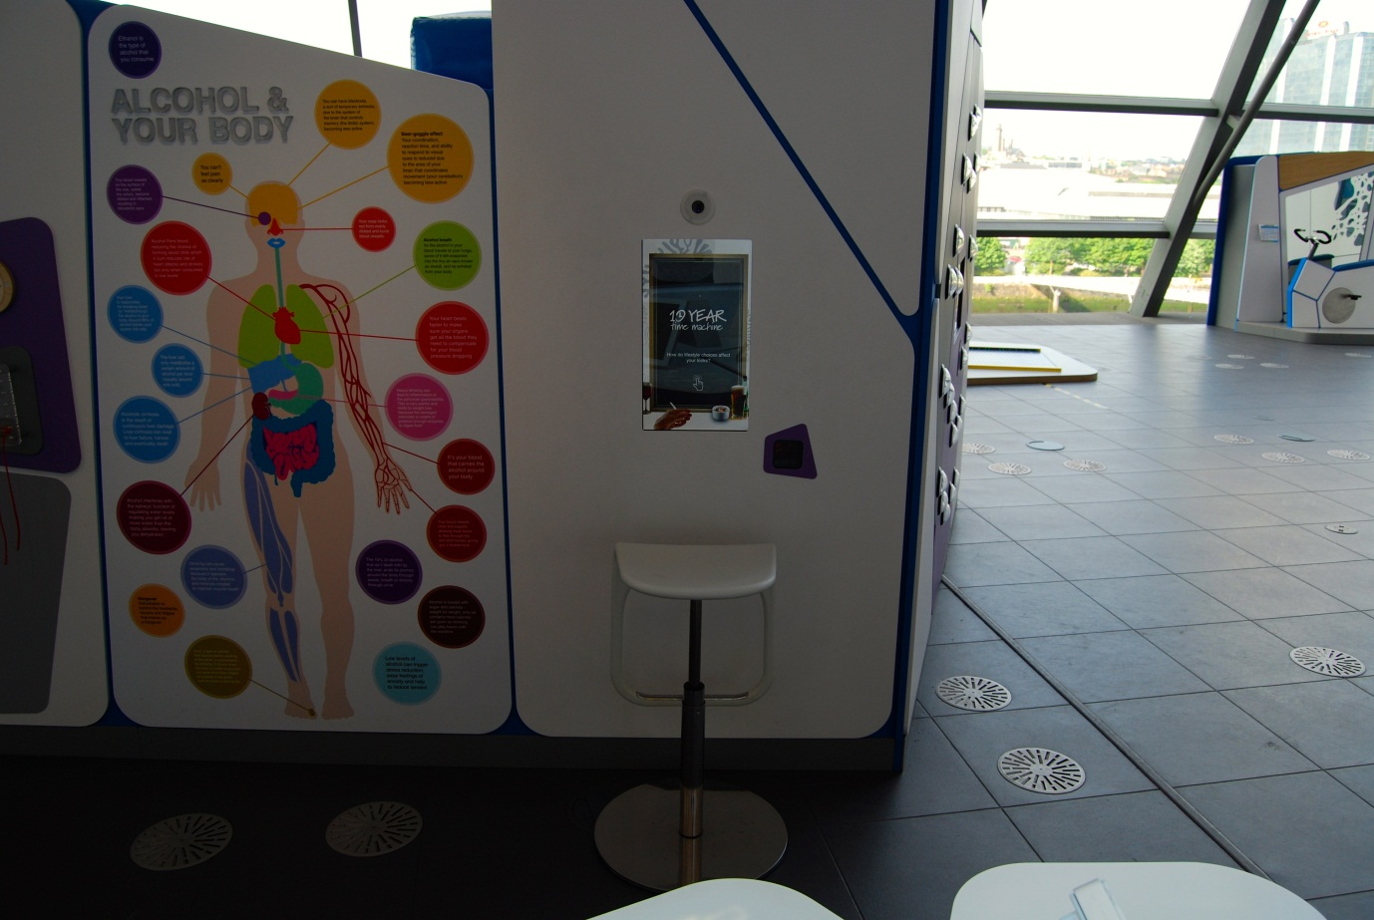

## 10-Year Time Machine

Also known as A5.10 / A3.18

### Description

An exhibit that allows visitors to explore the long-term consequences of alcohol and smoking through face-morphing software that ages the visitor by 10 years. It consists of a camera, wall-mounted touchscreen, barcode scanner and a moveable stool with height adjustment.

### Visitor experience

The visitor activates the exhibit by pressing the touchscreen. After a few stages, the visitor takes a photo of their face as a live video feed is shown on screen. The visitor can see how they might look in ten years’ time as a smoker or as a drinker. The visitor can save their photos to their My BodyWorks profile.

### Visitor interaction tips

* Encourage use of the My BodyWorks cards by explaining how they work and highlighting the benefits of using the website.
* Offer assistance on how to use the exhibit, as you highlight key learning outcomes tailored to the visitor.
* Try asking thought-provoking questions related to the visitor, such as ‘how else could smoking or drinking affect your body?’

### Accessibility

For visitors with sight problems, offer assistance with the touchscreen.

For visitors unable to use this exhibit, offer to explain how it works before pointing them in the direction of a related exhibit.

### Good to know

The software was produced by Rancon / [www.changemyface.com](http://www.changemyface.com). They have free apps available for iPhone and Android.

Your looks change as you grow older but your lifestyle choices can affect these natural changes. If you drink excessive amounts of alcohol, you might develop bloodshot eyes, red cheeks and gain weight. If you smoke tobacco, you might develop deeper wrinkles, pale skin and sagging jowls.

### Daily checks by science communicators

The exhibit components are in good working order.

### Cleaning

Clean the screen with appropriate screen cleaner.

Clean the camera window with appropriate glass cleaner.

Clean the surfaces and moveable stool with appropriate surface cleaner.

Dust the ledges using a microfibre duster or static duster.

### Risks

See risk assessment in Risk Assessments folder.

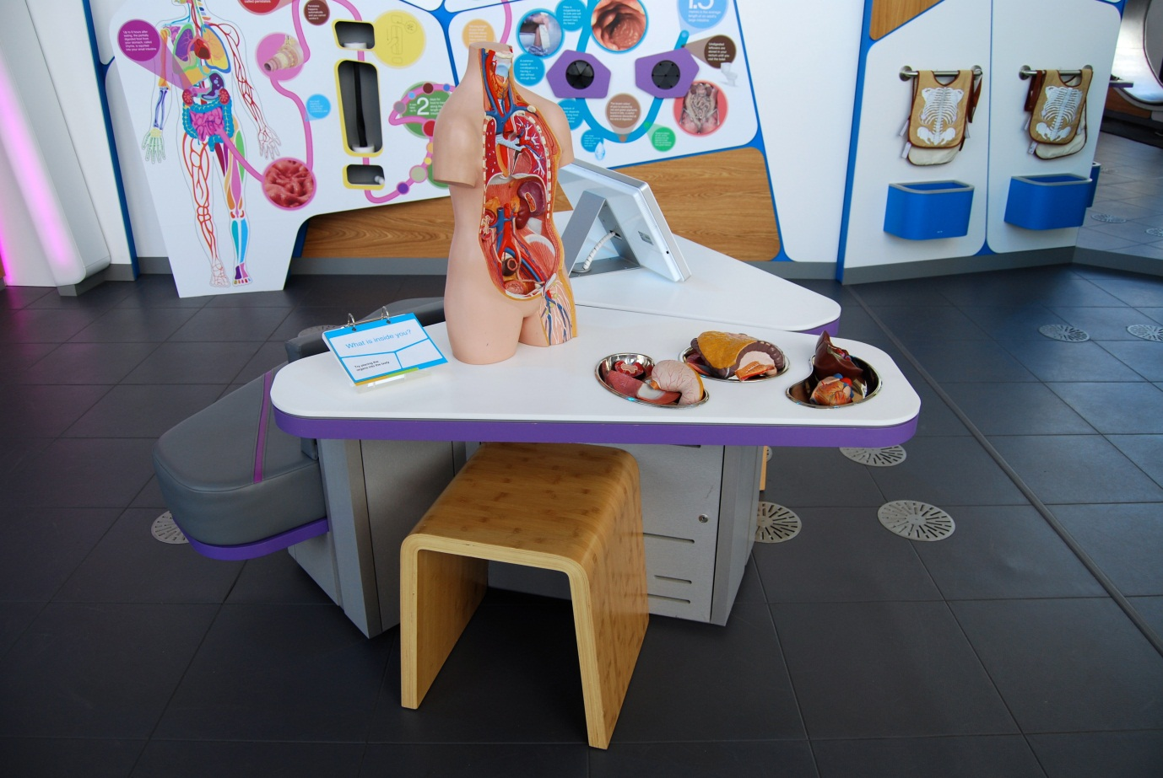

## What is inside you?

Also known as Plastic Torso Model / A3.01

### Description

An exhibit that allows visitors to complete a physical puzzle featuring a life-size plastic torso model with removable organs. It consists of an empty torso, heart, left lung, right lung, right kidney, stomach, liver, intestines, metal bowls, a 3-layer flapper label and moveable stool.

### Visitor experience

The visitor picks up the loose organs and tries to fit them into the correct positions in the empty torso model.

### Visitor interaction tips

* Suggest to visitors that they fill the torso up from the bottom (because the model is mounted vertically).
* Discuss the role of each organ inside the body and how the organs are connected.
* When all organs are in position, point out that the ribcage covers the chest to protect the heart and lungs. Parts of the ribs can be seen on the torso model.

### Accessibility

For visitors unable to use this exhibit, offer to explain how it works before pointing them in the direction of a related exhibit.

### Good to know

Made by the inhouse engineers.

### Daily checks by science communicators

The exhibit components are in good working order.

### Cleaning

Clean the surfaces, bowls and moveable stool with appropriate surface cleaner.

Remember to clean the flapper label.

Dust the torso and organs using a microfibre duster, or appropriate surface cleaner if required.

To polish the bowls, appropriate glass cleaner can be used.

### Risks

See risk assessment in Risk Assessments folder.

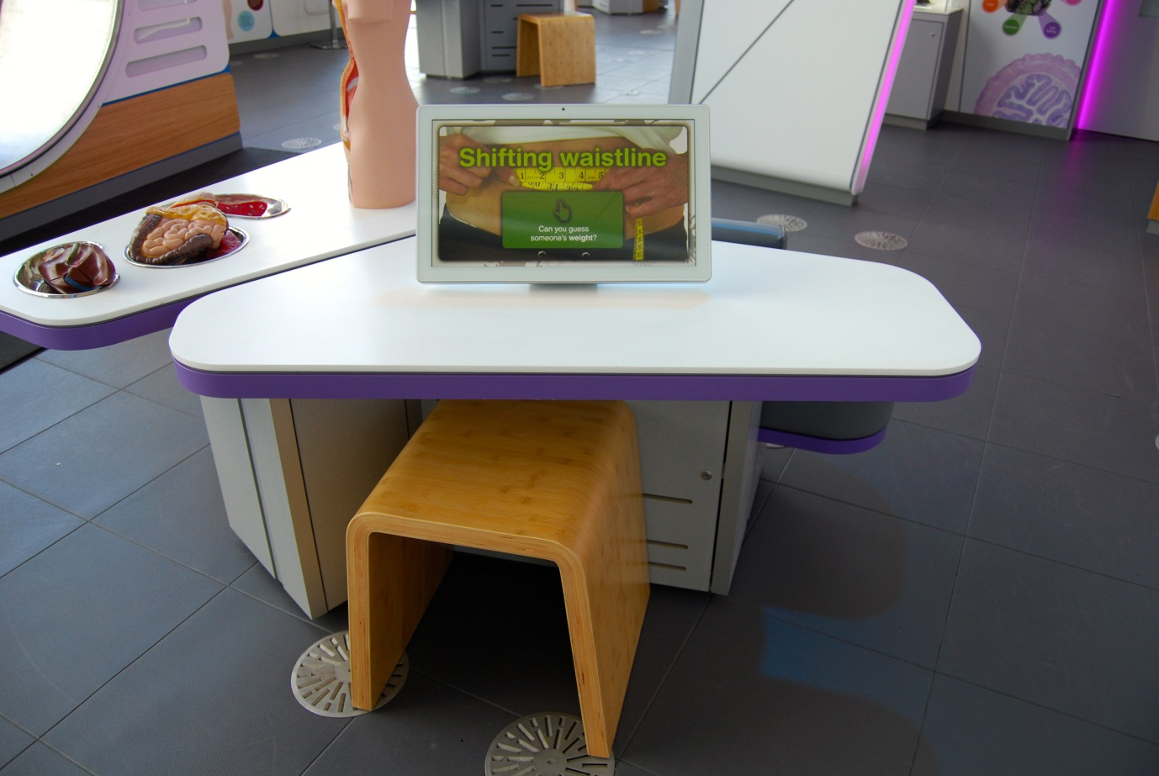

## Shifting Waistline

Also known as A3.15b

### Description

An IT game that allows visitors to test their perceptions of body size against BMI ratings. It consists of a touchscreen and moveable stool.

### Visitor experience

The visitor activates the exhibit by pressing the touchscreen. During the game, the visitor is shown a series of photos of people. For each photo, the visitor selects a rating on a BMI scale. For each photo the real BMI is revealed and shows whether the visitor over- or underestimated the rating.

### Visitor interaction tips

* Offer assistance on how to play the game, as you highlight key learning outcomes tailored to the visitor.
* Suggest related exhibits: ‘If you liked this, you’ll love this’

### Accessibility

For visitors with sight problems, offer assistance with the touchscreen.

For visitors unable to use this exhibit, offer to explain how it works before pointing them in the direction of a related exhibit.

### Good to know

This exhibit is inspired by research at the MRC Social and Public Health Sciences Unit based at the University of Glasgow.

### Daily checks by science communicators

The exhibit components are in good working order.

### Cleaning

Clean the screen with appropriate screen cleaner.

Clean the surfaces and moveable stool with appropriate surface cleaner.

### Risks

See risk assessment in Risk Assessments folder.

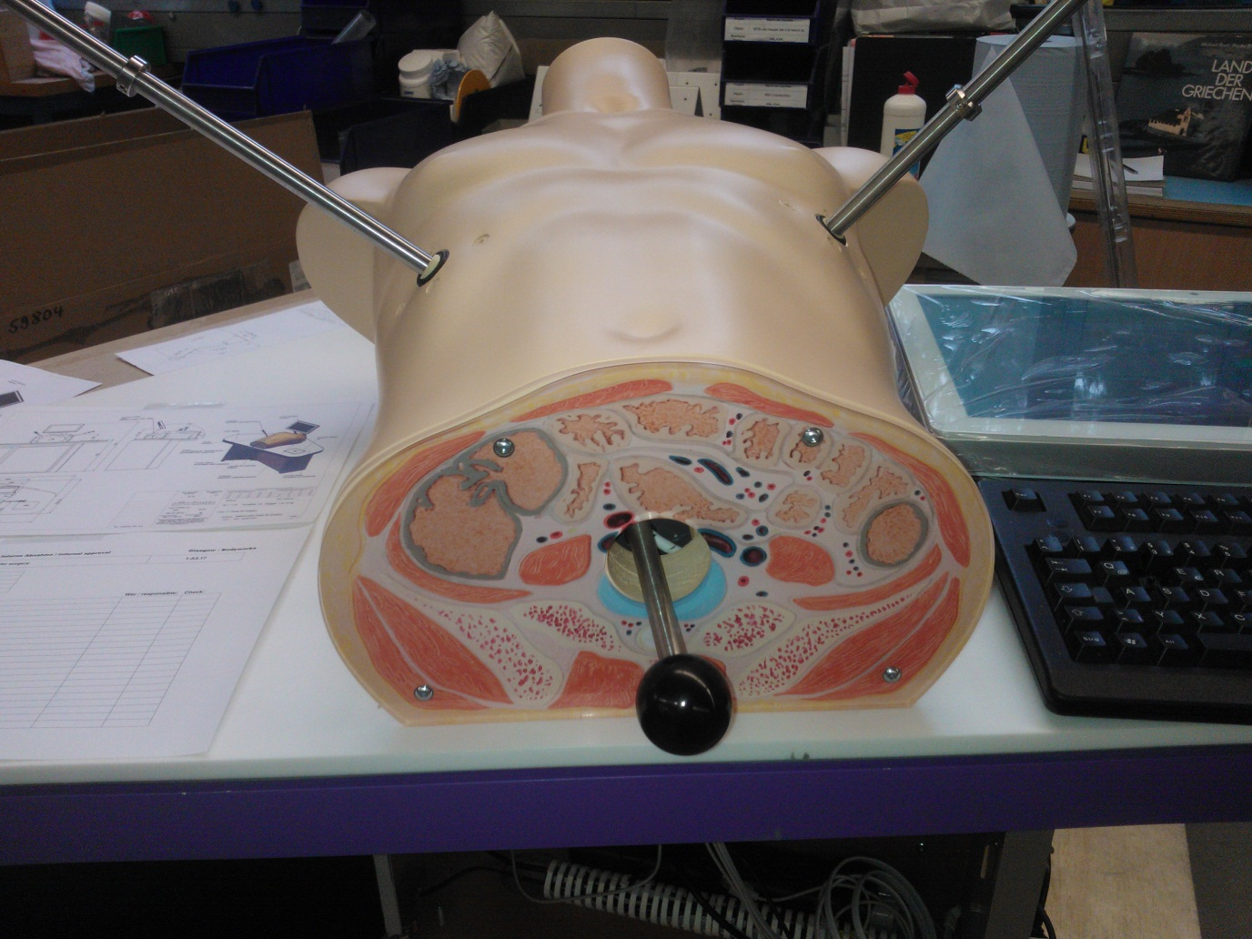

## How good are your surgical skills?

Also known as Keyhole Surgery / Tools for Surgery / A3.17

### Description

An exhibit that allows visitors to complete a simple task using tools similar to those found in keyhole surgery. It consists of a torso model, screen, video camera, two manipulators, marbles and a 3-layer flapper label. The marbles are housed inside the torso and can only be seen by watching the live video feed on the screen. The video camera angle can be adjusted by moving a handle at the end of the torso. The challenge is to scoop up a marble using the manipulators.

### Visitor experience

The visitor holds a manipulator in each hand and moves them in an attempt to scoop up a marble.

### Visitor interaction tips

* Give visitors a time limit to make the challenge more intense. In reality, surgeons work against the clock.
* Suggest related exhibits: ‘If you liked this, you’ll love this’

### Accessibility

For visitors with sight problems, offer assistance with the screen by describing the visitor’s performance and offering suggestions.

For visitors unable to use this exhibit, offer to explain how it works before pointing them in the direction of a related exhibit.

### Good to know

Made by Hüttinger.

### Daily checks by science communicators

The exhibit components are in good working order. In particular:

* A marble is available inside the torso.
* The manipulators are in good condition.

### Cleaning

Clean the screen with appropriate screen cleaner.

Clean the surfaces, handles and moveable stool with appropriate surface cleaner.

Remember to clean the flapper label.

### Risks

See risk assessment in Risk Assessments folder.

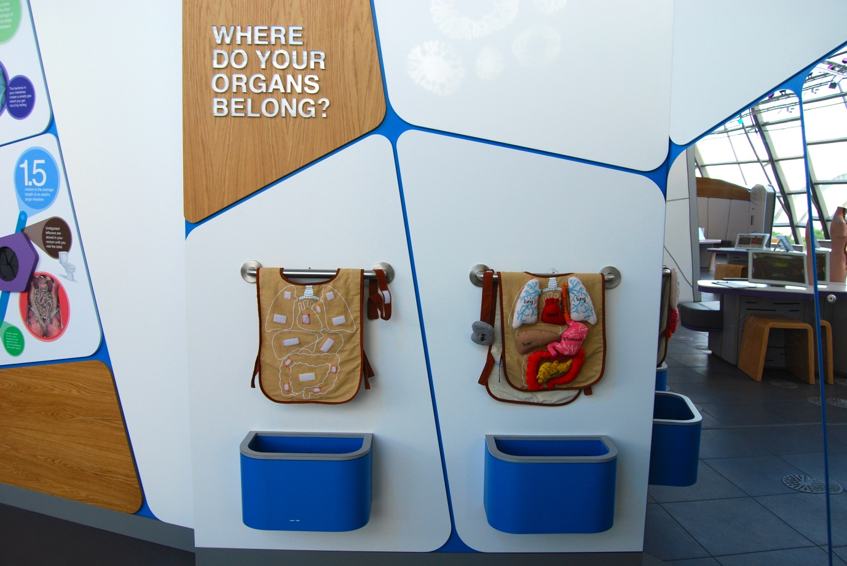

## Where do your organs belong?

Also known as Anato-me Vests / A3.02

### Description

An exhibit that allows visitors to explore the locations of a number of organs of the body. It consists of a vest, headband, and fabric organs: heart, left lung, right lung, right kidney, left kidney, stomach (with oesophagus), small intestine, large intestine and brain. The organs can be attached to the vest or headband using fixed Velcro pieces. There are two sets which are housed in separate wall-mounted storage boxes with a hangar. A large mirror panel allows visitors to see themselves.

### Visitor experience

The visitor puts on a vest and headband. They attach each organ in the correct location. If they are unsure, they can match the shape of each organ with the shapes found on the vest.

### Visitor interaction tips

* Why not act as a guide, helping visitors through the experience and highlighting key learning outcomes tailored to each visitor.
* Use the words on each organ to help children learn the names of organs together with reading them out loud.
* Suggest to visitors that they take a photo or a video of their completed vest.

### Accessibility

For visitors unable to use this exhibit, offer to explain how it works before pointing them in the direction of a related exhibit.

### Good to know

We chose not to use a flapper label with this exhibit.

### Daily checks by science communicators

The exhibit components are in good working order. In particular:

* All the organs, vests and headbands are present and in good condition.

### Cleaning

Clean the mirrors with appropriate glass cleaner.

Clean the surfaces with appropriate surface cleaner.

To remove dust from the boxes, use a vacuum cleaner.

If the organs, vests or headbands look grubby, inform an Exhibit Engineer.

### Risks

See risk assessment in Risk Assessments folder.

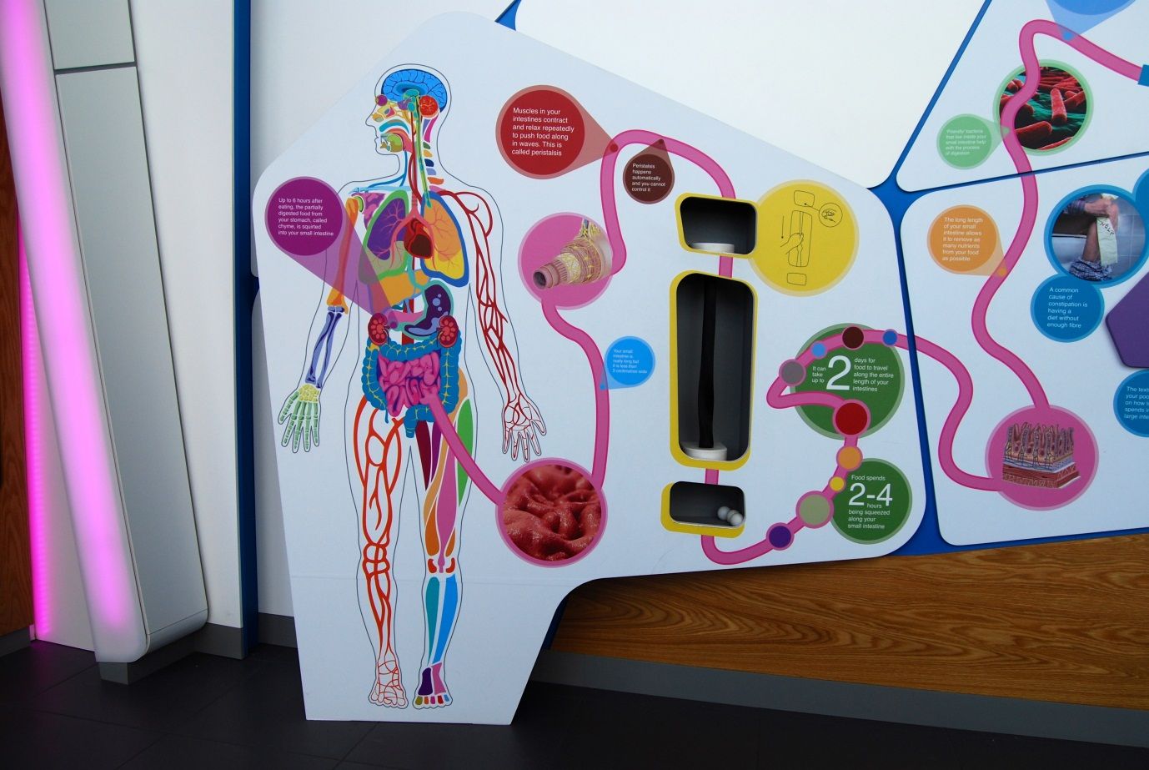

## Intestines – peristalsis

Also known as A3.03b. Previously known as Oesophagus.

### Description

An exhibit that allows visitors to try moving a ball through a tube in a similar fashion to the intestinal actions of peristalsis. It consists of a vertical mesh tube and table tennis balls.

### Visitor experience

The visitor picks up a ball from the recess under the tube and places it in the top of the tube. The visitor moves the ball downwards by squeezing the tube just above the ball.

### Visitor interaction tips

* Highlight to visitors that this is the process that pushes food through your digestive system.
* Suggest related exhibits: ‘If you liked this, you’ll love this’

### Accessibility

For visitors unable to use this exhibit, offer to explain how it works before pointing them in the direction of a related exhibit.

### Good to know

(from wisegeek.com)

The role of peristalsis in the digestive system is that it is the way food is propelled down the oesophagus and into the stomach; then peristalsis moves the digested food through the small and large intestine and then through the rectum and anus. It is a series of smooth muscle contractions and relaxations moving food in a wave-like manner through the different processes in the gastrointestinal tract.

The movement of peristalsis in the digestive system relies on two major reflexes that contract above the food that was swallowed, or bolus, and relax below it.

### Daily checks by science communicators

The exhibit components are in good working order. In particular:

* Ping pong balls are available in the recess.

### Cleaning

Clean the surfaces with appropriate surface cleaner.

Dust the ledges using a microfibre duster or static duster.

### Risks

See risk assessment in Risk Assessments folder.

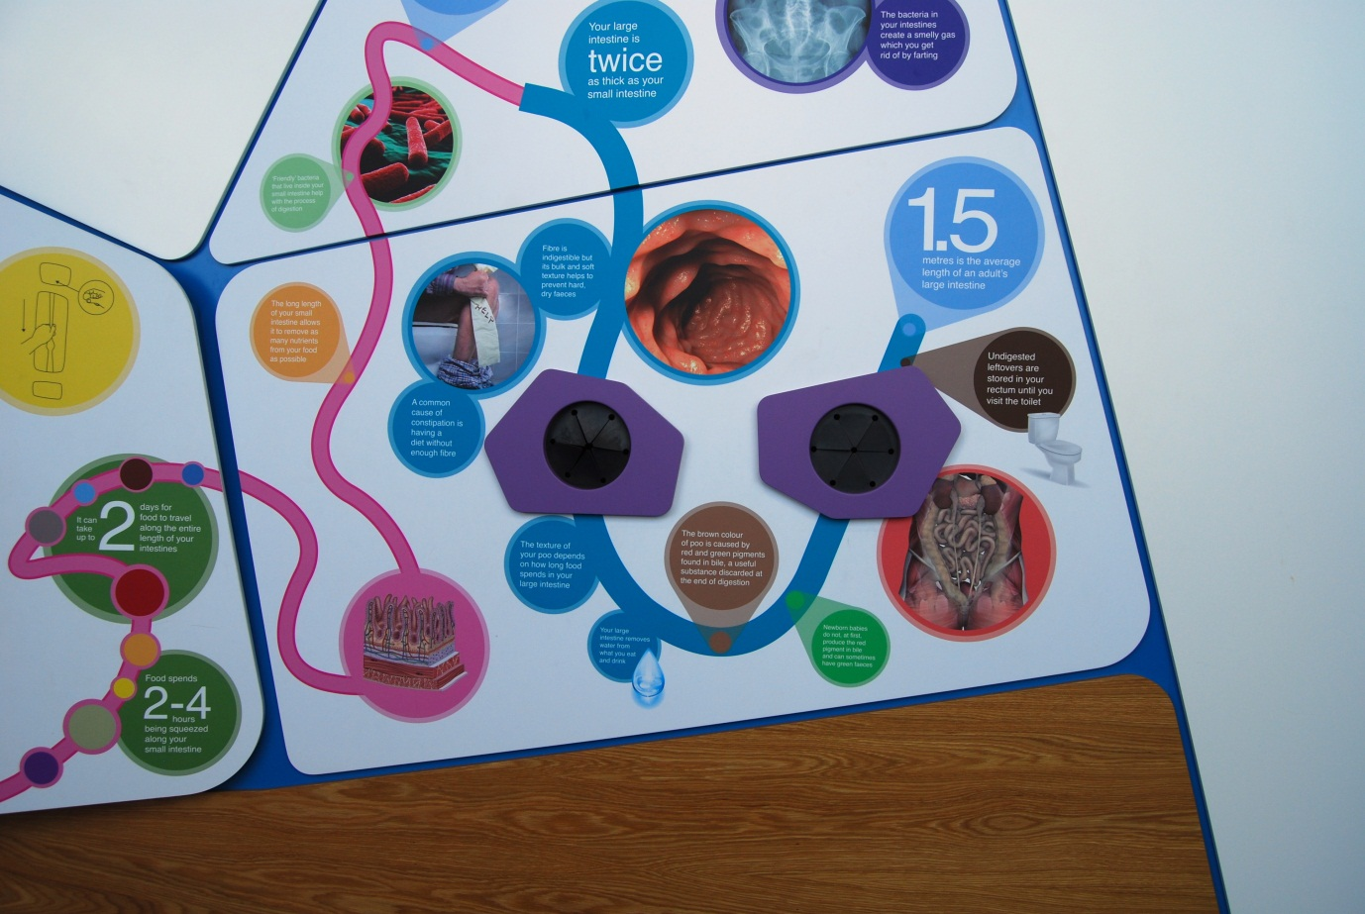

## Intestines – feely boxes

Also known as High Fibre Diet / A3.04

### Description

An exhibit that allows visitors to compare the textures of digested food, one with a high fibre diet and one without. It consists of two squeezable ‘large intestines’ within a feely box.

### Visitor experience

The visitor squeezes the contents of each tube to compare the difference in texture from different diets.

### Visitor interaction tips

* Highlight to visitors that the consistency of their faeces depends on the contents of their diet and how quickly the food passes through their digestive system.
* Suggest related exhibits: ‘If you liked this, you’ll love this’

### Accessibility

For visitors unable to use this exhibit, offer to explain how it works before pointing them in the direction of a related exhibit.

### Good to know

(from Bupa)

Fibre is an essential part of a healthy diet and helps to keep your digestive system in good working order. But many people aren’t getting enough.

Fibre is a type of carbohydrate that is found in all types of plant-based foods, including fruit, vegetables and grains. However, unlike other types of complex carbohydrate, it’s not easily broken down by your digestive system and most of it passes through your body unchanged.

There are two types of fibre – soluble and insoluble. Insoluble fibre passes through your digestive system undigested, whereas soluble fibre is broken down by bacteria in your large bowel.

Fibre is essential to keep your bowel healthy. When fibre passes through your bowel, it absorbs a lot of water and increases the bulk of any waste matter that leaves your body. This makes your faeces softer and easier to pass through your bowel.

### Daily checks by science communicators

The exhibit components are in good working order.

### Cleaning

Clean the surfaces with appropriate surface cleaner.

Dust the ledges using a microfibre duster or static duster.

### Risks

See risk assessment in Risk Assessments folder.



# Getting under your skin Research Capsule

“From dissections to imaging, transplants to research, human bodies have the potential to help others. How are scientists unlocking this life-saving potential?”

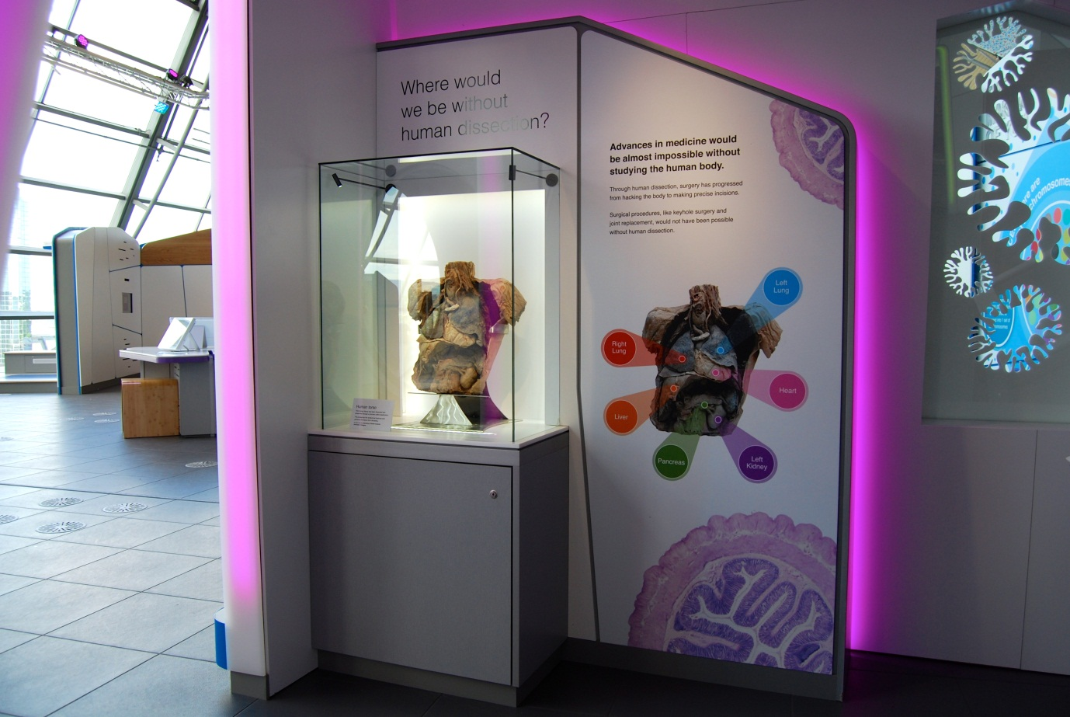

## Human torso

Also known as C3.01

### Description

An exhibit that allows visitors to examine a real human specimen used in medical training. It consists of a specimen of the torso and proximal abdomen housed within a glass display case. The specimen has been dissected and is lit to allow visitors to fully appreciate the intricate detail of the human digestive and respiratory systems. The exhibit, including its location, is designed to be respectful, dignified and give visitors an opportunity for contemplation.

### Visitor experience

Visitors can explore the wonders of the human digestive system by looking at a real human torso. Interpretation on the surrounding wall panels guides the visitor to notice different organs in the torso and describes the importance of body donation to science and medicine.

### Visitor interaction tips

* Why not spark a discussion on donating a body to medical science. Note body donation is different to organ donation, which are used for transplants. Body donation is used for medical science.
* For interested visitors, take out the body donation literature at the end of this folder. Please return the leaflets after use.
* If a visitor asks how they can donate their body to medical science, tell them to contact their local University Medical School.

### Accessibility

For visitors with sight problems, offer to describe the specimen. Borrowing the plastic organs from the nearby torso exhibit will give the visitors a tactile experience as you describe the dissected body.

### Good to know

BodyWorks features three specimens of human tissue. The specimens are all from people who donated their bodies for use in the training of future doctors, dentists, nurses and the allied health professionals.

They are on loan from the Laboratory of Human Anatomy, School of Life Sciences, University of Glasgow where they are used to help students study and understand human anatomy. At the Laboratory is the Museum of Anatomy, which is open to the public.

The specimens in BodyWorks have been created by a process called plastination. This is a process used in anatomy to preserve body parts. Fat and water is replaced in the fixed tissue with polymers like silicone and epoxy. This allows the specimens to be touched and prevents them from decaying and retains many of their original features.

Glasgow Science Centre has permission to display the human material. Permission was sought from Her Majesty’s Inspector for Anatomy Scotland and St Andrew’s House (Scottish Government). As the specimen is from before the 1984 Anatomy Act, there are no restrictions on photography. However we endeavour to display the specimen in a sensitive manner with the utmost respect.

### Daily checks by science communicators

The exhibit components are in good working order. In particular:

* The surrounding area is clean and respectful.

### Cleaning

Clean the glass with appropriate glass cleaner.

Clean the surfaces with appropriate surface cleaner.

Dust the ledges using a microfibre duster or static duster.

### Risks

See risk assessment in Risk Assessments folder.

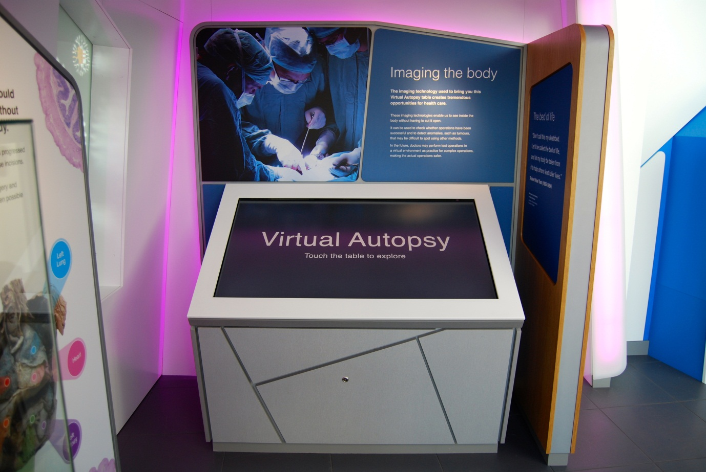

## Virtual Autopsy: What lies hidden under the skin?

Also known as Virtual Autopsy Table / C3.03

### Description

An exhibit that allows visitors to explore the inside of three humans through medical visualisation tools. It consists of a 55” multitouch screen mounted at an angle against a wall. The scans were taken of real people using Computed Tomography (CT) technology.

### Visitor experience

The visitor activates the exhibit by pressing the touchscreen. They are given the choice of three specimens to examine. The visitor can view different layers of the body (such as bones, fat, gas) by pressing a button along the bottom of the screen. The visitor can move and rotate the specimen using a finger and zoom in and out using two fingers. A sectioning tool allows visitors to slice through the body. Information points are found through the specimens and are opened by pressing an ‘i’ symbol. A home button at the bottom left resets the exhibit.

### Visitor interaction tips

* Compare the different ways of learning from real bodies, which are illustrated in the capsule with this exhibit (3D scans) and the *Human torso* (dissection).
* Offer assistance on how to play the game, as you highlight key learning outcomes tailored to the visitor.
* Suggest related exhibits: ‘If you liked this, you’ll love this’

### Accessibility

For visitors with sight problems, offer assistance with the touchscreen.

For visitors unable to use this exhibit, offer to explain how it works before pointing them in the direction of a related exhibit.

### Good to know

(from press release)

The visualization system is developed by Interactive Institute Swedish ICT, Visualization Center C and CMIV, and this is the first permanent installation of an Inside Explorer Virtual Autopsy table in the UK.

Inside Explorer is a powerful visualization system that gives visitors to museums and science centres the chance to virtually interact with subjects that have been scanned using medical imaging systems such as Computer Tomography (CT) or Magnetic Resonance Imaging (MRI). A large interactive touch screen enables visitors to enlarge, rotate and virtually dissect different examples on the table and explore them in intricate detail.

Originally developed to support forensic autopsy work, the first prototype of the Virtual Autopsy Table was developed in 2009. Now universities and hospitals use it for educational purposes as well in preparation for performing physical autopsies.

Today, the visualization system has found a new user base by providing amazing visualization experiences to visitors at science centres and museums. Anything that can be scanned can also be visualized, explored and used as basis for an interactive visitor experience – from meteorites to ancient mummies. The system requires no training, and visitors can interact with it in seconds. More than 10 institutions are now actively involved worldwide in using Inside Explorer, including the British Museum, London’s Natural History Museum, the Singapore Science Centre, the Field Museum in Chicago, and the National Museum of Science and Technology in Stockholm.

### Daily checks by science communicators

The exhibit components are in good working order.

### Cleaning

Clean the screen with appropriate screen cleaner.

Clean the surfaces with appropriate surface cleaner.

Dust the ledges using a microfibre duster or static duster.

### Risks

See risk assessment in Risk Assessments folder.

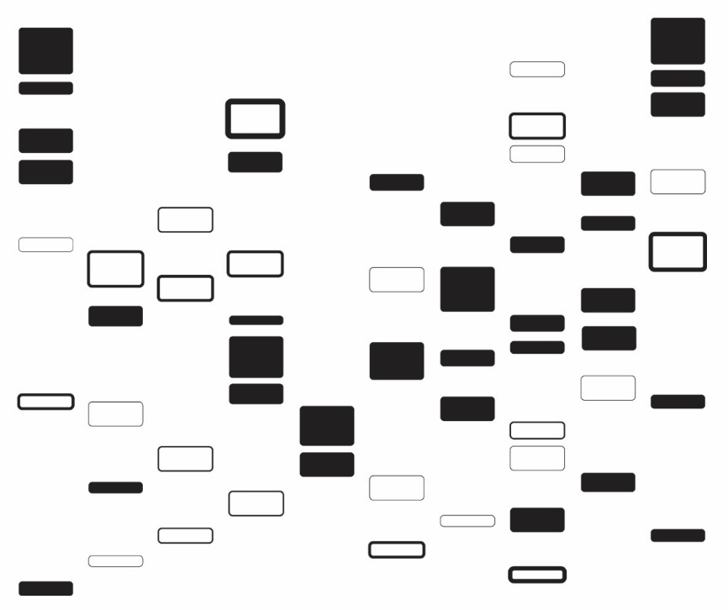

# DNA & Cell Biology exhibits

“Your DNA contains all of your genetic information, but how does it store it and how can it be used to prove your identity?”

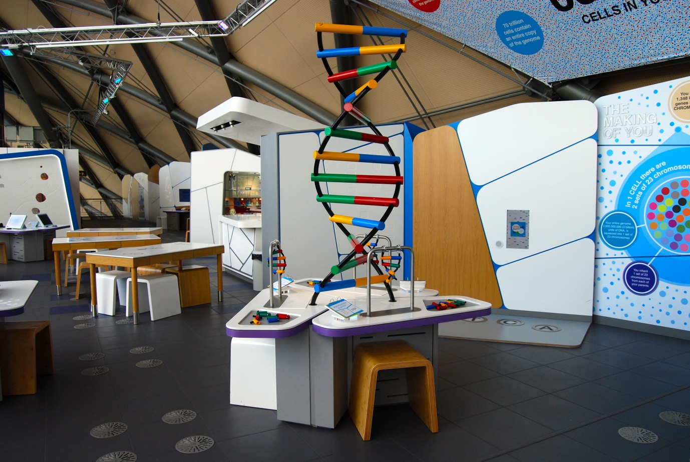

## What is the structure of your DNA?

Also known as Giant DNA Model / DNA Construction Stations / A4.03a+b

### Description

An exhibit that allows visitors to view and construct a model of a double helix DNA molecule. It consists of a large scale model in the centre of three workstations containing hands-on, magnetic pieces. Each workstation has a metal frame, around a dozen loose pieces, a 3-layer flapper label and a moveable stool.

### Visitor experience

The visitor picks up the loose pieces and attempts to attach them together. The pieces are magnetic and only attach in a particular way. The visitor attempts to produce a small version of the large DNA model by assembling the pieces onto the frame.

### Visitor interaction tips

* Offer assistance on how to attach the pieces together.
* Highlight key learning outcomes tailored to each visitor.
* Suggest related exhibits: ‘If you liked this, you’ll love this’

### Accessibility

For visitors unable to use this exhibit, offer to explain how it works before pointing them in the direction of a related exhibit.

### Good to know

Made by Hüttinger. Original construction station designs from W19 designs.

### Daily checks by science communicators

The exhibit components are in good working order. In particular:

* There are plenty of DNA base pieces available.

### Cleaning

Clean the surfaces, DNA base pieces, moveable stools with appropriate surface cleaner.

Remember to clean the flapper labels.

Dust the giant DNA model using a microfibre duster or static duster.

### Risks

See risk assessment in Risk Assessments folder.

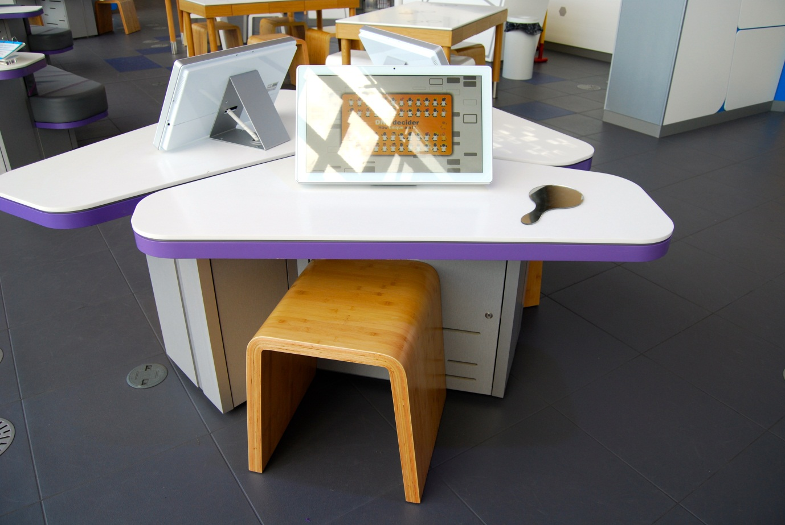

## DNA Decider: How unique are you?

Also known as A4.01

### Description

An IT game that allows visitors to discover how many other visitors share a range of physical attributes with them. It consists of a touchscreen, mirror and moveable stool.

### Visitor experience

The visitor activates the exhibit by pressing the touchscreen. The visitor answers 8 questions about themselves, such as eye and hair colour. The mirror is available for visitors who wish to check their traits against the options. After each question the visitor is told how many other visitors have answered the same way. In addition a cartoon character reflects their answers in a visual way. At the end, the visitor finds out how many other visitors are like them.

### Visitor interaction tips

* Offer assistance on how to play the game, as you highlight key learning outcomes tailored to the visitor.
* Suggest related exhibits: ‘If you liked this, you’ll love this’

### Accessibility

For visitors with sight problems, offer assistance with the touchscreen.

For visitors unable to use this exhibit, offer to explain how it works before pointing them in the direction of a related exhibit.

### Good to know

We each receive one copy of our genome from each of our parents, so the instructions (the genes) that make you come from both of these. For some genes there are lots of different variants available, just like there are lots of different words with the same meaning in a thesaurus. In a population of people there might be several different genes for skin colour for example. This creates a range of skin colours in the population. These different versions of genes are called alleles. We each inherit two alleles for every gene, one from each parent. Some of the phenotypes (physical outcomes of the genome plus environment including height, eye colour and every other characteristic) that make us unique are multifactorial. This means they are dependent on a number of factors. There might be multiple genes involved, as is the case with hair colour, and there might also be influence from the environment as is the case with handedness.

### Daily checks by science communicators

The exhibit components are in good working order. In particular:

* The mirror is intact and not badly scratched.

### Cleaning

Clean the screen with appropriate screen cleaner.

Clean the surfaces and moveable stool with appropriate surface cleaner.

Clean the mirror with appropriate glass cleaner.

### Risks

See risk assessment in Risk Assessments folder.

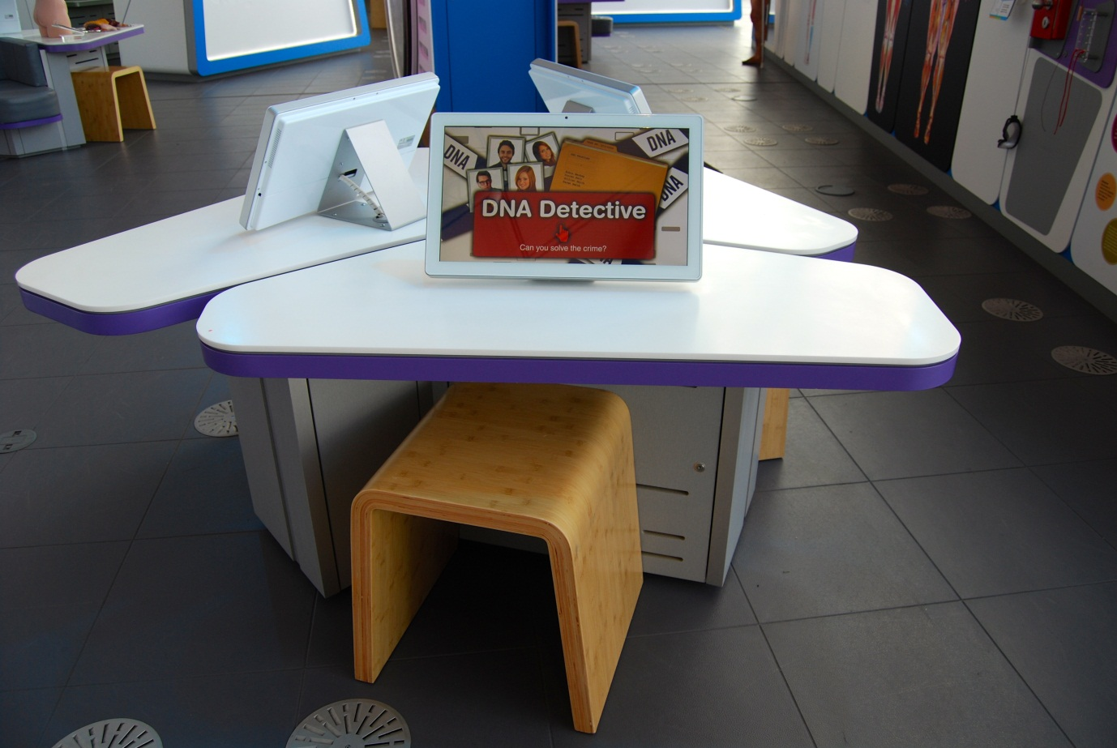

## DNA Detective: Can you solve the crime?

Also known as A4.05

### Description

An IT game that allows visitors to solve a crime using DNA and other evidence. It consists of a touchscreen and moveable stool.

### Visitor experience

The visitor activates the exhibit by pressing the touchscreen. In the game, the visitor takes on the role of a Crime Scene Investigator and is guided through the stages of collecting evidence and analysing the samples. The visitor must eliminate suspects and find the guilty person.

### Visitor interaction tips

* Offer assistance on how to play the game, as you highlight key learning outcomes tailored to the visitor.
* Suggest related exhibits: ‘If you liked this, you’ll love this’

### Accessibility

For visitors with sight problems, offer assistance with the touchscreen.

For visitors unable to use this exhibit, offer to explain how it works before pointing them in the direction of a related exhibit.

### Good to know

In this exhibit, we were keen to show that DNA evidence must be used together with other forms of evidence. This is why we included identical twins who have the same DNA but different fingerprints.

### Daily checks by science communicators

The exhibit components are in good working order.

### Cleaning

Clean the screen with appropriate screen cleaner.

Clean the surfaces and moveable stool with appropriate surface cleaner.

### Risks

See risk assessment in Risk Assessments folder.

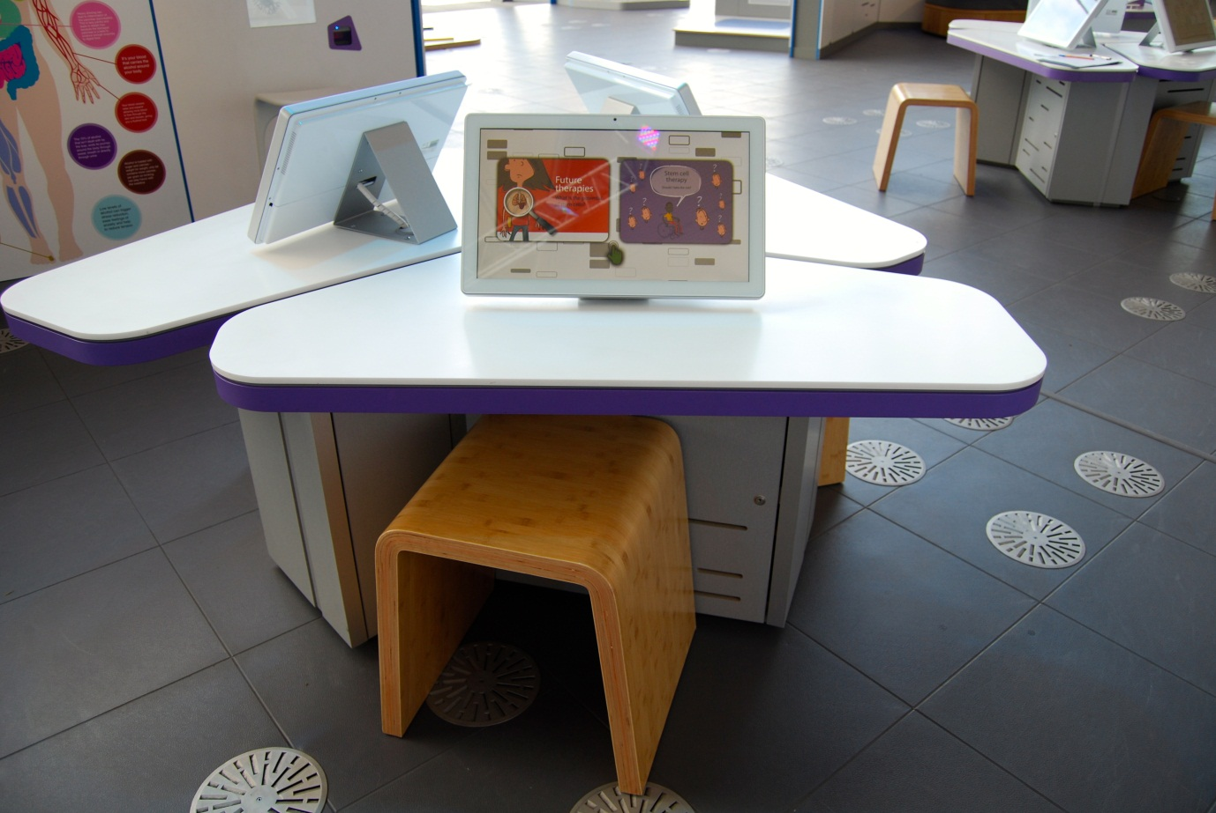

## Future Therapies: What is the potential of stem cells?

Also known as A4.09

### Description

An IT game that allows visitors to explore the recent and potential advances in stem cell treatments. It consists of a touchscreen and moveable stool.

### Visitor experience

The visitor activates the exhibit by pressing the touchscreen. They can select from two options. ‘Stem cell stories’ allows visitors to find out about current treatments and clinical trials. ‘Dilemma’ allows visitors to explore the pitfalls and veracity of stem cell treatments that are currently sold online.

### Visitor interaction tips

* Offer assistance on how to play the game, as you highlight key learning outcomes tailored to the visitor.
* Suggest related exhibits: ‘If you liked this, you’ll love this’

### Accessibility

For visitors with sight problems, offer assistance with the touchscreen.

For visitors unable to use this exhibit, offer to explain how it works before pointing them in the direction of a related exhibit.

### Good to know

This exhibit features two exhibits produced by the Scottish Stem Cell Network. Before BodyWorks they were available to visitors in Floor 2, Science in the Dock.

### Daily checks by science communicators

The exhibit components are in good working order.

### Cleaning

Clean the screen with appropriate screen cleaner.

Clean the surfaces and moveable stool with appropriate surface cleaner.

### Risks

See risk assessment in Risk Assessments folder.

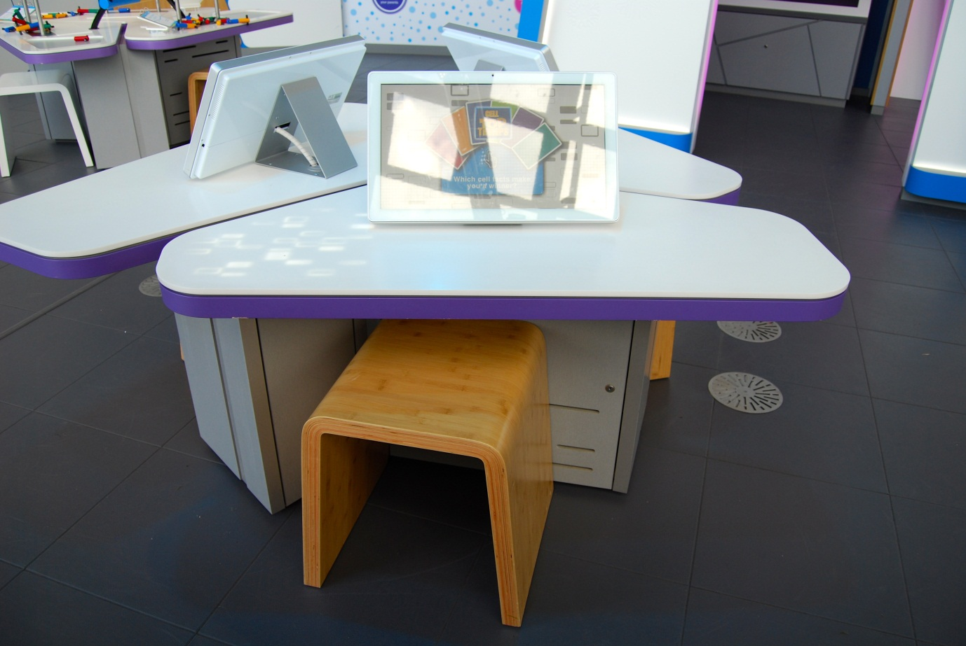

## Cell Top Trumps: Can you beat the computer?

Also known as A4.06

### Description

An IT game that allows visitors to play a virtual version of Top Trumps™ on the topic of human cells. It consists of a touchscreen and moveable stool. In the game, the visitor plays against the computer.

### Visitor experience

The visitor activates the exhibit by pressing the touchscreen. Virtual cards are shuffled between the visitor and the computer opponent. Each card features categories of information on a type of human cell. The visitor selects a category they feel would ‘trump’ the same category on the opponent’s card. The aim of the game is to win all the available cards.

### Visitor interaction tips

* Offer assistance on how to play the game, as you highlight key learning outcomes tailored to the visitor.
* Suggest related exhibits: ‘If you liked this, you’ll love this’

### Accessibility

For visitors with sight problems, offer assistance with the touchscreen.

For visitors unable to use this exhibit, offer to explain how it works before pointing them in the direction of a related exhibit.

### Good to know

The trademark holders of Top Trumps, Winning Moves, gave GSC permission to create this exhibit and feature the Top Trumps name.

### Daily checks by science communicators

The exhibit components are in good working order.

### Cleaning

Clean the screen with appropriate screen cleaner.

Clean the surfaces and moveable stool with appropriate surface cleaner.

### Risks

See risk assessment in Risk Assessments folder.

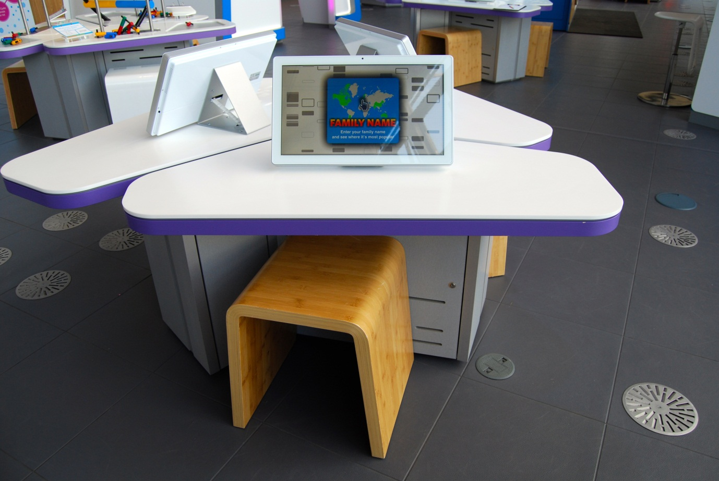

## Family Name: Which is your family name most popular?

Also known as A4.07

### Description

An IT game that allows visitors to explore the relative frequency of different names across the world. It consists of a touchscreen and moveable stool. The exhibit allows visitors to consider the analogous spread of genes across the world.

### Visitor experience

The visitor activates the exhibit by pressing the touchscreen. The visitor types in a family name using the on-screen keyboard and a world map displays the relative frequency of that name using colours. The visitor is able to tap on a country to zoom in to see more detail.

### Visitor interaction tips

* Offer assistance on how to play the game, as you highlight key learning outcomes tailored to the visitor.
* Suggest related exhibits: ‘If you liked this, you’ll love this’

### Accessibility

For visitors with sight problems, offer assistance with the touchscreen.

For visitors unable to use this exhibit, offer to explain how it works before pointing them in the direction of a related exhibit.

### Good to know

Data is only available for 29 countries across the world. This is why some countries are blank.

For a more in-depth look at the spread of names across the UK over time, go to <http://gbnames.publicprofiler.org/>

### Daily checks by science communicators

The exhibit components are in good working order.

### Cleaning

Clean the screen with appropriate screen cleaner.

Clean the surfaces and moveable stool with appropriate surface cleaner.

### Risks

See risk assessment in Risk Assessments folder.

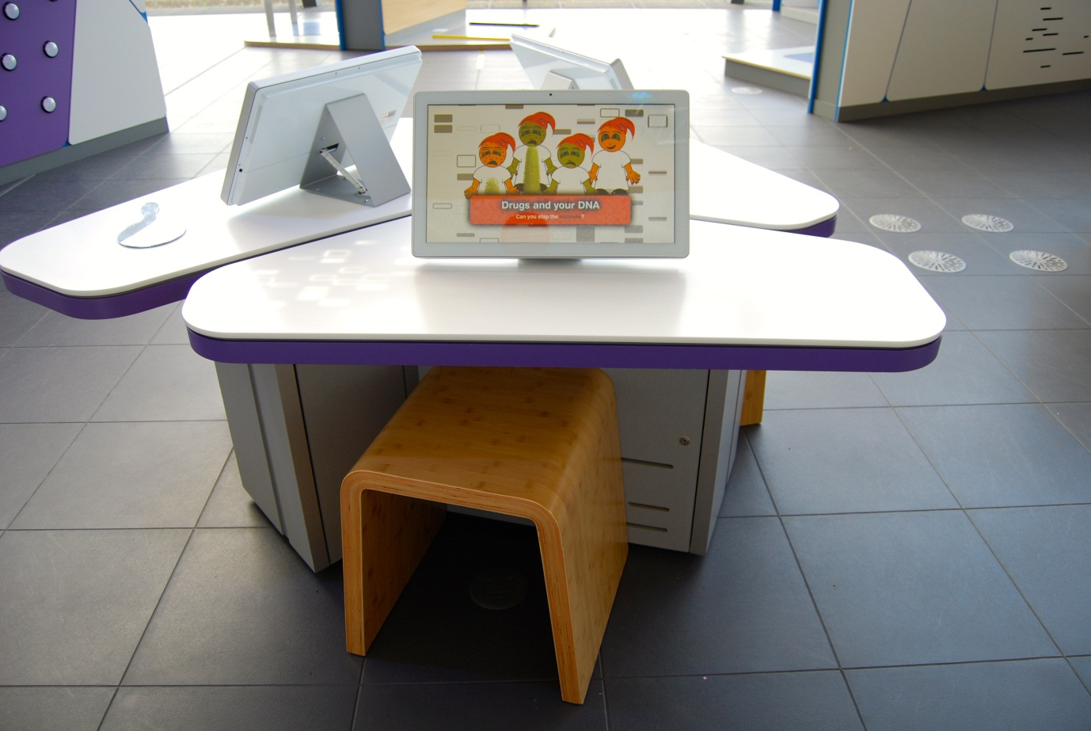

## Drugs and your DNA: Can you stop the outbreak?

Also known as You’re the Doctor, You Decide / A4.10

### Description

An IT game that allows visitors to combat an imaginary disease using the emerging tools of personalised medicine. It consists of a touchscreen and moveable stool.

### Visitor experience

The visitor activates the exhibit by pressing the touchscreen. The visitor takes on the role of a doctor and must decide which patients should receive particular drugs. When each patient’s genetic information is known, the visitor can pair them up with personalised medicine to increase the odds of beating the imaginary disease.

### Visitor interaction tips

* Offer assistance on how to play the game, as you highlight key learning outcomes tailored to the visitor.
* Suggest related exhibits: ‘If you liked this, you’ll love this’

### Accessibility

For visitors with sight problems, offer assistance with the touchscreen.

For visitors unable to use this exhibit, offer to explain how it works before pointing them in the direction of a related exhibit.

### Good to know

(From Cancer Research UK)

Personalised medicine is about matching patients with the treatments that will work best for them. It could transform the lives of cancer patients in the UK. The ultimate aim is to treat every patient as an individual, but this vision is still some way off.

No two cancers are the same. This is because the molecular characteristics of a cancer vary from one patient to the next. So, even patients with the same type of cancer will respond differently to treatment – not just cancer drugs, but often radiotherapy and surgery too. The first step towards personalised medicine is to group together patients whose cancers have similar characteristics and to treat them accordingly.

Cancer Research UK is leading the way towards an era of personalised medicine. Our research spans many areas of cancer – from hunting for faulty genes and other molecular markers to guide treatment decisions, through to developing new targeted treatments, and using the latest imaging technologies to see how patients are responding to treatment.

### Daily checks by science communicators

The exhibit components are in good working order.

### Cleaning

Clean the screen with appropriate screen cleaner.

Clean the surfaces and moveable stool with appropriate surface cleaner.

### Risks

See risk assessment in Risk Assessments folder.

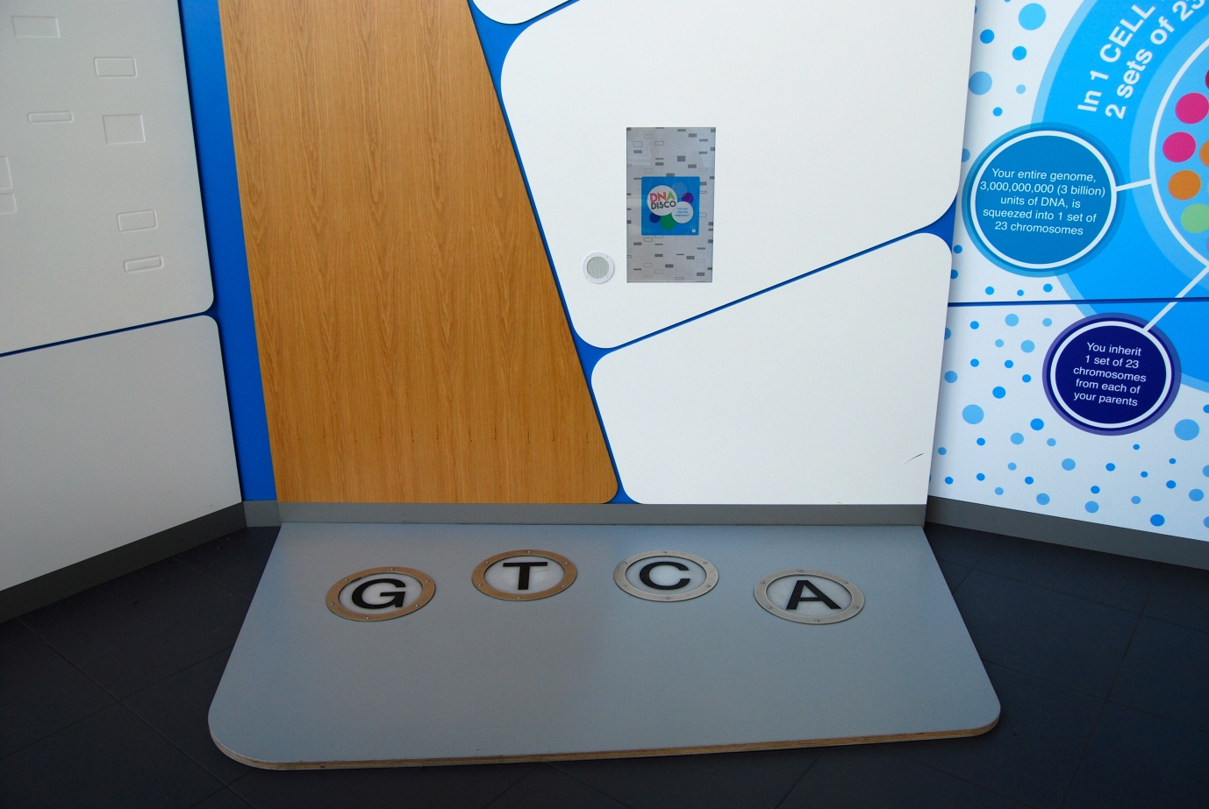

## DNA Disco: Can you copy the sequence?

Also known as A4.08

### Description

An exhibit that allows visitors to copy out a sequence of DNA bases by pressing four pressure-sensitive floor tiles. It consists of four LED-lit pressure pads on a raised platform, wall-mounted touchscreen and speaker. The four bases of DNA (C, A, T and G) are represented by a floor tile.

### Visitor experience

The visitor activates the exhibit by pressing the touchscreen. During the game, a series of letters appear on the screen and the visitor is challenged to press the matching floor tiles. The game lasts 30 seconds and at the end the visitor is given a score, calculated from the numbers of correct and incorrect presses.

### Visitor interaction tips

* Offer assistance on how to play the game, as you highlight key learning outcomes tailored to the visitor.
* Suggest related exhibits: ‘If you liked this, you’ll love this’

### Accessibility

For visitors with sight problems, offer assistance with the touchscreen and the pressure tiles.

For visitors unable to use this exhibit, offer to explain how it works before pointing them in the direction of a related exhibit.

### Good to know

Made by Hüttinger.

### Daily checks by science communicators

The exhibit components are in good working order. In particular:

* The pressure tiles are intact.

### Cleaning

Clean the screen with appropriate screen cleaner.

Clean the surfaces with appropriate surface cleaner.

Clean the raised platform with a broom and dustpan & brush.

### Risks

See risk assessment in Risk Assessments folder.



# Reproduction exhibits

“We are all part of the circle of life, but what happens to our bodies as we reproduce, mature, age and finally die?”

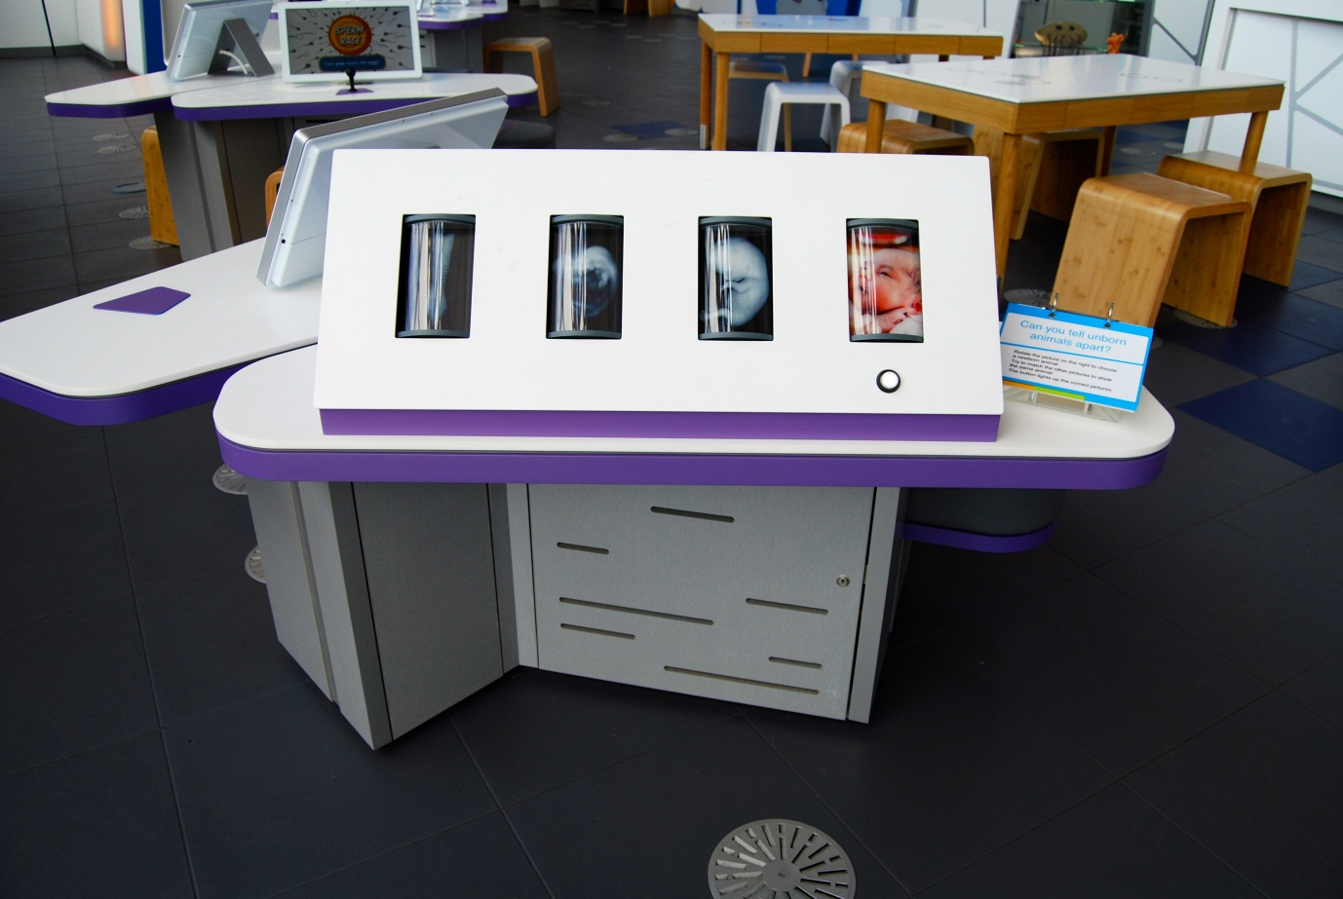

## Can you tell unborn animals apart?

Also known as Find the Human / A5.15

### Description

An exhibit that allows visitors to try matching up the different stages of embryonic development for a human, bat, chicken and mouse. It consists of a row of four rotatable drums containing images, a button and a 3-layer flapper label. Each drum contains four images. Each drum represents a different time point in the development of the animals. The button illuminates the images that match the one on display in the far-right drum.

### Visitor experience

The visitor chooses an animal by rotating the drum on the far right. They then proceed to find the remaining images of the same species. Pressing the button reveals the answer. The visitor discovers that the animals look similar in the early stages of embryonic development, making the game difficult.

### Visitor interaction tips

* Offer assistance on how to use the exhibit, from selecting a newborn animal to matching up the embryos.
* Highlight key learning outcomes tailored to the visitor.

### Accessibility

For visitors with sight problems, offer assistance by describing the images.

For visitors unable to use this exhibit, offer to explain how it works before pointing them in the direction of a related exhibit.

### Good to know

Images donated by the University of Dundee.

### Daily checks by science communicators

The exhibit components are in good working order.

### Cleaning

Clean the surfaces and moveable stool with appropriate surface cleaner.

Remember to clean the flapper label and the table behind the purple housing.

### Risks

See risk assessment in Risk Assessments folder.

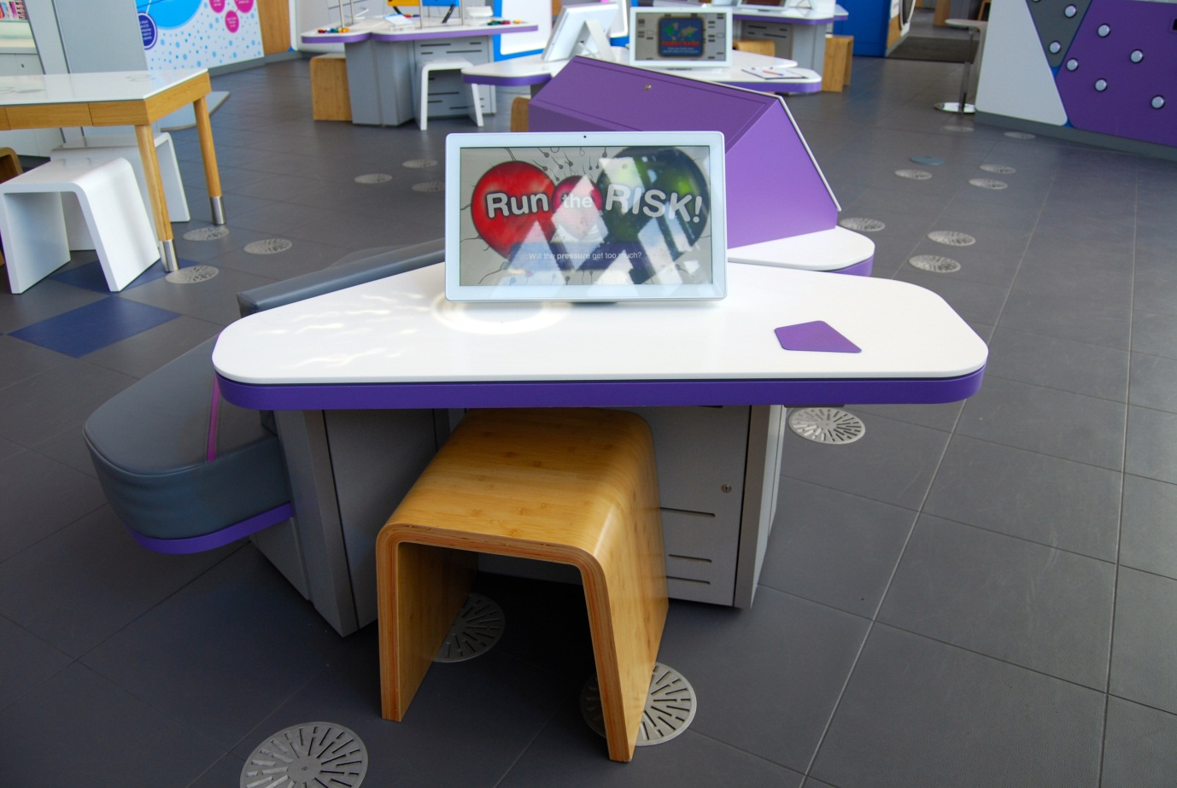

## Run the Risk: Will the pressure get too much?

Also known as Balloon Risk Game / A5.07

### Description

An IT game that allows visitors to complete a decision-making test based on the Balloon Analogue Risk Task. It consists of a touchscreen and moveable stool.

### Visitor experience

The visitor activates the exhibit by pressing the touchscreen. During the game the visitor inflates a virtual balloon by pressing an inflate button. As the balloon is inflated, the number of potential points increases. The visitor can collect the points by pressing a button. The balloon bursts after a random number of inflations and the potential points are lost. The challenge is to balance inflating the balloon and collecting the points to maximise the collected points. At the end, the visitor is given their result in context of previous visitors’ results.

### Visitor interaction tips

* Offer assistance on how to play the game, as you highlight key learning outcomes tailored to the visitor.
* Suggest related exhibits: ‘If you liked this, you’ll love this’

### Accessibility

For visitors with sight problems, offer assistance with the touchscreen.

For visitors unable to use this exhibit, offer to explain how it works before pointing them in the direction of a related exhibit.

### Good to know

(From the International Society for Research on Impulsivity)

The Balloon Analogue Risk Task (BART) is a computerized measure of risk taking behaviour. The BART models real-world risk behaviour through the conceptual frame of balancing the potential for reward versus loss. In the task, the participant is presented with a balloon and offered the chance to earn money by pumping the balloon up by clicking a button. Each click causes the balloon to incrementally inflate and money to be added to a counter up until some threshold, at which point the balloon is over inflated and explodes. Thus, each pump confers greater risk, but also greater potential reward. If the participant chooses to cash-out prior to the balloon exploding then they collect the money earned for that trail, but if balloon explodes earnings for that trial are lost. Participants are not informed about the balloons breakpoints; the absence of this information allows for testing both participants' initial responses to the task and changes in responding as they gain experience with the task contingencies. Risk taking is a related, but phenomenologically distinct process from impulsivity.

### Daily checks by science communicators

The exhibit components are in good working order.

### Cleaning

Clean the screen with appropriate screen cleaner.

Clean the surfaces and moveable stool with appropriate surface cleaner.

### Risks

See risk assessment in Risk Assessments folder.

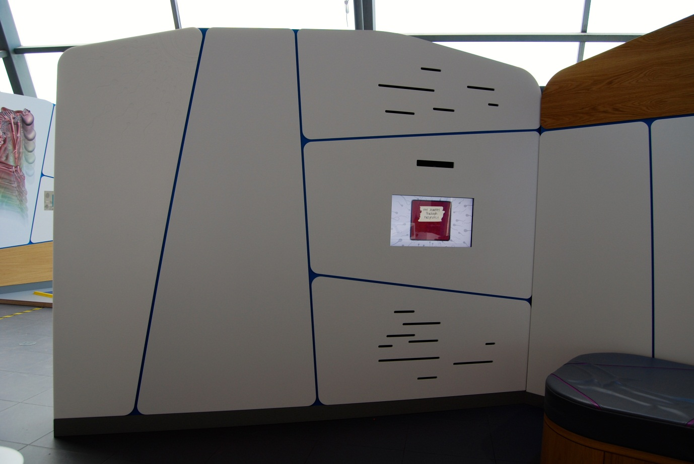

## My Journey through Pregnancy

Also known as Pregnancy Diary / A5.01b

### Description

An information screen that allows visitors to explore the different stages of pregnancy from the perspective of the mother. It consists of a wall-mounted touchscreen and speaker.

### Visitor experience

The visitor activates the exhibit by pressing the touchscreen. The visitor is presented with an interactive, multimedia diary containing text, images and videos. The content covers the effects of pregnancy on the mother’s body both from her perspective and from the science behind each change.

### Visitor interaction tips

* Why not use the pregnancy suits BodyWorks busking activity and relate the impacts of pregnancy to the content in this exhibit.
* Offer assistance on how to explore the multimedia diary, as you highlight key learning outcomes tailored to the visitor.
* Suggest related exhibits: ‘If you liked this, you’ll love this’

### Accessibility

For visitors with sight problems, offer assistance with the touchscreen.

For visitors unable to use this exhibit, offer to explain how it works before pointing them in the direction of a related exhibit.

### Good to know

All the expectant mothers featured in this exhibit volunteered their time for this exhibit. GSC supplied them with video cameras and the mothers recorded video diaries throughout their pregnancy.

Looking for more information aimed at expectant mothers? There’s a copy of *Ready, Steady, Baby* in the Floor 3 cupboard.

### Daily checks by science communicators

The exhibit components are in good working order.

### Cleaning

Clean the screen with appropriate screen cleaner.

Clean the surfaces with appropriate surface cleaner.

### Risks

See risk assessment in Risk Assessments folder.

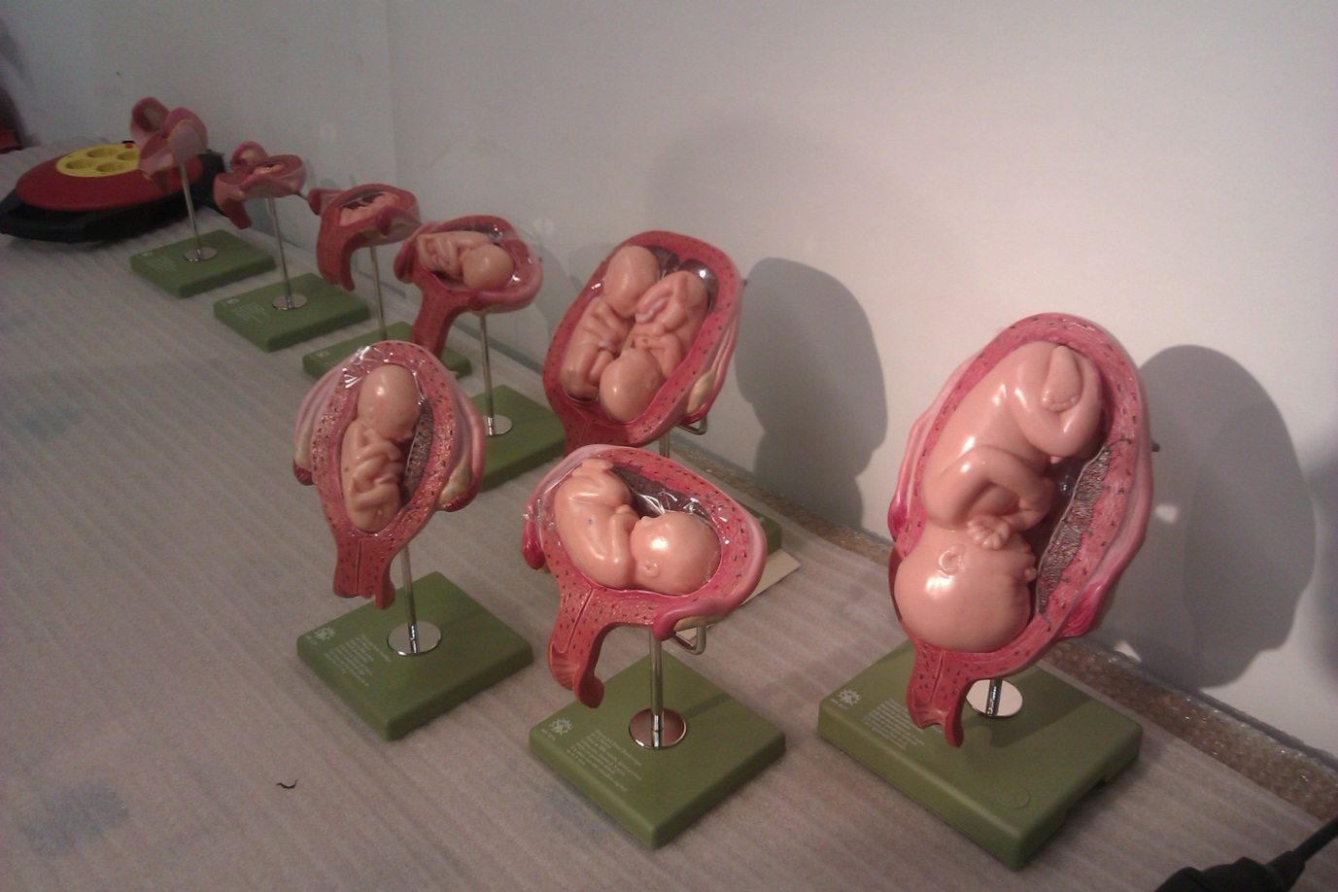

## How does a baby grow?

Also known as Foetal Models / A5.01a

### Description

An exhibit that allows visitors to view and hold model foetuses at different stages of development inside the womb. It consists of three cut-outs on the wall representing a pregnant woman where the wombs are recesses that hold physical models of the foetus. The models are attached to wall by cords that also represent the umbilical cords. The model foetuses are the real size and weight according to their developmental age. The exhibit is accompanied by a 3-layer flapper label.

### Visitor experience

The visitor can look at and lift out the physical models.

### Visitor interaction tips

* Why not use the pregnancy suits BodyWorks busking activity and relate the impacts of pregnancy to the content in this exhibit.
* Point out the impacts on the mother’s body caused by the growing baby as her organs move and get squashed.
* Discuss how a growing baby survives without eating or breathing.

### Accessibility

For visitors unable to use this exhibit, offer to explain how it works before pointing them in the direction of a related exhibit.

### Good to know

Made by Hüttinger.

### Daily checks by science communicators

The exhibit components are in good working order. In particular:

* The model foetuses are in good condition.
* The model foetuses are securely attached to the housing.

### Cleaning

Clean the surfaces with appropriate surface cleaner.

Remember to clean the flapper label.

### Risks

See risk assessment in Risk Assessments folder.

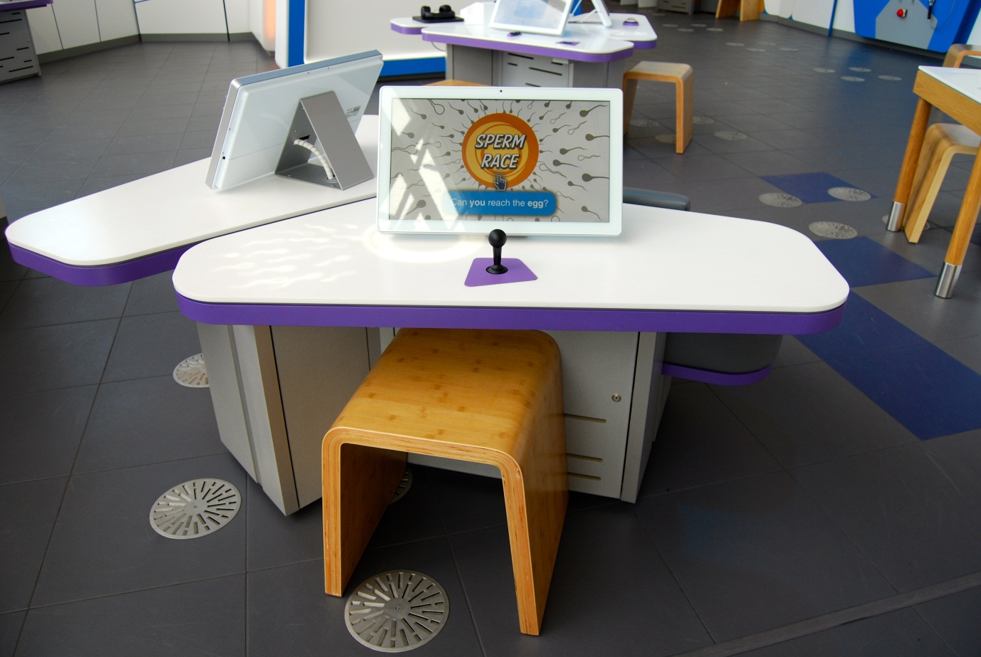

## Sperm Race: Can you reach the egg?

Also known as Sperm Game / A5.03a

### Description

An IT game that allows visitors to manoeuvre a sperm character with the challenge of navigating through the vagina, cervix, uterus and fallopian tube to fertilise an egg cell. It consists of a joystick, touchscreen and moveable stool. The game is split into four levels, each with unique challenges.

### Visitor experience

The visitor activates the exhibit by either pressing the touchscreen or by moving the joystick. During the game, the visitor controls the sperm by moving the joystick. On screen, there is an option to view an overview map of the current level. At the end, the visitor sees an animation of the fertilised egg develop into an embryo then foetus.

### Visitor interaction tips

* Offer assistance on how to play the game, as you highlight key learning outcomes tailored to the visitor.
* Suggest related exhibits: ‘If you liked this, you’ll love this’

### Accessibility

For visitors with sight problems, offer assistance with the touchscreen.

For visitors unable to use this exhibit, offer to explain how it works before pointing them in the direction of a related exhibit.

### Good to know

This game was originally developed for Channel 4 in partnership with the Wellcome Trust.

### Daily checks by science communicators

The exhibit components are in good working order.

### Cleaning

Clean the screen with appropriate screen cleaner.

Clean the surfaces, joystick and moveable stool with appropriate surface cleaner.

### Risks

See risk assessment in Risk Assessments folder.

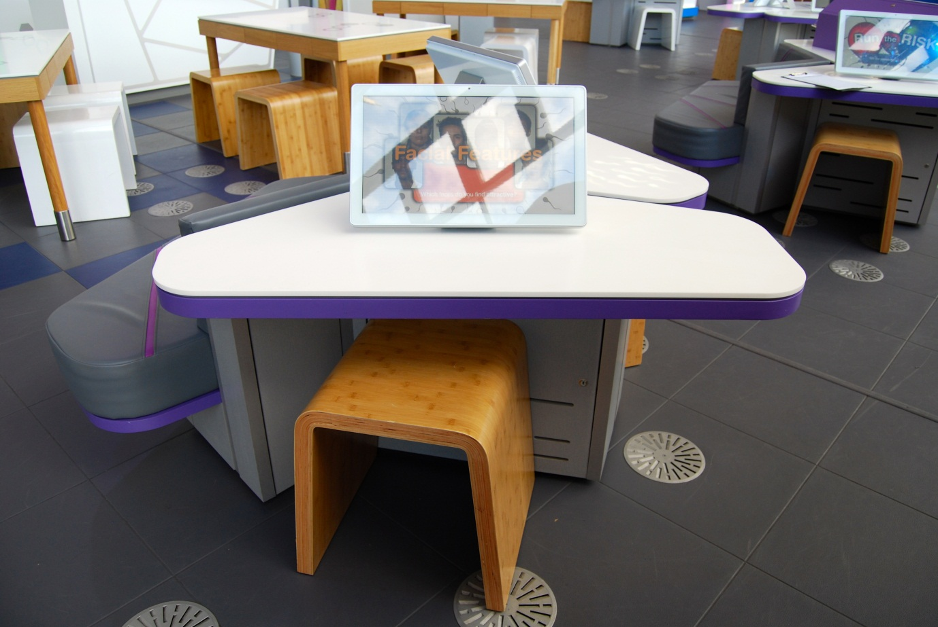

## Facial Features: Which faces do you find attractive?

Also known as Facial Attractiveness / A5.05

### Description

An IT game that allows visitors to complete a psychological test on the attractiveness of facial features. It consists of a touchscreen and moveable stool.

### Visitor experience

The visitor activates the exhibit by pressing the touchscreen. During the test, the visitor is shown a pair of faces of the same person. One face has been manipulated to look more ‘masculine’ and the other more ‘feminine’. The visitor is asked to select the face they find more attractive. After 12 pairs of faces, the visitor is told their results. This is given in context of previous visitors’ results.

### Visitor interaction tips

* Offer assistance on how to play the game, as you highlight key learning outcomes tailored to the visitor.
* Suggest related exhibits: ‘If you liked this, you’ll love this’

### Accessibility

For visitors with sight problems, offer assistance with the touchscreen.

For visitors unable to use this exhibit, offer to explain how it works before pointing them in the direction of a related exhibit.

### Good to know

Interested in this research behind this exhibit? There are some printed resources in this folder.

Physical attractiveness influences many different aspects of human social interaction. For example, people preferentially mate with, date, associate with, employ, and even vote for physically attractive individuals. People also tend to automatically ascribe positive personality characteristics to physically attractive individuals. This is often referred to as the ‘attractiveness halo effect’ or ‘beauty is good stereotype’. Although both males and females claim in self-report (i.e. when answering questionnaires) that physical attractiveness is not of primary importance when choosing a partner, the single best predictor of satisfaction with a ‘blind date’ is facial attractiveness for both men and women.

This exhibit was developed in collaboration with Prof Ben Jones and Dr Lisa DeBruine at the Institute of Neuroscience and Psychology at the University of Glasgow. They have further psychology tests on their website [www.faceresearch.org](http://www.faceresearch.org).

### Daily checks by science communicators

The exhibit components are in good working order.

### Cleaning

Clean the screen with appropriate screen cleaner.

Clean the surfaces and moveable stool with appropriate surface cleaner.

### Risks

See risk assessment in Risk Assessments folder.

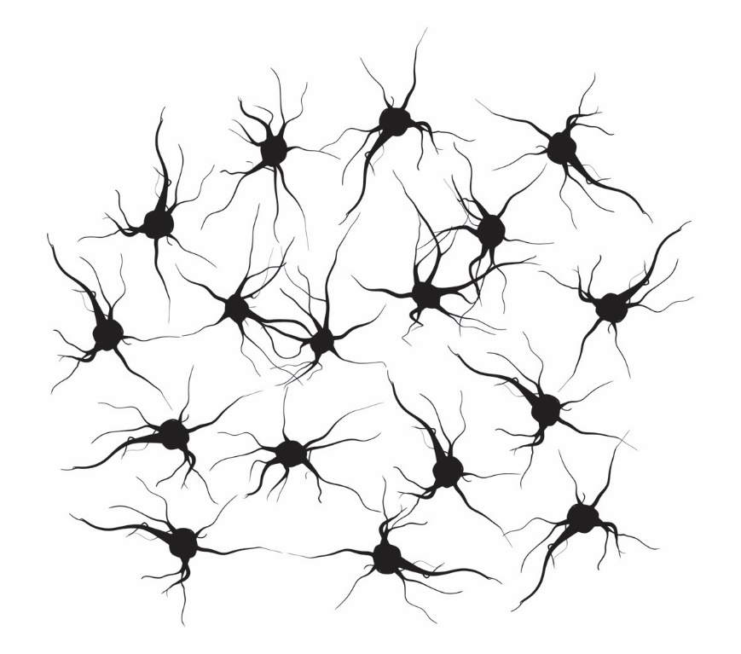

# Nervous & Endocrine exhibits

“Your nervous system allows you to think, move, feel, speak and do almost everything you want, but how does it work?”

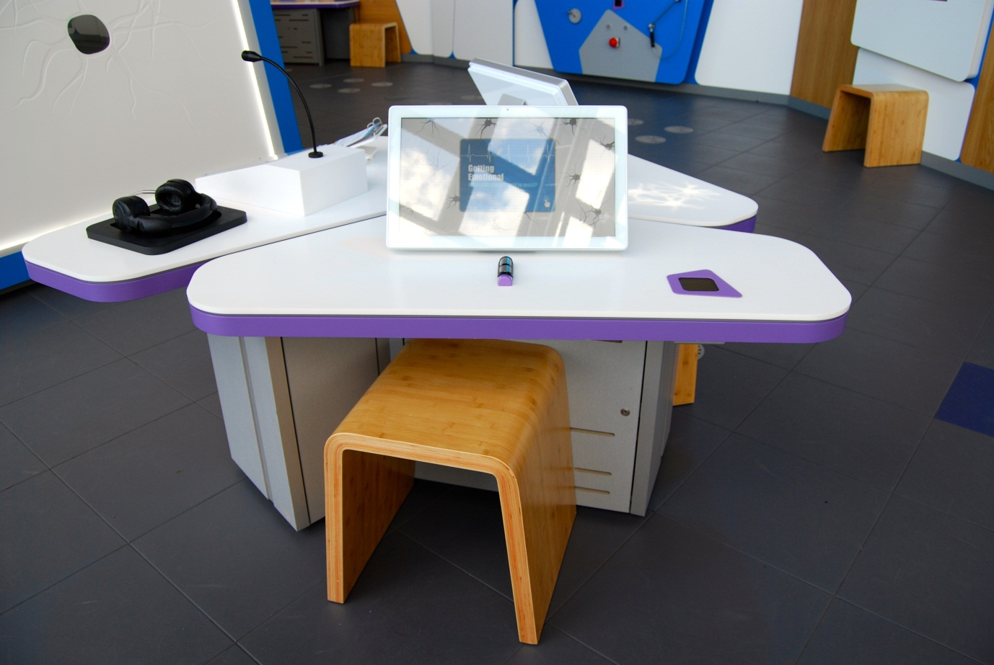

## Getting Emotional: What will you respond to most?

Also known as Measuring Emotions (pulse) / A6.12

### Description

An IT game that allows visitors to measure how their body responds as they look at a series of provocative images. It consists of a skin conductance sensor, touchscreen, barcode scanner and moveable stool. During the game, ten random images are shown as the sensor records the electrical conductance of the visitor’s skin. The images range in their level of provocation.

### Visitor experience

The visitor activates the exhibit by either pressing the touchscreen or by scanning their My BodyWorks barcode card. During the test, the visitor places their fingers on the sensor and keeps them still. At the end, the visitor is shown which image provoked the greatest conductance response. The visitor can save their results to their My BodyWorks profile.

### Visitor interaction tips

* Offer assistance on how to play the game, as you highlight key learning outcomes tailored to the visitor.
* Suggest related exhibits: ‘If you liked this, you’ll love this’

### Accessibility

For visitors with sight problems, offer assistance with the touchscreen.

For visitors unable to use this exhibit, offer to explain how it works before pointing them in the direction of a related exhibit.

### Good to know

Your emotions do not exist only in your brain. They can change what is happening in the rest of your body. Many clues to how you are feeling are shown in your facial expressions. But if you encounter a dangerous situation, your heart rate increases rapidly, your pupils get bigger and your digestive system slow down. This fight-or-flight response prepares your body for action.

(from Massachusetts Institute of Technology)

The skin conductance response, also known as the electrodermal response (and in older terminology as "galvanic skin response"), is the phenomenon that the skin momentarily becomes a better conductor of electricity when either external or internal stimuli occur that are physiologically arousing. Arousal is a broad term referring to overall activation, and is widely considered to be one of the two main dimensions of an emotional response. Measuring arousal is therefore not the same as measuring emotion, but is an important component of it. Arousal has been found to be a strong predictor of attention and memory.

There are only a couple of places where it is widely recognized as easy and reliable to measure the skin conductance response: the palms and the soles of the feet. In these places there is a high density of the eccrine sweat glands, which are known to be responsive to emotional and other psychological stimuli. In either of these areas, the conductance is measured by placing two electrodes next to the skin and passing a tiny electric charge between the two points. When the subject increases in arousal, his/her skin immediately becomes a slightly better conductor of electricity. This response can then be measured and communicated.

### Daily checks by science communicators

The exhibit components are in good working order.

### Cleaning

Clean the screen with appropriate screen cleaner.

Clean the surfaces, sensor and moveable stool with appropriate surface cleaner.

### Risks

See risk assessment in Risk Assessments folder.

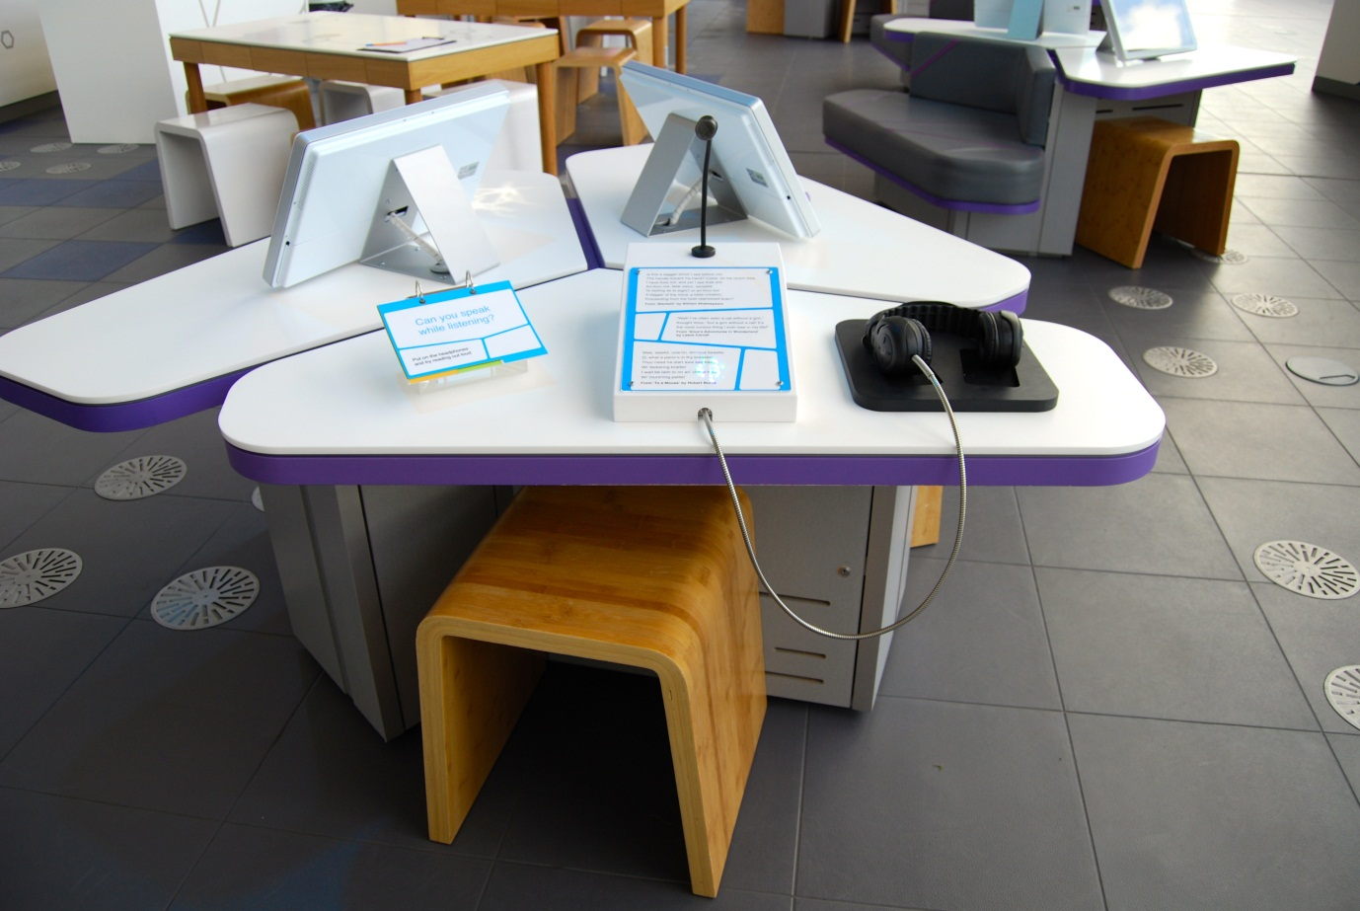

## Can you speak while listening?

Also known as Listening While Talking / A6.02

### Description

An exhibit that allows visitors to experience the phenomenon of delayed auditory feedback. It consists of a pair of headphones, microphone, a ‘script’, a 3-layer flapper label and moveable stool. The headphones play the sounds from the microphone delayed by roughly 200 milliseconds.

### Visitor experience

The visitor puts on the headphones and speaks into the microphone. A script is available from which they can read out loud. As they speak they can hear their delayed voice. This can affect their speech, causing them to speak slower or even stop.

### Visitor interaction tips

* Encourage visitors to read from the script. Research shows that the phenomenon is more effective when reading something out loud as opposed to normal speech.
* Point out the clinical use of this phenomenon for some people who stammer.
* Suggest related exhibits: ‘If you liked this, you’ll love this’

### Accessibility

For visitors who are hard of hearing or who are unable to use this exhibit, offer to explain how it works before pointing them in the direction of a related exhibit.

### Good to know

Made by Hüttinger.

### Daily checks by science communicators

The exhibit components are in good working order. In particular:

* The headphones are securely attached and in good condition.
* The microphone is intact.

### Cleaning

Clean the surfaces, Perspex, microphone and moveable stool with appropriate surface cleaner.

Remember to clean the flapper label.

### Risks

See risk assessment in Risk Assessments folder.

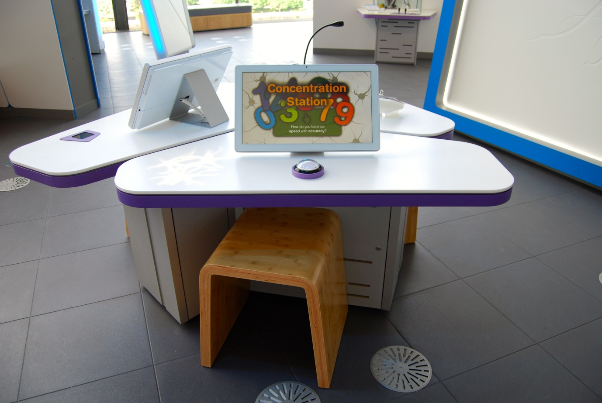

## Concentration Station: How do you balance speed with accuracy?

Also known as A6.07

### Description

An IT game that allows the visitor to complete a concentration test. It consists of a touchscreen, a single button and a moveable stool. The game is a Sustained Attention to Response Test: a type of 'go / no-go' recognition reaction test used by psychologists. The visitor responds to visual stimuli (numbers) by pressing the button, but withholds the response to a particular stimulus (number 3). At the end, the visitor is shown their results of speed and accuracy in the context of previous visitors.

### Visitor experience

The visitor activates the exhibit by either pressing the touchscreen or pressing the button. During the test, the visitor is encouraged to press the button as soon as a number appears on screen, except when it is a number 3. Due to the repetitive nature of the game and the low probability of a number 3 appearing, the visitor must concentrate hard to avoid hitting the button when they see a number 3. A further test is available at the end.

### Visitor interaction tips

* Offer assistance on how to play the game, as you highlight key learning outcomes tailored to the visitor.
* Suggest related exhibits: ‘If you liked this, you’ll love this’

### Accessibility

For visitors with sight problems, offer assistance with the touchscreen. You could say each number out loud as it appears.

For visitors unable to use this exhibit, offer to explain how it works before pointing them in the direction of a related exhibit.

### Good to know

The ability to make fast and accurate responses is necessary for many aspects of daily life and is crucial for survival, both in earlier times and today (depending on the activity). Being prepared to make a response will speed up reaction time but in an ever-changing environment, what was the correct response a second ago may suddenly be the worst thing you could possibly do. Even when we are prepared to make a response, there has to be a mechanism which allows us to check whether that response is still appropriate and if necessary, inhibit it.

The go/no-go task measures response inhibition. When you are prepared to make a response at speed or the nature of the stimulus triggers an automatic response (this needn’t be fast but simply habitual e.g. saying ‘bless you’ when someone sneezes) then under circumstances where this may not be the appropriate response, a checking procedure has to be implemented. This means reaction times will be slower in a go/no-go task than in a simple reaction time. So the first thing a go/no-go task can tell us is about the different processes that may be involved in making a decision and response.

If speed is required or the response is very automatic, then the checking procedure may not generate the inhibitory signal with enough speed to prevent the response. The inhibition is thought to be generated in the frontal parts of the brain and is a so-called ‘executive process’. The task can show how these parts of the brain are still developing in children as performance on the task only approaches adult performance at about age 12. The other important information that the go/no-go task can tell us is whether someone may have a deficit in frontal functioning of the brain. Conditions such as ADHD, Parkinson’s disease and schizophrenia though only in conjunction with many other tests and expert evaluation. Response inhibition ability has been shown to have a partly genetic basis and is also used to test the individual differences between individuals in personality variables like ‘impulsivity’.

### Daily checks by science communicators

The exhibit components are in good working order.

### Cleaning

Clean the screen with appropriate screen cleaner.

Clean the surfaces, button and moveable stool with appropriate surface cleaner.

### Risks

See risk assessment in Risk Assessments folder.

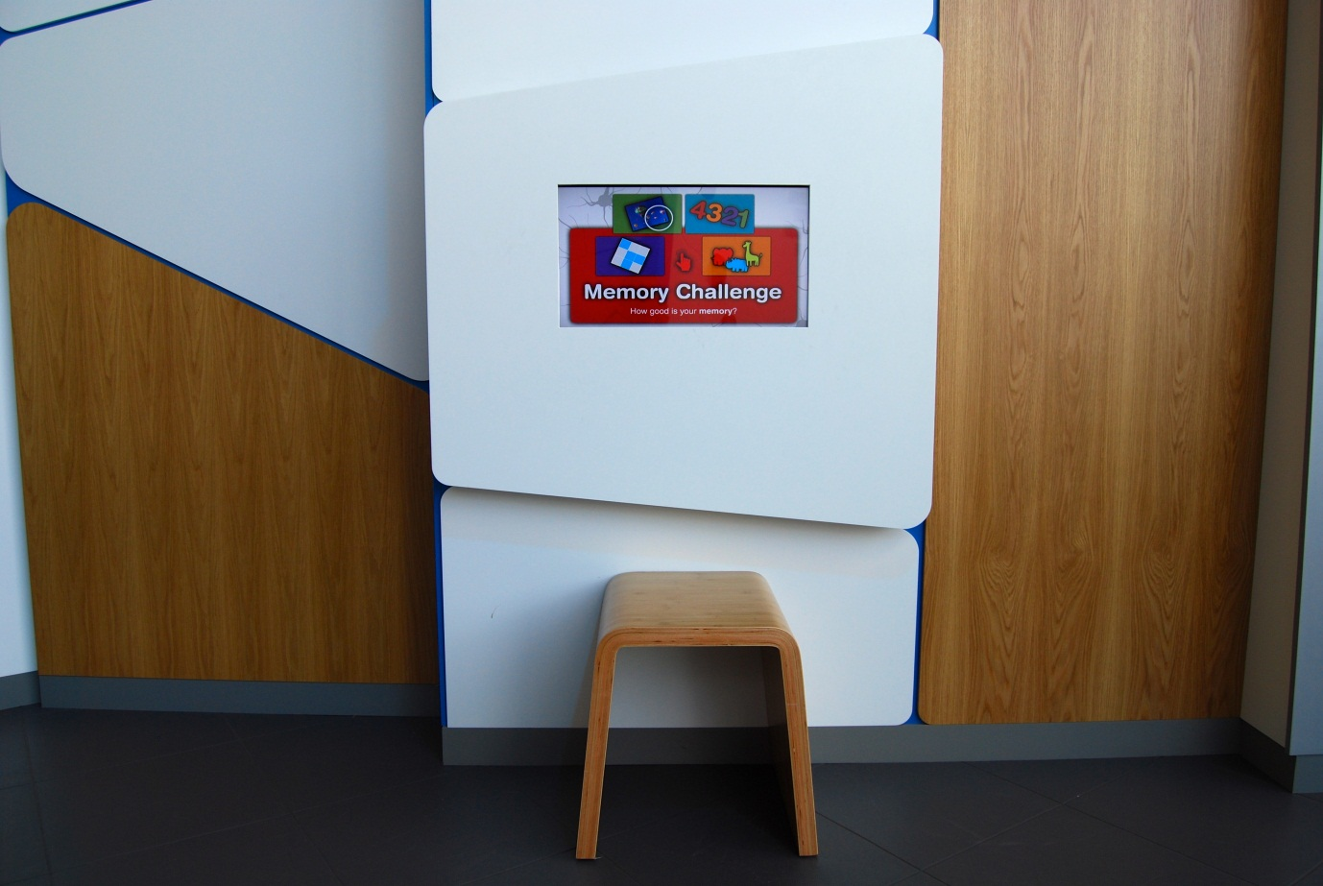

## Memory Challenge: How good is your memory?

Also known as A6.14

### Description

An IT game that allows visitors to complete a series of memory challenges. It consists of a wall-mounted touchscreen and moveable stool. The tests are similar to those used in the diagnosis of neurodegenerative disorders (although the exhibit itself provides no diagnoses). Four types of test are available: spot the difference; number recall; grid patterns; and colours and animals.

### Visitor experience

The visitor activates the exhibit by pressing the touchscreen. The visitor selects which category of memory tests they would like to try. The visitor is shown their result at the end of the tests.

### Visitor interaction tips

* Offer assistance on how to play the game, as you highlight key learning outcomes tailored to the visitor.
* Suggest related exhibits: ‘If you liked this, you’ll love this’

### Accessibility

For visitors with sight problems, offer assistance with the touchscreen.

For visitors unable to use this exhibit, offer to explain how it works before pointing them in the direction of a related exhibit.

### Good to know

To measure different aspects of working memory, a number of tests can be used, including Spot the Difference, Number Recall and Grid Pattern Recognition. An additional test has been more recently developed to potentially identify specific AD deficits. The test is known as memory binding and measures an individual’s ability to remember different types of visual information simultaneously (for example the colour and shape of an object). These cognitive tests have been developed to test different aspects of your short-term memory. This type of memory helps us keep track of what is happening to us moment by moment. Professor Logie at the University of Edinburgh has developed tests to help understand how our memory works and how it may change as we age. In Alzheimer’s disease, you lose the ability to remember things and tests like these may help us tell the difference between normal memory loss during healthy ageing and memory loss resulting from a disease such as Alzheimer’s.

### Daily checks by science communicators

The exhibit components are in good working order.

### Cleaning

Clean the screen with appropriate screen cleaner.

Clean the surfaces and moveable stool with appropriate surface cleaner.

Dust the ledges using a microfibre duster or static duster.

### Risks

See risk assessment in Risk Assessments folder.

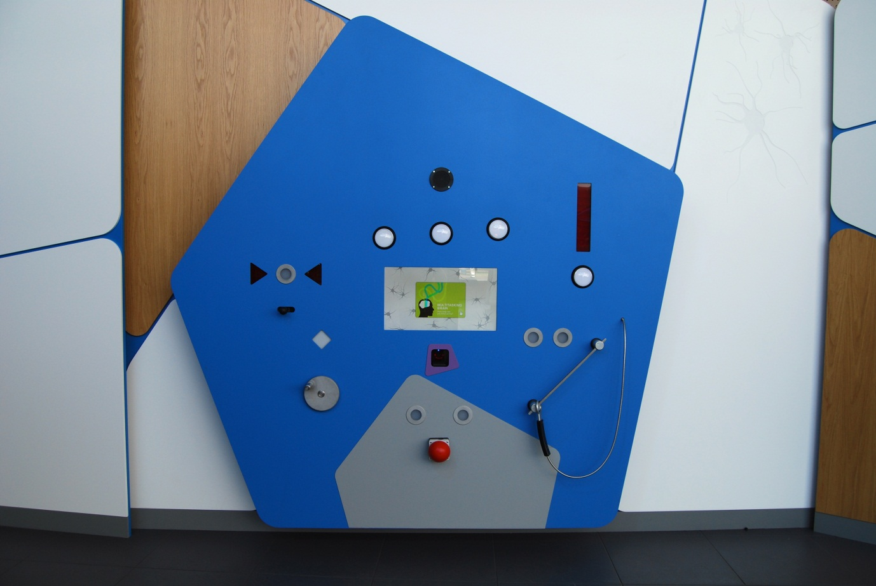

## Multitasking Brain: How can you keep going?

Also known as A6.03

### Description

An exhibit that allows visitor to perform multiple tasks simultaneously, just as the human brain does to ensure the functioning of the whole body. It consists of a touchscreen, barcode scanner, five buttons, a lever, rotatable disc and slider sensor. Each control is accompanied by a red light.

### Visitor experience

The visitor activates the exhibit either by pressing the touchscreen or by scanning their My BodyWorks barcode scanner. During the game, the visitor is challenged to switch off any red lights by using the nearest control to the light. As the game progresses, the random appearance of red lights becomes more frequent. At the end, the visitor is given the time they lasted before too many red lights had appeared.

### Visitor interaction tips

* Encourage use of the My BodyWorks cards by explaining how they work and highlighting the benefits of using the website.
* Offer assistance on how to play the game, as you highlight key learning outcomes tailored to the visitor.
* Highlight that your brain is always working to keep functions of the body between limits, just like this game.

### Accessibility

For visitors with sight problems, offer assistance with the touchscreen.

For visitors unable to use this exhibit, offer to explain how it works before pointing them in the direction of a related exhibit.

### Good to know

As of 17 May 2013, the most common game time recorded at this exhibit was 11.2 seconds. The overall average was 34.49 seconds.

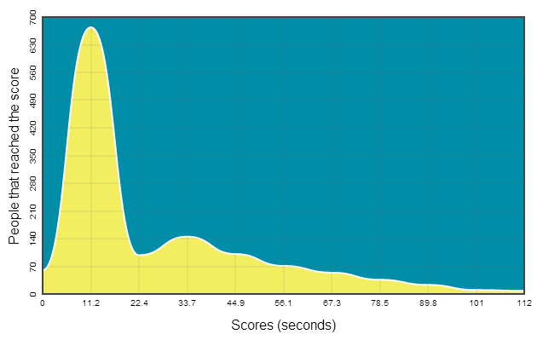

Your brain makes sure your body's organs and systems work within set parameters. If you get too warm, you sweat to cool your body down. If your blood sugar levels get too high, the hormone insulin is released. If you get dehydrated, you feel thirsty until you take a drink. Your brain multitasks to keep you alive.

### Daily checks by science communicators

The exhibit components are in good working order.

### Cleaning

Clean the screen with appropriate screen cleaner.

Clean the surfaces and controls with appropriate surface cleaner.

Dust the ledges using a microfibre duster or static duster.

### Risks

See risk assessment in Risk Assessments folder.

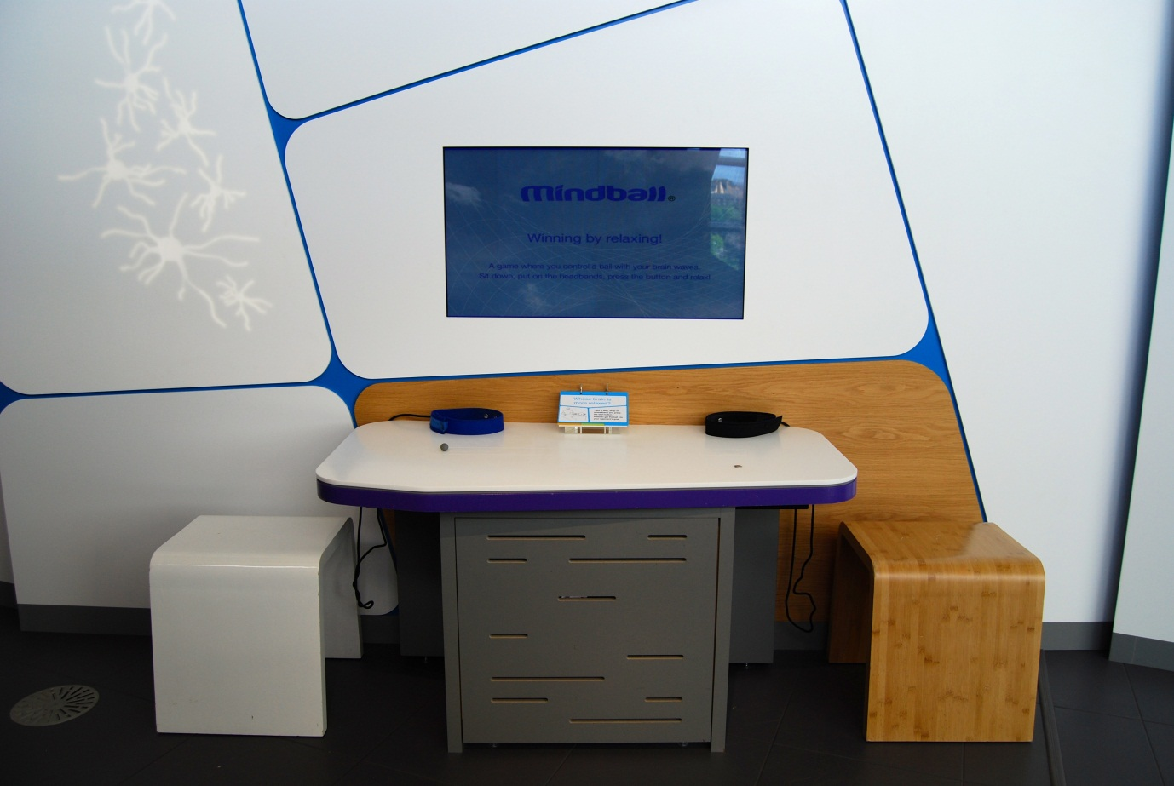

## Whose brain is more relaxed?

Also known as Mindball / A6.01

### Description

An exhibit that allows two visitors to compete to be the most relaxed. It consists of a table, magnetic ball, two headbands containing EEG sensors, screen, start button, 3-layer flapper label and two moveable stools. The headband sensors measure the brainwaves of each visitor and compare them to calculate who appears more relaxed. The measurements are shown on screen and affect the position of the magnetic ball, which can move in a straight line between the visitors on the table. The ball is moved by a computer-controlled magnet under the table.

### Visitor experience

The visitors sit down and put on the headbands (with the electrodes touching the skin on their forehead). One visitor presses the start button. This resets the magnetic ball to the centre of the table. As the visitors relax, their brainwave measurements are shown on screen. The ball moves away from the visitor who appears more relaxed. The game ends when the ball reaches the end of the magnetic strip.

### Visitor interaction tips

* Discuss different techniques visitors could try in order to relax their mental state.
* Explain how brainwave research is giving new levels of independence to people with paralysis and locked-in syndrome.
* Suggest related exhibits: ‘If you liked this, you’ll love this’

### Accessibility

For visitors unable to use this exhibit, offer to explain how it works before pointing them in the direction of a related exhibit.

### Good to know

The Mindball game is made by Interactive Productline IP AB but we adapted the housing to fit in with the rest of the exhibition.

### Daily checks by science communicators

The exhibit components are in good working order. In particular:

* The magnetic ‘mindball’ is present.
* The headbands are in good condition.

### Cleaning

Clean the screen with appropriate screen cleaner.

Clean the surfaces and moveable stools with appropriate surface cleaner.

Remember to clean the flapper label.

Clean the floor under the table with a broom and dustpan & brush.

### Risks

See risk assessment in Risk Assessments folder.

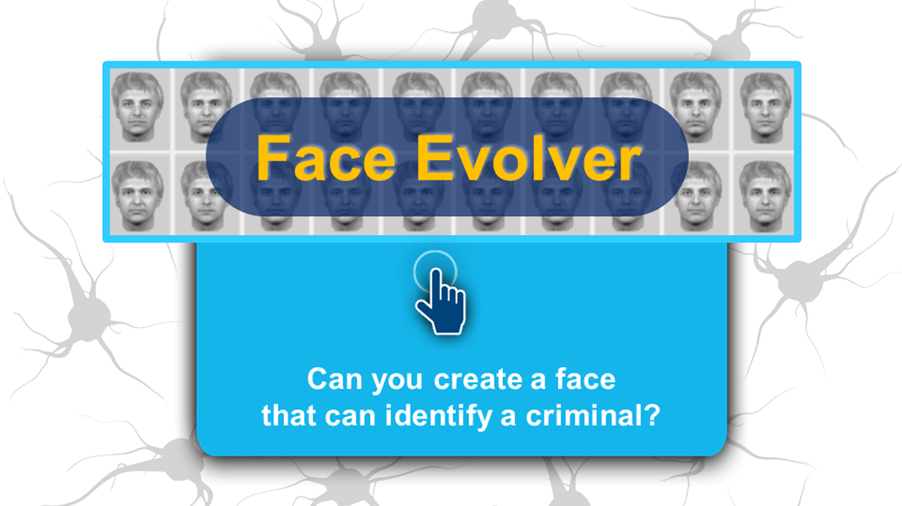

## Face Evolver: Can you reproduce the criminal’s face?

Also known as EvoFIT / Facial Recognition / A6.15

### Description

An IT game that allows visitors to reproduce a face after watching a video of a ‘criminal’. It consists of a touchscreen and moveable stool. The game uses a real facial composite system used by police called EvoFIT.

### Visitor experience

The visitor activates the exhibit by pressing the touchscreen. After watching a video of a man pretend to commit a crime, the visitor selects similar-looking faces from an array of random faces. These faces ‘breed’ to preserve certain features and after several round and adjusting the face, the visitor is shown the constructed face next to a video still of the ‘criminal’.

### Visitor interaction tips

* Offer assistance on how to play the game, as you highlight key learning outcomes tailored to the visitor.
* Suggest related exhibits: ‘If you liked this, you’ll love this’

### Accessibility

For visitors with sight problems, offer assistance with the touchscreen.

For visitors unable to use this exhibit, offer to explain how it works before pointing them in the direction of a related exhibit.

### Good to know

(From EvoFIT)

EvoFIT is an award-winning system for constructing facial composites of offenders by witnesses and victims of crime. It is currently being used by police forces around the world with great success.

The traditional composite systems used by police forces require witnesses and victims to describe an offender’s face and then to select individual facial features; tough, when under pressure.

EvoFIT uses a different approach. Faces in EvoFIT are modelled in their entirety and are not separated into component parts. A facial composite is created by first displaying a number of faces containing random features such as eyes, noses and mouths. A witness selects a few of these faces that are most similar to a criminal. The selected faces are then mixed or ‘bred’ together to produce another set for selection. Repeating this process a number of times allows a composite to be ‘evolved’.

EvoFIT begins by creating a set of faces with random facial shapes and facial textures. A witness would normally select six of these shapes and textures that most resemble a suspect. These selections then become the “parents” of the next population; to produce another generation, the components of the selected faces are mixed together. The “offspring” faces are selected and bred together as before. The selections enable the set of faces to become more like the suspect. Evolution is completed when an acceptable likeness is found.

EvoFIT is unique in helping a witness to focus on the central part of the face, the region that is important for recognition by another person later (a police officer or member of the public). The system also contains holistic tools to improve the match — 20 scales that change the perceived age, pleasantness, masculinity and other such properties of the face.

### Daily checks by science communicators

The exhibit components are in good working order.

### Cleaning

Clean the screen with appropriate screen cleaner.

Clean the surfaces and moveable stool with appropriate surface cleaner.

### Risks

See risk assessment in Risk Assessments folder.



# Making sense of your brain Research Capsule

“It is the most complex thing in your body - and possibly the universe. Now scientists, armed with the latest imaging technologies, are revealing the wonders - and problems - lying deep within the brain.”

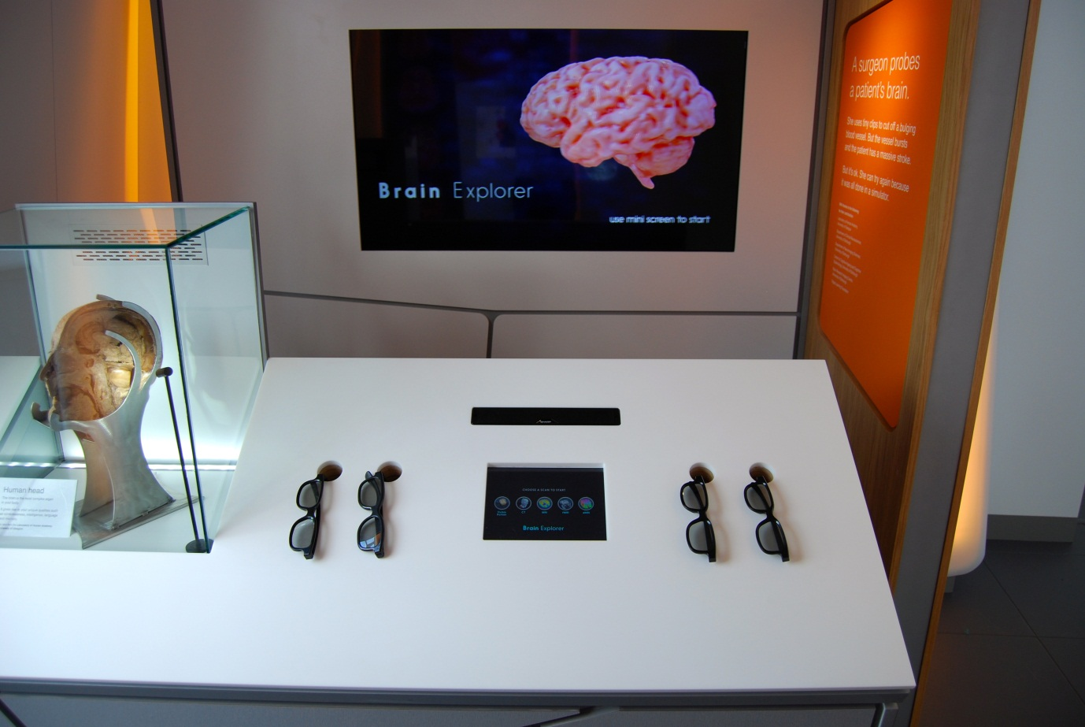

## Brain Explorer

Also known as 3D Brain / C6.03b

### Description

An exhibit that allows visitors to explore a 3D volume rendering of real brain scans. It consists of wall-mounted 3D television, iPad control screen and four pairs of 3D glasses. The brain scans are shown on the 3D television and controlled from the iPad. The images were taken with the following types of scan: CT, MRI, fMRI and dMRI.

### Visitor experience

The visitor puts on a pair of 3D glasses and activates the exhibit by pressing the iPad control screen. Buttons are available on the iPad to control which brain scan is shown on the television together with options for further information. For each brain scan, the visitor can move their finger across part of the iPad screen to either section through the brain or rotate the specimen.

### Visitor interaction tips

* Explain to visitors that they are standing in an area showcasing some of the ways science is trying to understand the brain (see the text on the capsule welcome panels).
* Offer assistance on how to use this exhibit, as you highlight key learning outcomes tailored to the visitor.
* Point out the differences in studying the brain scans to the real brain in the *Human head* exhibit.
* Suggest related exhibits: ‘If you liked this, you’ll love this’

### Accessibility

For visitors with sight problems, offer to describe the exhibit and assist with the touchscreen.

For visitors unable to use this exhibit, offer to explain how it works before pointing them in the direction of a related exhibit.

### Good to know

This exhibit was created by the Digital Learning Foundation.

### Daily checks by science communicators

The exhibit components are in good working order. In particular:

* Four pairs of 3D glasses are available.
* Each pair of 3D glasses is in good condition.

### Cleaning

Clean the iPad screen (and 3D television when required) with appropriate screen cleaner.

Clean the surfaces with appropriate surface cleaner. The 3D glasses can be cleaned when required.

Dust the ledges using a microfibre duster or static duster.

### Risks

See risk assessment in Risk Assessments folder.

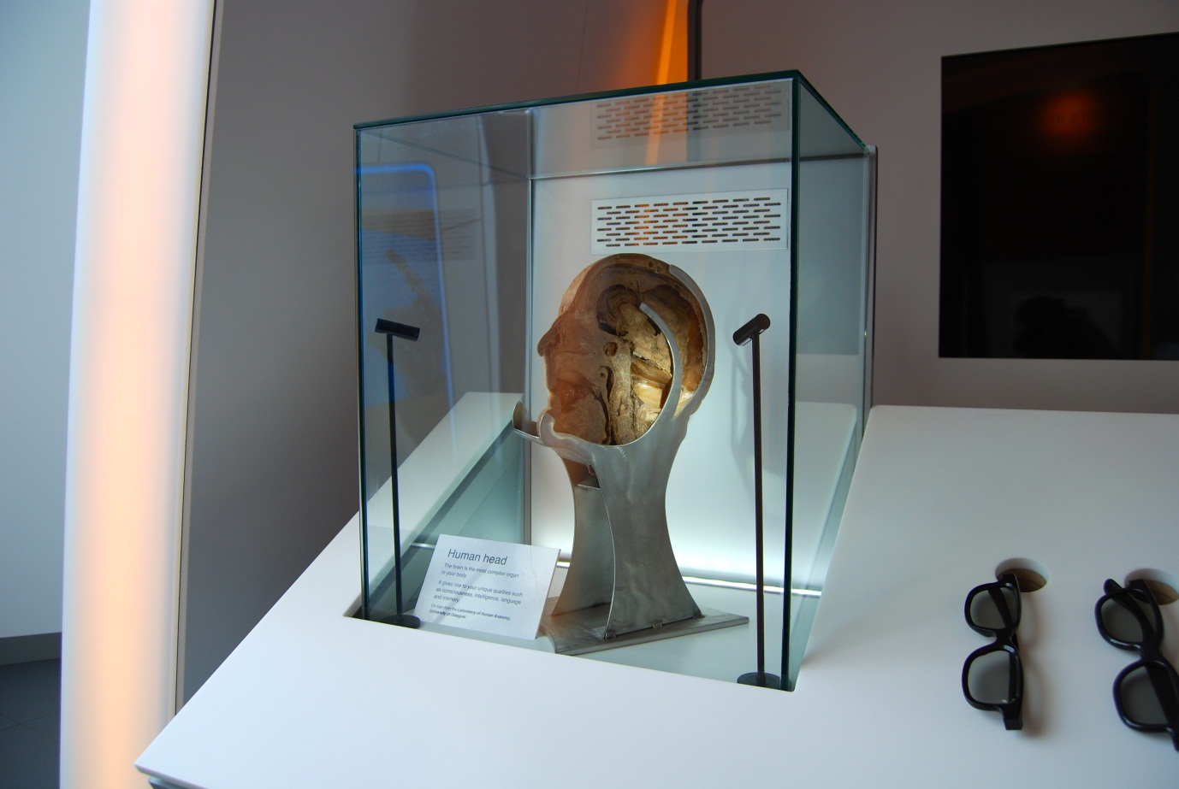

## Human head

Also known as C6.03a

### Description

An exhibit that allows visitors to examine a real human specimen used in medical training. It consists of a half head specimen housed within a glass display case. The specimen has been dissected and is lit to allow visitors to fully appreciate the intricate detail of the head including brain. The exhibit, including its location, is designed to be respectful, dignified and give visitors an opportunity for contemplation.

### Visitor experience

Visitors can explore the wonders of the brain by looking at a real human head.

### Visitor interaction tips

* Explain to visitors that they are standing in an area showcasing some of the ways science is trying to understand the brain (see the text on the capsule welcome panels).
* Why not spark a discussion on donating a body to medical science. Note body donation is different to organ donation, which are used for transplants. Body donation is used for medical science.
* For interested visitors, take out the body donation literature at the end of this folder. Please return the leaflets after use.
* If a visitor asks how they can donate their body to medical science, tell them to contact their local University Medical School.

### Accessibility

For visitors with sight problems, offer to describe the specimen and how it was preserved.

### Good to know

BodyWorks features three specimens of human tissue. The specimens are all from people who donated their bodies for use in the training of future doctors, dentists, nurses and the allied health professionals.

They are on loan from the Laboratory of Human Anatomy, School of Life Sciences, University of Glasgow where they are used to help students study and understand human anatomy. At the Laboratory is the Museum of Anatomy, which is open to the public.

The specimens in BodyWorks have been created by a process called plastination. This is a process used in anatomy to preserve body parts. Fat and water is replaced in the fixed tissue with polymers like silicone and epoxy. This allows the specimens to be touched and prevents them from decaying and retains many of their original features.

Glasgow Science Centre has permission to display the human material. Permission was sought from Her Majesty’s Inspector for Anatomy Scotland and St Andrew’s House (Scottish Government). As the specimen is from before the 1984 Anatomy Act, there are no restrictions on photography. However we endeavour to display the specimen in a sensitive manner with the utmost respect.

### Daily checks by science communicators

The exhibit components are in good working order.

### Cleaning

Clean the glass with appropriate glass cleaner.

Clean the surfaces with appropriate surface cleaner.

Dust the ledges using a microfibre duster or static duster.

### Risks

See risk assessment in Risk Assessments folder.

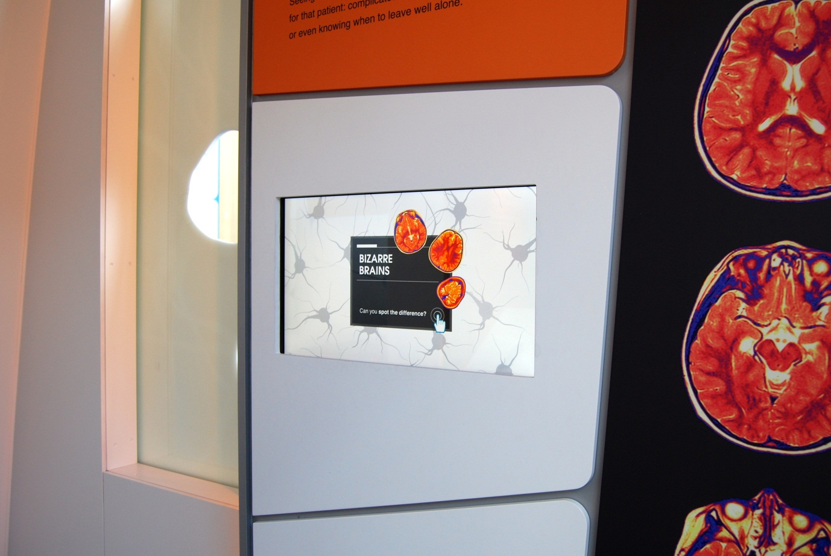

## Spot the Difference: Can you see the brain pathology?

Also known as C6.02

### Description

An IT game that allows visitors to play a game of spot the difference using pairs of brain scans. It consists of a wall-mounted touchscreen. The game is structured into seven rounds, with each difference getting progressively more difficult to spot. For each pair of scans, one brain is healthy and the other features a condition such as a lesion or aneurysm.

### Visitor experience

The visitor activates the exhibit by pressing the touchscreen. During the game, the visitor presses the screen where they believe the difference is. At the end, the visitor is given a score out of 7.

### Visitor interaction tips

* Explain to visitors that they are standing in an area showcasing some of the ways science is trying to understand the brain (see the text on the capsule welcome panels).
* Offer assistance on how to play the game, as you highlight key learning outcomes tailored to the visitor.
* Suggest related exhibits: ‘If you liked this, you’ll love this’

### Accessibility

For visitors with sight problems, offer assistance with the touchscreen.

For visitors unable to use this exhibit, offer to explain how it works before pointing them in the direction of a related exhibit.

### Good to know

The brain scans were donated by the University of Edinburgh. To create a playable game, the ‘healthy’ brain scan in each pair was carefully manipulated on a computer. Each pair of images came from an original scan containing a brain condition. To create the ‘healthy’ image, the brain condition was removed. This process was necessary because of the natural variations in brain scans, which would have prevented non-specialists to spot the brain conditions.

### Daily checks by science communicators

The exhibit components are in good working order.

### Cleaning

Clean the screen with appropriate screen cleaner.

Clean the surfaces with appropriate surface cleaner.

### Risks

See risk assessment in Risk Assessments folder.



# Musculoskeletal exhibits

“Your bones and muscles give your body structure, but how do they work together to make possible all the movements you can make?”

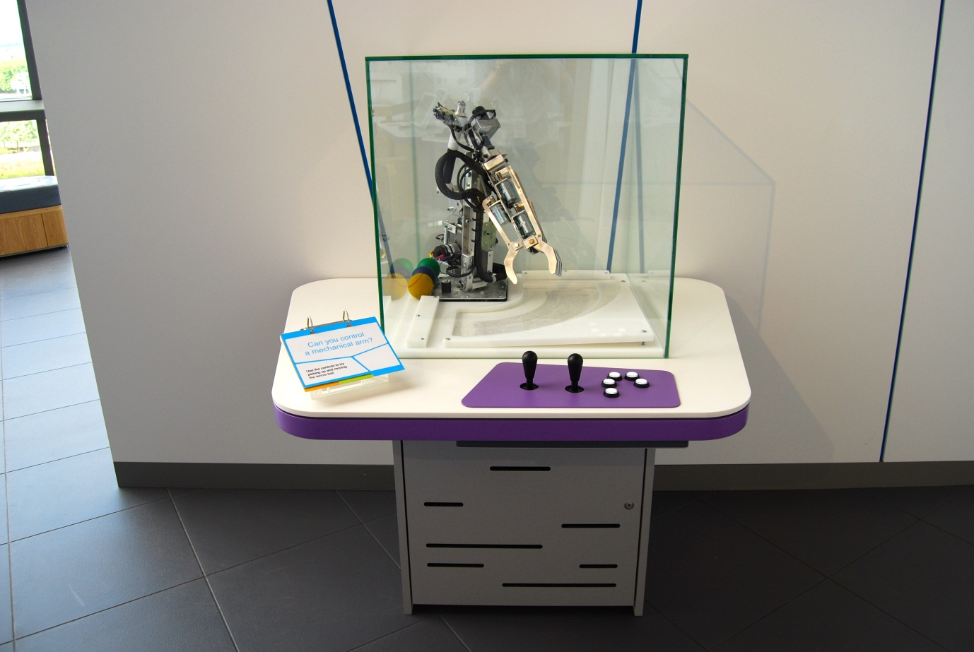

## Can you control a mechanical arm?

Also known as Robotic Arm / C7.04

### Description

An exhibit that allows visitors to control a mechanical forearm. It consists of a robotic arm, joystick, five buttons, tennis balls and a 3-layer flapper label.

### Visitor experience

The visitor uses the joystick and button to control the robotic arm. The challenge is to pick up a tennis ball. The visitor discovers that the simple task of lifting a ball is surprisingly complicated.

### Visitor interaction tips

* Highlight that the complexities in controlling a mechanical arm are what engineers must face when creating prosthetics hands such as seen in the *i-limb ultra* exhibit.
* Suggest related exhibits: ‘If you liked this, you’ll love this’

### Accessibility

For visitors with sight problems, offer to describe the exhibit.

For visitors unable to use this exhibit, offer to explain how it works before pointing them in the direction of a related exhibit.

### Good to know

Fabricated by Hüttinger.

### Daily checks by science communicators

The exhibit components are in good working order. In particular:

* The tennis balls are within reach of the mechanical arm.

### Cleaning

Clean the glass with appropriate glass cleaner.

Clean the surfaces, joystick, buttons and moveable stool with appropriate surface cleaner.

Remember to clean the flapper label.

### Risks

See risk assessment in Risk Assessments folder.

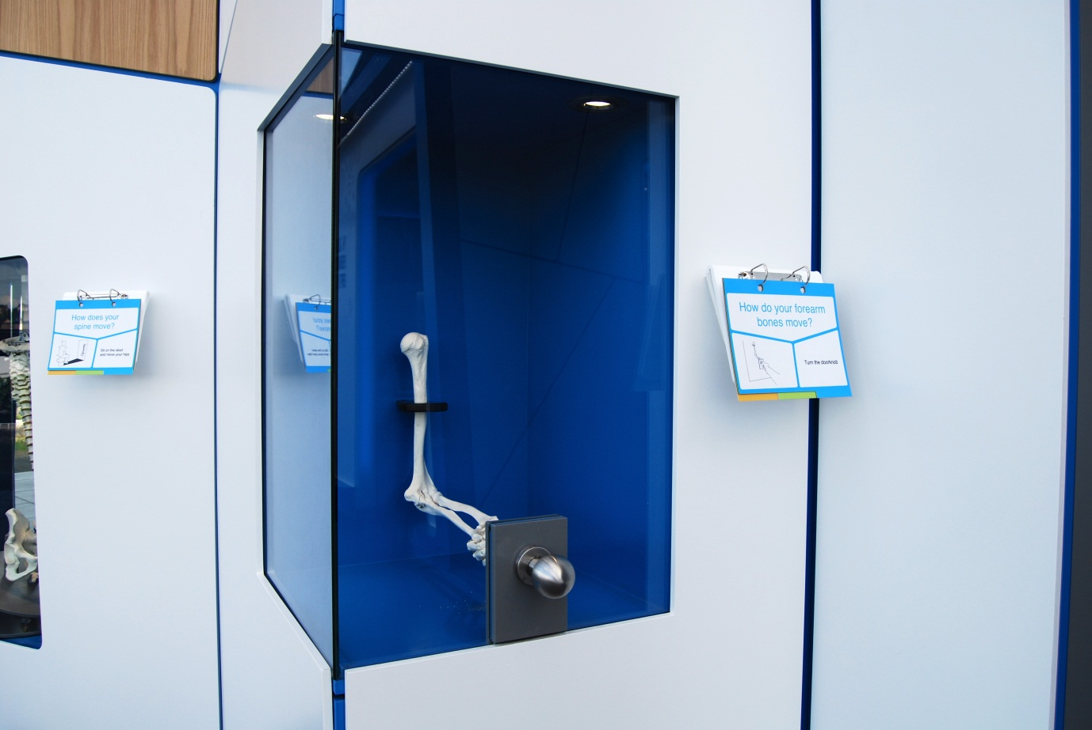

## How do your forearm bones move?

Also known as Inside Your Arm / Doorknob / A7.12

### Description

An exhibit that allows visitors to see how their forearm bones move when turning a doorknob. It consists of a skeleton forearm, doorknob and a 3-layer flapper label. The skeleton arm is housed within a glass cabinet.

### Visitor experience

The visitor grasps the doorknob and rotates it. As the doorknob is turned, the skeleton arm copies the movements of the visitor’s arm.

### Visitor interaction tips

* Point out how many bones make up the hand in comparison to the forearm.
* Suggest related exhibits: ‘If you liked this, you’ll love this’

### Accessibility

For visitors with sight problems, offer to describe the exhibit.

For visitors unable to use this exhibit, offer to explain how it works before pointing them in the direction of a related exhibit.

### Good to know

This was one of the original exhibits from when Glasgow Science Centre opened in 2001. Originally it was on Floor 1 near the top of the escalators.

### Daily checks by science communicators

The exhibit components are in good working order. In particular:

* The doorknob is secure.

### Cleaning

Clean the glass with appropriate glass cleaner.

Clean the surfaces and doorknob with appropriate surface cleaner.

Remember to clean the flapper label.

### Risks

See risk assessment in Risk Assessments folder.

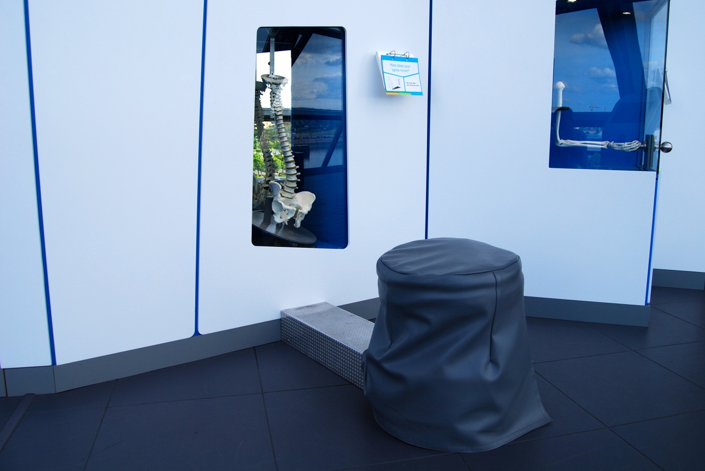

## How does your spine move?

Also known as Your Bendy Backbone / A7.13

### Description

An exhibit that allows visitors to see how their backbone moves. It consists of a stool, model spine, mirrors and a 3-layer flapper label. The model is housed inside a glass cabinet and is connected to the stool such that movements of the stool move the model spine.

### Visitor experience

The visitor sits on the stool and rocks and rotates their hips. The model backbone copies their movements. The mirrors allow the visitor to see the spine from different angles.

### Visitor interaction tips

* Highlight that despite being called your ‘backbone’, it is made of several bones, not just one.
* Suggest related exhibits: ‘If you liked this, you’ll love this’

### Accessibility

For visitors with sight problems, offer to describe the exhibit and assist with them sitting safely on the seat.

For visitors unable to use this exhibit, offer to explain how it works before pointing them in the direction of a related exhibit.

### Good to know

This was one of the original exhibits from when Glasgow Science Centre opened in 2001. Originally it was on Floor 1 near the top of the escalators.

### Daily checks by science communicators

The exhibit components are in good working order.

### Cleaning

Clean the glass with appropriate glass cleaner.

Clean the surfaces, floor panel and stool with appropriate surface cleaner.

Remember to clean the flapper label.

Inform the Exhibit Engineers if the stool cover looks grubby.

### Risks

See risk assessment in Risk Assessments folder.

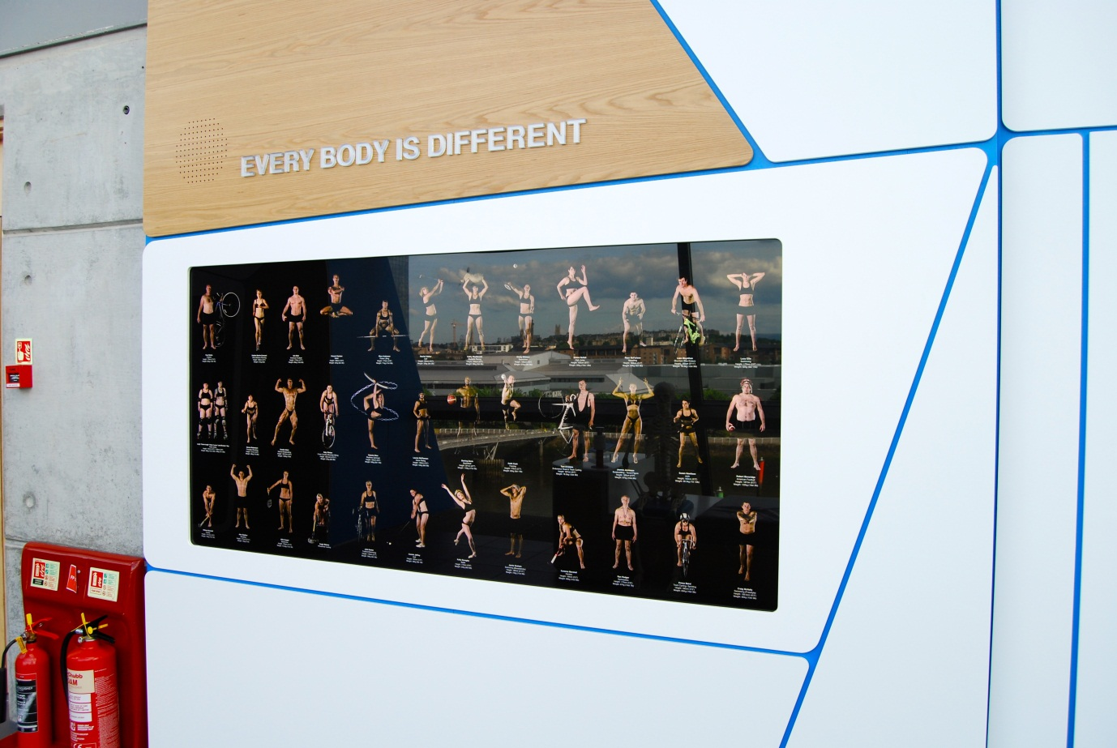

## Every body is different

Also known as Body Shapes / Athlete Line-up / Photo shoot / A7.05

### Description

A visual exhibit that allows visitors to see the variety of physiques among athletes. It consists of a backlit graphic of 37 athletes. Each athlete is accompanied by their name and sport or physical activity. The able-bodied athletes are also accompanied by their height and weight.

### Visitor experience

The visitor compares the physiques of the athletes and discovers the wide range of healthy bodies.

### Visitor interaction tips

* Encourage visitors to compare the different physiques and how they might give advantages for each sport.
* Point out that some of the athletes visited a motion-capture laboratory to create the nearby *Get Moving* exhibit.
* Suggest related exhibits: ‘If you liked this, you’ll love this’

### Accessibility

For visitors with sight problems, offer to describe the graphic.

### Good to know

The people in the line-up are all local athletes who agreed to take part. They attended a photo shoot held in the BBC.

### Daily checks by science communicators

The exhibit components are in good working order.

### Cleaning

Clean the Perspex with appropriate glass cleaner.

Clean the surfaces with appropriate surface cleaner.

### Risks

See risk assessment in Risk Assessments folder.

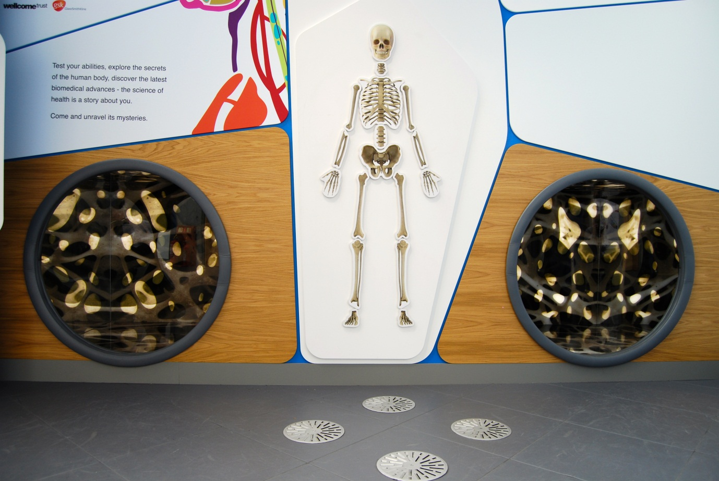

## Crawl inside a bone

Also known as Crawl Tunnel / A7.19

### Description

An exhibit that allows visitors to crawl through a tunnel that represents the internal structure of bones. It consists of a mirrored crawl tunnel with bone graphics.

### Visitor experience

The visitor crawls through the tunnel and can see the patterns of the internal structure of bones.

### Visitor interaction tips

* Discuss what makes bones strong and how you can look after your bones.
* Suggest related exhibits: ‘If you liked this, you’ll love this’

### Accessibility

For visitors with sight problems, offer to assist the visitor to crawl safely through the tunnel.

For visitors unable to use this exhibit, offer to explain how it works before pointing them in the direction of a related exhibit.

### Good to know

N/A

### Daily checks by science communicators

The exhibit components are in good working order.

### Cleaning

Clean the mirrors with appropriate glass cleaner.

Clean the non-mirror surfaces with appropriate surface cleaner.

Use the vacuum cleaner to remove any stubborn dust inside the tunnel.

### Risks

See risk assessment in Risk Assessments folder.

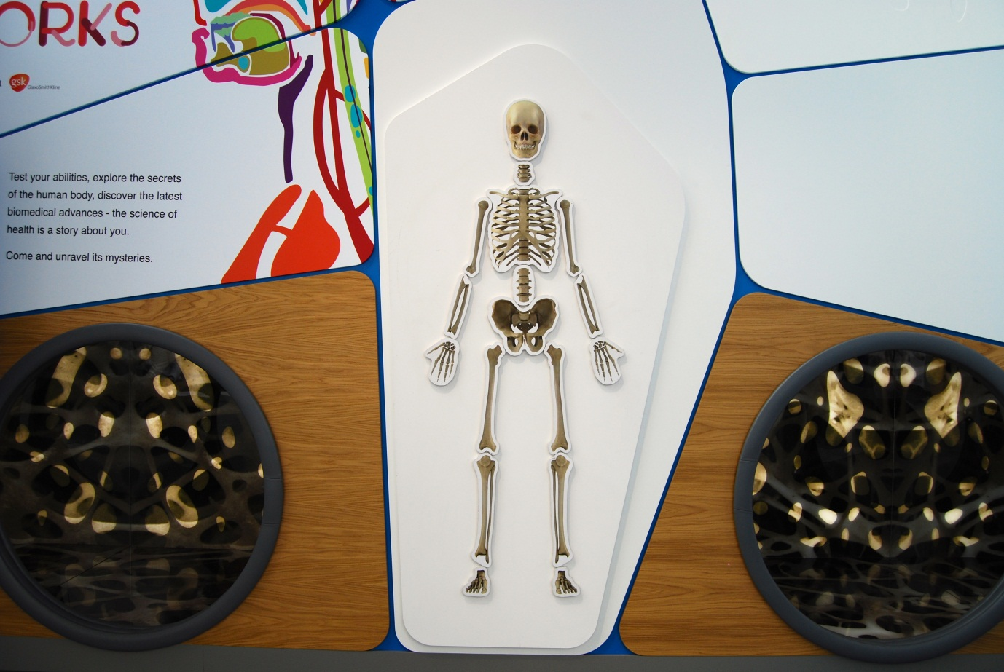

## What is the shape of your skeleton?

Also known as Build the Magnetic Skeleton / A7.11

### Description

A wall-mounted exhibit that allows visitors to complete a skeleton puzzle. It consists of magnetic pieces on a white magnetic wall. Each magnetic piece contains a graphic of a bone or group of bones. The skeleton is split into 17 pieces.

### Visitor experience

The visitor moves the bone pieces to try completing the shape of a skeleton.

### Visitor interaction tips

* Assist visitors in working out where each piece should go, linking it to the possible movements of the skeleton.
* Suggest related exhibits: ‘If you liked this, you’ll love this’

### Accessibility

For visitors with sight problems, offer to describe the exhibit.

For visitors unable to use this exhibit, offer to explain how it works before pointing them in the direction of a related exhibit.

### Good to know

Here is the correct layout of the pieces:

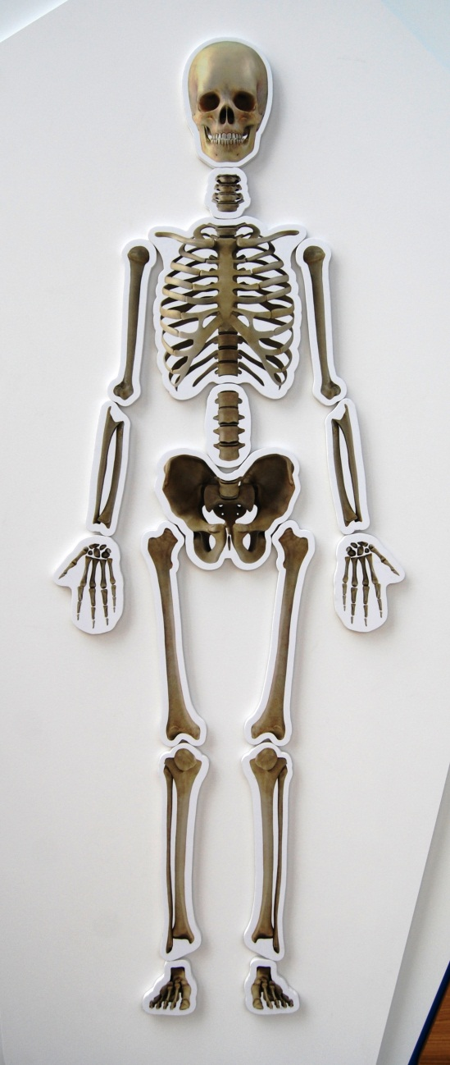

### Daily checks by science communicators

The exhibit components are in good working order. In particular:

* All 17 magnetic pieces are available.

### Cleaning

Clean the surfaces with appropriate surface cleaner.

Dust the ledges using a microfibre duster or static duster.

### Risks

See risk assessment in Risk Assessments folder.

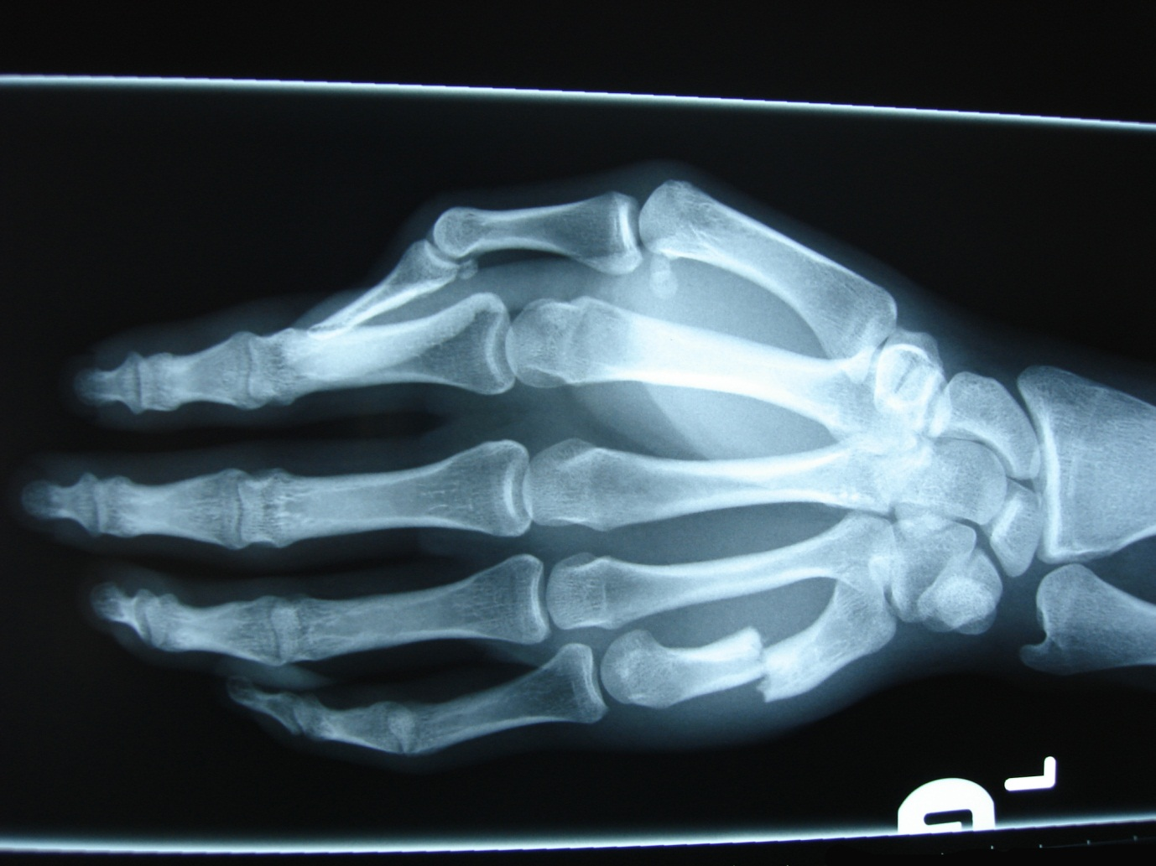

## X-ray viewer

Also known as A7.17

### Description

An exhibit that allows visitors to investigate a range of real X-ray images. It consists of a wall-mounted lightbox, a range of X-ray graphics and storage trays. The lightbox features a grabber along the top to hold the X-rays in place. The X-rays are real and have had information overlaid.

### Visitor experience

The visitor selects an X-ray graphic from a tray and places it into the lightbox grabber. The visitor can try to spot the interesting parts in each X-ray, from fractured bones to swallowed objects.

### Visitor interaction tips

* Offer to help visitors find the interesting part in each X-ray.
* Ask visitors if they have had an X-ray before.
* Suggest related exhibits: ‘If you liked this, you’ll love this’

### Accessibility

For visitors with sight problems, offer to describe the exhibit.

For visitors unable to use this exhibit, offer to explain how it works before pointing them in the direction of a related exhibit.

### Good to know

The X-rays were donated Prof Sue Black.

### Daily checks by science communicators

The exhibit components are in good working order. In particular:

* A range of X-rays are available and in good condition.

### Cleaning

Clean the surfaces with appropriate surface cleaner.

Dust the ledges using a microfibre duster or static duster.

### Risks

See risk assessment in Risk Assessments folder.

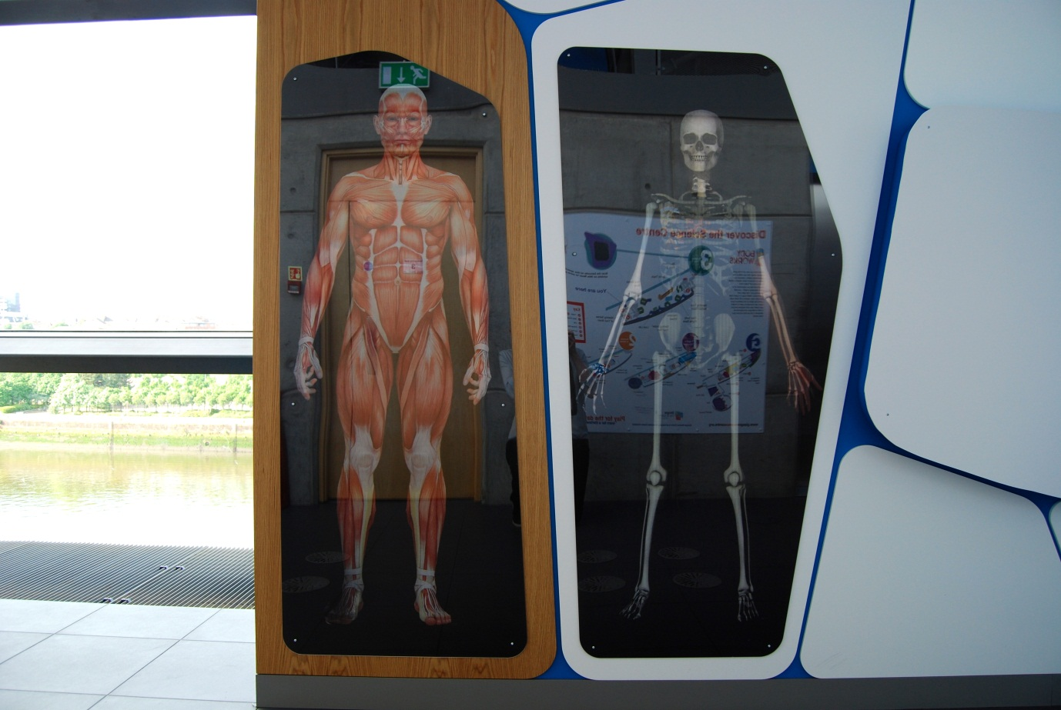

## Lenticular skeleton & muscles

Also known as Ross & Morna Images / A7.15a+b

### Description

A visual exhibit that allows visitors to watch two life-size images of people reveal either their skeleton or musculature. It consists of two lenticular graphics using a left-to-right flip action.

### Visitor experience

The visitor walks past the graphics to see them change. From one position they see the human form and as they move they merge into the skeleton or muscles.

### Visitor interaction tips

* Suggest visitors try out the *Virtual Autopsy Table* exhibit as it provides them with an interactive experience of seeing the different layers of the body.

### Accessibility

For visitors with sight problems, offer to describe the experience.

### Good to know

The real images are of Ross and Morna, Senior Science Communicators.

### Daily checks by science communicators

The exhibit components are in good working order.

### Cleaning

Clean the surfaces with appropriate surface cleaner.

Dust the ledges using a microfibre duster or static duster.

### Risks

See risk assessment in Risk Assessments folder.

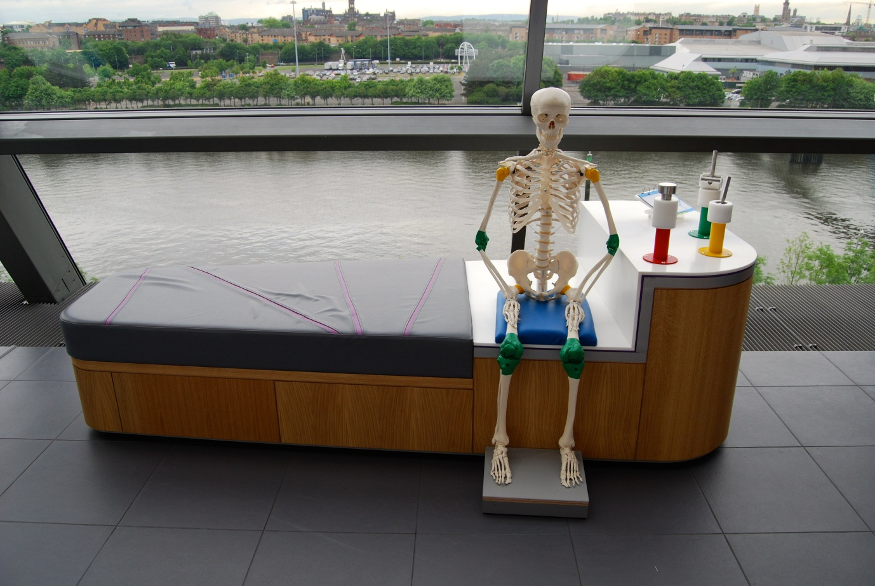

## How do your joints move?

Also known as Your Body’s Joints / A7.08

### Description

An exhibit that allows visitors to explore the range of movements of three types of skeletal joint. It consists of three mechanical joints, illustrative skeleton and 3-layer flapper label. The joints are colour-coded so examples can be found on the skeleton.

### Visitor experience

The visitor moves the mechanical joints to discover their range of movement. Examples of each type of joint can be found on the skeleton.

### Visitor interaction tips

* Offer to help visitors find examples of each type of joint on the skeleton and encourage them to move their joints too.
* Suggest related exhibits: ‘If you liked this, you’ll love this’

### Accessibility

For visitors unable to use this exhibit, offer to explain how it works before pointing them in the direction of a related exhibit.

### Good to know

Fabricated by Hüttinger.

### Daily checks by science communicators

The exhibit components are in good working order.

### Cleaning

Clean the surfaces and seat with appropriate surface cleaner.

Remember to clean the flapper label.

Dust the skeleton using a microfibre duster or static duster.

### Risks

See risk assessment in Risk Assessments folder.

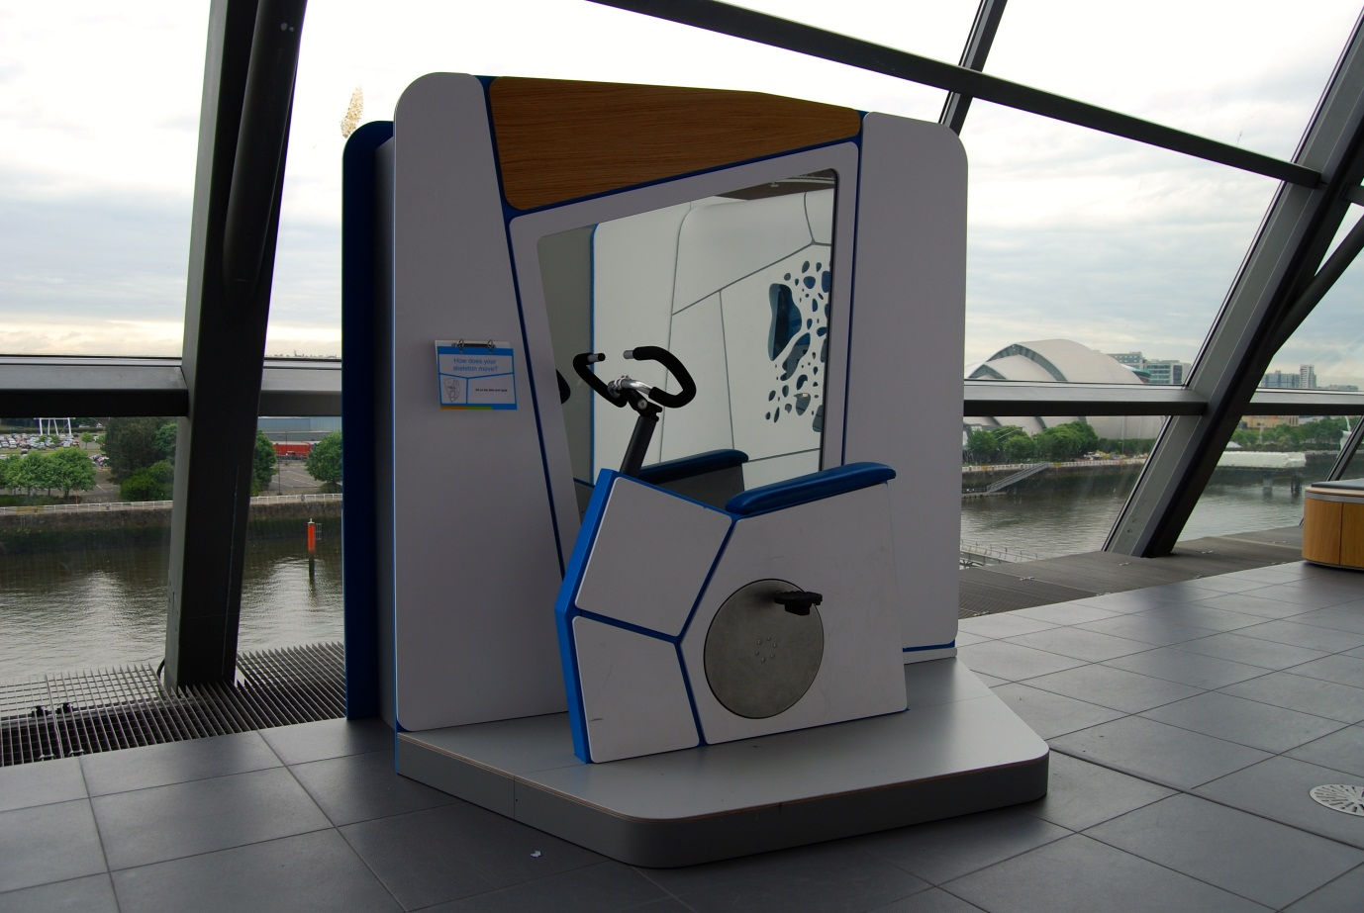

## How does your skeleton move?

Also known as Cycling Skeleton / A7.14

### Description

An exhibit that allows visitors to see how their skeleton moves when cycling. It consists of a bicycle on a raised platform, one-way mirror, skeleton and a 3-layer flapper label. The pedals of the bicycle control the movements of the skeleton’s legs.

### Visitor experience

The visitor sits on the bicycle and pedals. Initially they can see their reflection in the mirror but as they cycle, lights illuminate the skeleton and it appears through the one-way mirror. The skeleton mimics their cycling actions.

### Visitor interaction tips

* Point out how long their femur bone in their leg is – the longest bone in the body.
* Suggest related exhibits: ‘If you liked this, you’ll love this’

### Accessibility

For visitors with sight problems, offer assistance with using the bicycle and describe how the skeleton is moving.

For visitors unable to use this exhibit, explain how it works before pointing them in the direction of a related exhibit.

### Good to know

Fabricated by Hüttinger.

### Daily checks by science communicators

The exhibit components are in good working order.

### Cleaning

Clean the mirror with appropriate glass cleaner.

Clean the surfaces with appropriate surface cleaner.

Remember to clean the flapper label.

Clean the raised platform with a broom and dustpan & brush.

Dust the ledges using a microfibre duster or static duster.

### Risks

See risk assessment in Risk Assessments folder.

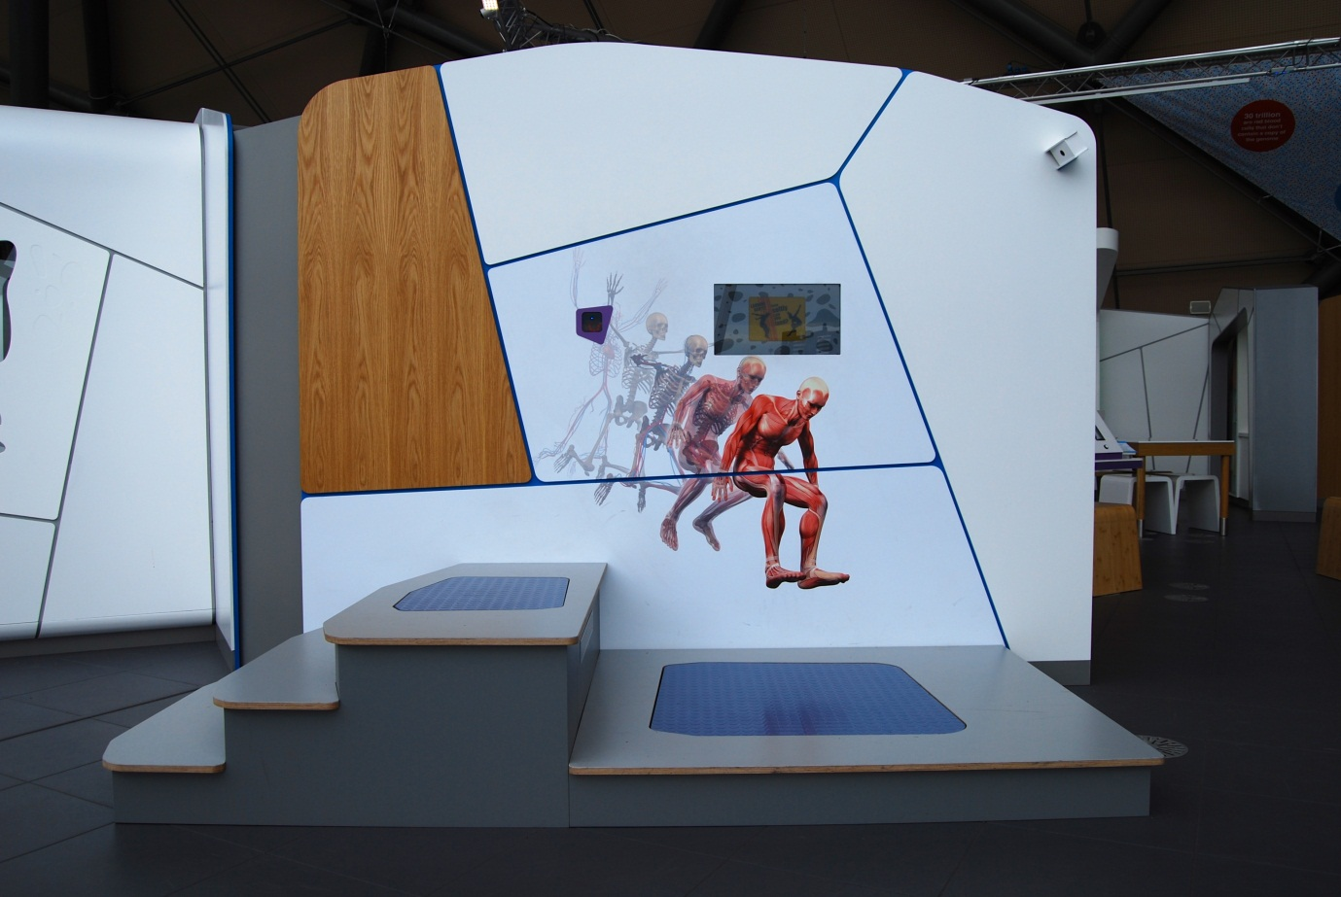

## Landing Gently: How softly can you land?

Also known as A7.04

### Description

An exhibit that allows visitors to test how softly they can land after jumping from a platform. It consists of a pressure pad, steps, touch screen, barcode scanner and video camera.

### Visitor experience

The visitor activates the exhibit by either pressing the touchscreen or by scanning their My BodyWorks barcode card. After pressing start, the visitor climbs the steps to the upper step and at the end of the countdown, they jump and land on the lower pressure pad. At the end, the visitor is shown a graph of force against time together with a video replay of their jump. A successful jump has a flat force reading over time. The visitor can save their results to their My BodyWorks profile.

### Visitor interaction tips

* Encourage use of the My BodyWorks cards by explaining how they work and highlighting the benefits of using the website.
* Try asking thought-provoking questions related to the visitor, such as ‘what could you do to improve your technique?’ or ‘why is it important for you to absorb the impact of landing?’
* Suggest related exhibits: ‘If you liked this, you’ll love this’

### Accessibility

For visitors with sight problems, offer assistance with this exhibit. Offer to take them on a walk-through first, taking care with the steps and edges.

For visitors unable to use this exhibit, offer to explain how it works before pointing them in the direction of a related exhibit.

### Good to know

After a jump, your body needs to land safely. The forces of the impact when landing could easily injure your body. To land safely, your leg muscles spread the force of your jump like shock absorbers. Landing safely from jumps is an important part of sports like skiing, ballet and parkour.

### Daily checks by science communicators

The exhibit components are in good working order.

### Cleaning

Clean the screen with appropriate screen cleaner.

Clean the surfaces with appropriate surface cleaner.

Clean the raised platforms with a broom and dustpan & brush.

Dust the ledges using a microfibre duster or static duster.

### Risks

See risk assessment in Risk Assessments folder.



# Your bionic body Research Capsule

“From prosthetic limbs to motion-capture technology, replacing and understanding body parts is no longer science fiction. How are engineers pushing the boundaries to mimic nature itself?”

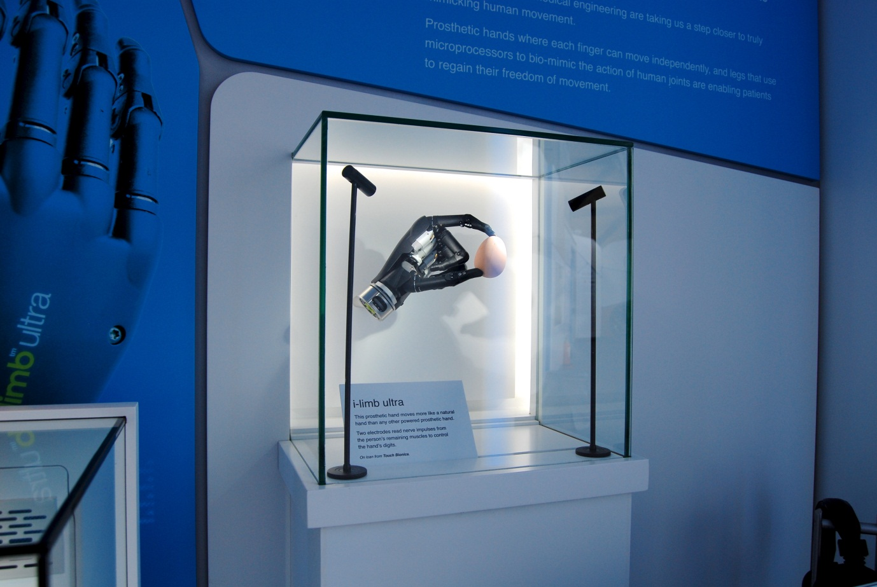

## i-limb ultra

Also known as Prosthetic Hand Display Case / C7.06

### Description

A display case that allows visitors to see one of the latest prosthetic limbs, the i-limb ultra from Touch Bionics. It is housed in a glass display case with an A6 label. The object is lit.

### Visitor experience

The visitor can view the prosthetic hand.

### Visitor interaction tips

* Explain to visitors that they are standing in an area showcasing some of the ways science is working on bionics and prosthetics (see the text on the capsule welcome panels).
* Use the information contained on the *Bionic Body information screen* to explain more about the prosthetic hand.

### Accessibility

For visitors with sight problems, offer to describe the prosthesis.

### Good to know

The product brochure from the manufacturer is available in this folder.

The prosthetic hand is on loan from Touch Bionics.

### Daily checks by science communicators

The exhibit components are in good working order.

### Cleaning

Clean the glass with appropriate glass cleaner.

Clean the surfaces with appropriate surface cleaner.

Dust the ledges using a microfibre duster or static duster.

### Risks

See risk assessment in Risk Assessments folder.

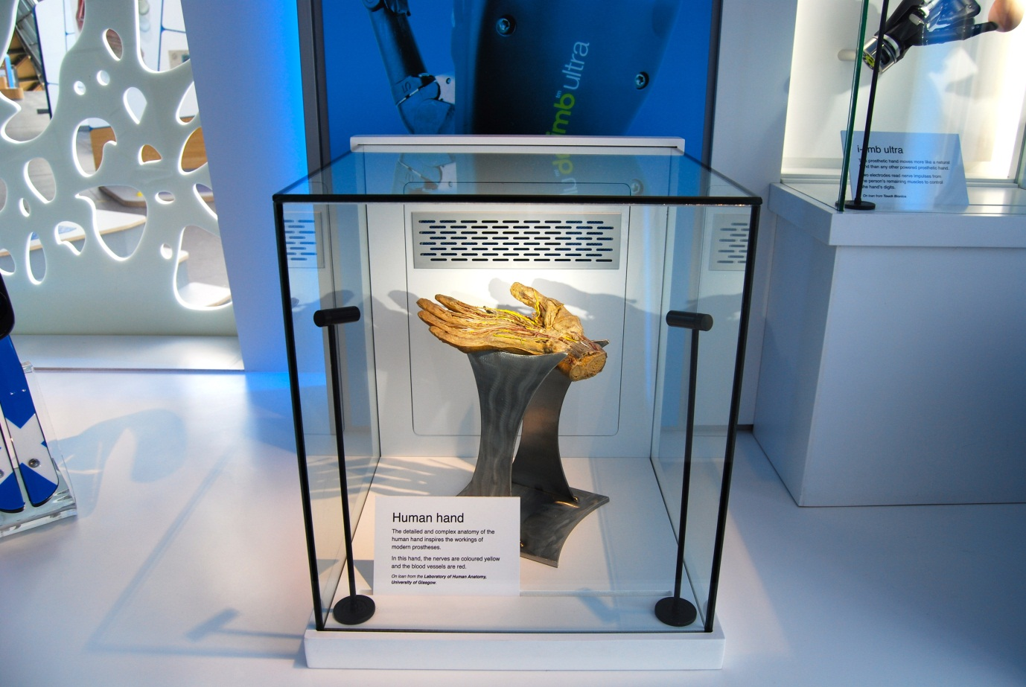

## Human hand

Also known as C7.05a

### Description

An exhibit that allows visitors to examine a real human specimen used in medical training. It consists of a human hand housed within a glass display case. The specimen has been dissected and is lit to allow visitors to fully appreciate the intricate detail of the nerves and blood vessels on the hand. The exhibit, including its location, is designed to be respectful, dignified and give visitors an opportunity for contemplation.

### Visitor experience

Visitors can explore the wonders of the human hand by looking at a real dissected hand.

### Visitor interaction tips

* Explain to visitors that they are standing in an area showcasing some of the ways science is working on bionics and prosthetics (see the text on the capsule welcome panels).
* Why not spark a discussion on donating a body to medical science. Note body donation is different to organ donation, which are used for transplants. Body donation is used for medical science.
* For interested visitors, take out the body donation literature at the end of this folder. Please return the leaflets after use.
* If a visitor asks how they can donate their body to medical science, tell them to contact their local University Medical School.

### Accessibility

For visitors with sight problems, offer to describe the specimen and how it was preserved.

### Good to know

BodyWorks features three specimens of human tissue. The specimens are all from people who donated their bodies for use in the training of future doctors, dentists, nurses and the allied health professionals.

They are on loan from the Laboratory of Human Anatomy, School of Life Sciences, University of Glasgow where they are used to help students study and understand human anatomy. At the Laboratory is the Museum of Anatomy, which is open to the public.

The specimens in BodyWorks have been created by a process called plastination. This is a process used in anatomy to preserve body parts. Fat and water is replaced in the fixed tissue with polymers like silicone and epoxy. This allows the specimens to be touched and prevents them from decaying and retains many of their original features.

Glasgow Science Centre has permission to display the human material. Permission was sought from Her Majesty’s Inspector for Anatomy Scotland and St Andrew’s House (Scottish Government). As the specimen is from before the 1984 Anatomy Act, there are no restrictions on photography. However we endeavour to display the specimen in a sensitive manner with the utmost respect.

### Daily checks by science communicators

The exhibit components are in good working order.

### Cleaning

Clean the glass with appropriate glass cleaner.

Clean the surfaces with appropriate surface cleaner.

Dust the ledges using a microfibre duster or static duster.

### Risks

See risk assessment in Risk Assessments folder.

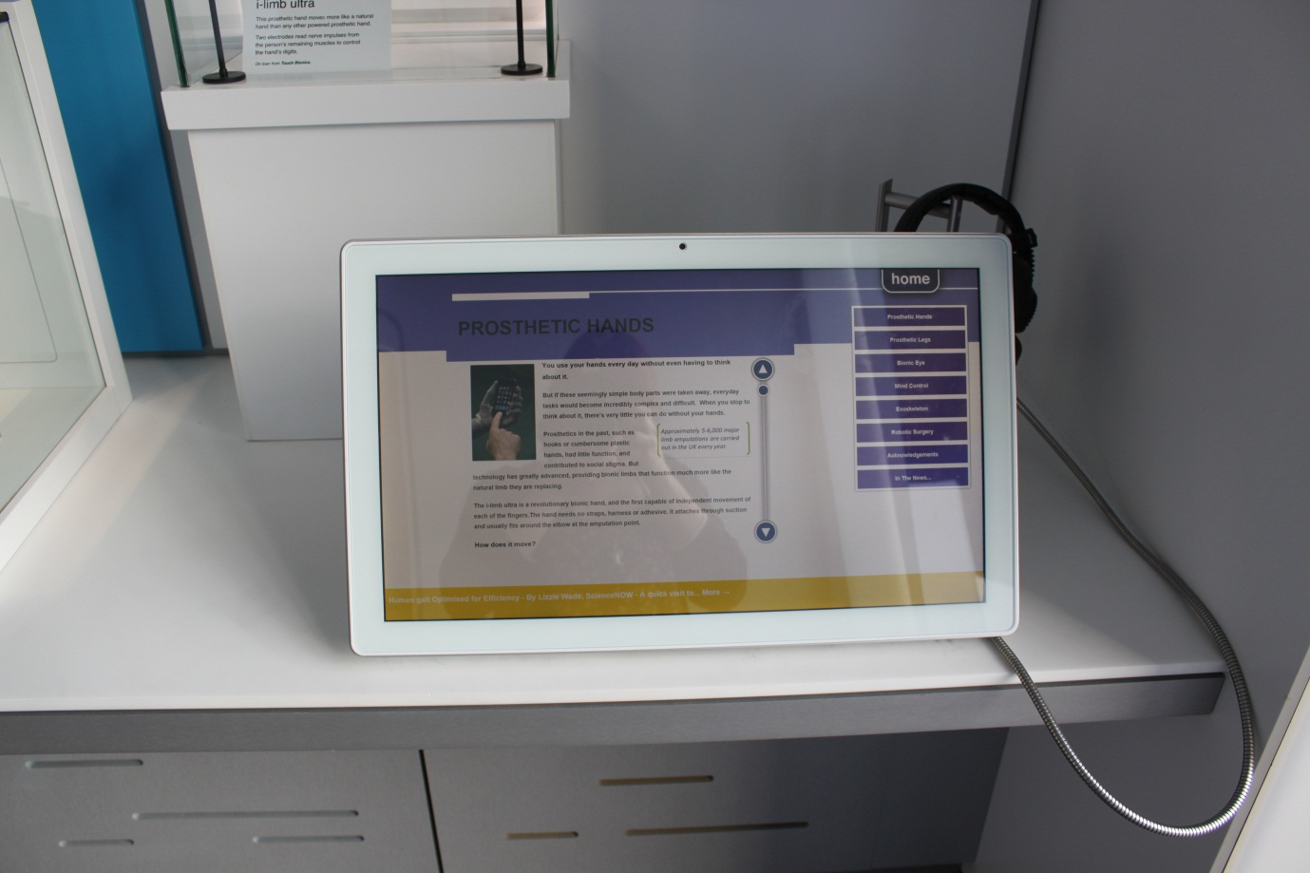

## Bionic Body information screen

Also known as C7.08

### Description

An information screen that allows visitors to explore the latest advances in prosthetics and biomechanics. It consists of a touchscreen, pair of headphones and moveable stool. The exhibit features 6 articles, news RSS feeds and an acknowledgments page. Articles contain text, images and videos.

### Visitor experience

On approach, the exhibit displays an overview article. Visitors tap the scroll buttons to read through the article. Further articles can be selected from the column on the right-hand side of the screen. News articles appear along the bottom of the screen.

### Visitor interaction tips

* Explain to visitors that they are standing in an area showcasing some of the ways science is working on bionics and prosthetics (see the text on the capsule welcome panels).
* Point out that many of the stories featured on this screen are related to the surrounding objects, displays and interactive exhibits.

### Accessibility

For visitors with sight problems, offer assistance with the touchscreen.

For visitors unable to use this exhibit, offer to explain how it works before pointing them in the direction of a related exhibit.

### Good to know

The information on this screen is updateable.

### Daily checks by science communicators

The exhibit components are in good working order.

### Cleaning

Clean the screen with appropriate screen cleaner.

Clean the surfaces and moveable stool with appropriate surface cleaner.

Dust the ledges using a microfibre duster or static duster.

### Risks

See risk assessment in Risk Assessments folder.

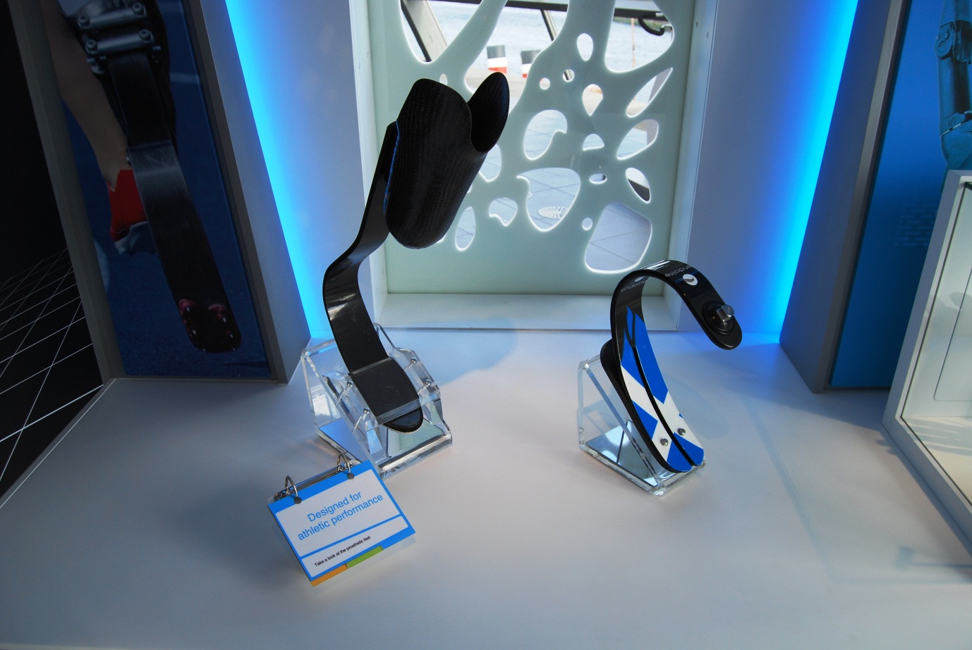

## Designed for athletic performance

Also known as Prosthetic Feet Display / C7.##

### Description

An exhibit that allows visitors to see some of the latest advances in prosthetic feet and knees. It consists of three prostheses mounted on a table with a 3-layer flapper label.

### Visitor experience

The visitor can view and touch the prostheses.

### Visitor interaction tips

* Explain to visitors that they are standing in an area showcasing some of the ways science is working on bionics and prosthetics (see the text on the capsule welcome panels).
* Use the information contained on the *Bionic Body information screen* to explain more about the prosthetic feet and knee.

### Accessibility

For visitors with sight problems, offer to describe the features of each prosthesis as they touch them.

### Good to know

The product brochures from the manufacturer are available in this folder.

These prosthetic devices are on loan from Össur and Chas A Blatchford & Sons Ltd.

### Daily checks by science communicators

The exhibit components are in good working order. In particular:

* Each prosthesis is secure.

### Cleaning

Clean the surfaces with appropriate surface cleaner.

Remember to clean the flapper label.

### Risks

See risk assessment in Risk Assessments folder.

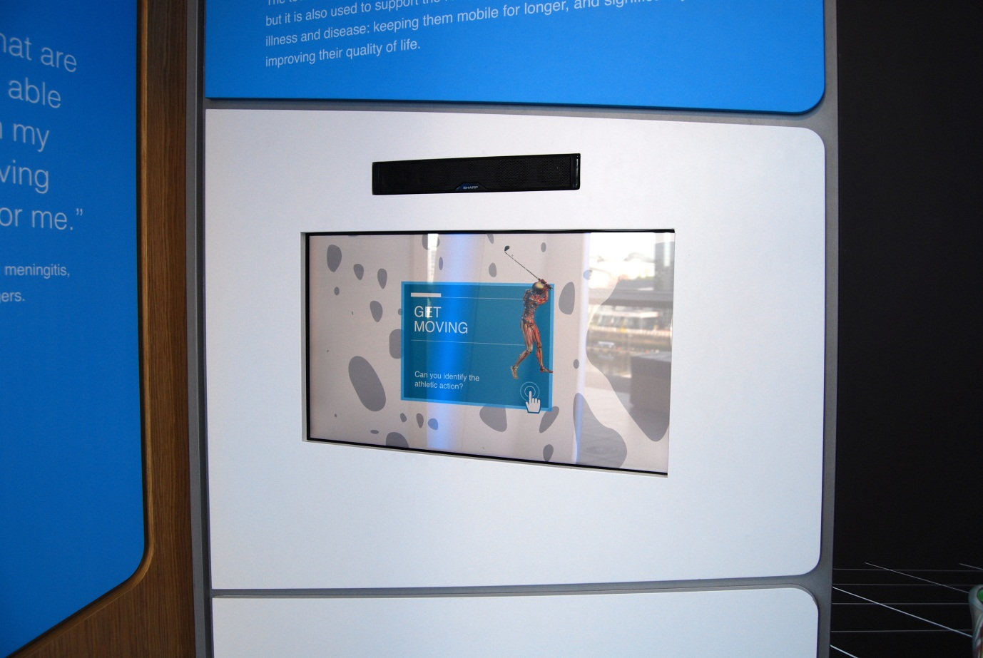

## Get Moving: Can you identify the athletic action?

Also known as C7.07

### Description

An IT game that challenges visitors to identify a sport from motion-capture footage of an athlete’s performance. It consists of a wall-mounted touchscreen. The game is structured as a multiple choice quiz with eight rounds.

### Visitor experience

The visitor activates the exhibit by pressing the touchscreen. The visitor chooses a difficulty setting for the game. During the game, the visitor watches a repeating video of motion-capture data. On easy, the data features ‘stick men’; on hard, the data features dots only. From a selection of four, the visitor selects the sport they believe the footage is showing. If they get it wrong, they get another guess. At the end they are given a score out of 8.

### Visitor interaction tips

* Explain to visitors that they are standing in an area showcasing some of the ways science is working on bionics and prosthetics (see the text on the capsule welcome panels).
* Point out that the athletes featured in this game, are also in the *Every Body is Different* exhibit.
* Offer assistance on how to play the game, as you highlight key learning outcomes tailored to the visitor.
* Suggest related exhibits: ‘If you liked this, you’ll love this’

### Accessibility

For visitors with sight problems, offer assistance with the touchscreen.

For visitors unable to use this exhibit, offer to explain how it works before pointing them in the direction of a related exhibit.

### Good to know

This exhibit was developed in partnership with a team at the University of Strathclyde. Local athletes attended the Gait Laboratory at The Department of Biomedical Engineering.

### Daily checks by science communicators

The exhibit components are in good working order.

### Cleaning

Clean the screen with appropriate screen cleaner.

Clean the surfaces with appropriate surface cleaner.

Dust the ledges using a microfibre duster or static duster.

### Risks

See risk assessment in Risk Assessments folder.

# Appendices

## Appendix A – Keys

### HAFELE 0001 (kept on Fire Tags)

Prep Room access door

Back wall access door next to Anato-me Vests (mirror)

Access door at thank you panel beside big lift

### HAFELE 0010 (kept on Fire Tags)

Access door to Human Hamster Wheel

Access door to Height Chart / Scoreboard

Access hatch to clean Lung Capacity mouthpiece dispenser

Access door to Standing Jump / Hang Time

Access door between Reaction Timer and Sprint Track crash mat

Access hatch for the pressure pads in Land Gently

Access door to Cycling Skeleton

### HAFELE FH001 (kept on Fire Tags)

All cupboards in cluster tables including Mechanical Arm exhibit

Back wall access door next to Mucus Ninjas

All cupboards in capsules

Live Lab glass door for lab coat cupboard

Live Lab cupboards under the sink

Live Lab presenter bench AV control

Live Lab presenter bench cupboards

### CODE e 005 (kept in cupboard under Live Lab sink)

Live Lab paper towel dispenser

### Blank key with 2 protruding points (kept in cupboard under Live Lab sink)

Live Lab soap dispenser

## Appendix B – Washing lung capacity mouthpieces

Later in this folder

## Appendix C – Additional resources on particular exhibits

Later in this folder